**ACADGILD**

**MAJOR PROJECT**

**Index**

|  |  |  |
| --- | --- | --- |
| **Sr No.** | **Title** | **Page No.** |
| **1.** | **Flow of Document** | **3** |
| **2.** | **Project Requirements** | **4** |
| **3.** | **Flow of solution(Generalized)** | **6** |
| **4.** | **Using Mapreduce Program(Individual Execution of Programs)** | **7** |
| **5.** | **Using Mapreduce Program(Shell Script Execution)** | **33** |
| **6.** | **Using Pig Script(Individual Execution of Scripts)** | **46** |
| **7.** | **Using Pig Script(Shell Script Execution)** | **69** |

**IMPORTANT**

**Flow of Document**

1. **Using Mapreduce Program(Individual Execution of Programs)**

* In this section I have implemented the solution using map reduce programs. Only exception is the second requirement where it was specified that the pig udf has to be used.
* This section has execution of the each part of the solution individually and their outputs.

1. **Using Mapreduce Program(Shell Script Execution)**

* In this section I have written a shell script and implemented all the jobs section one at once. i.e (from flume job to the ingestion of the data into mysql db using sqoop)
* At the end of the execution of the shell script I have attached the actual outputs from mysql db for both the requirments.
* Note:- I have uploaded the txt file where actual and full execution of the

Shell script is shown.

1. **Using Pig Script(Individual Execution of Scripts)**

* In this section I have implemented solution pig scripts. The solutions which were addressed using map reduce programs in section one are now in this section are addressed using pig scripts.
* Here in this section individual execution pig scripts is done and attached sample output for each case and sometimes full output wherever needed.

1. **Using Pig Script(Shell Script Execution)**

* In this section shell script for execution all the tasks that were implemented in section 3 is done. . i.e (from flume job to the ingestion of the data into mysql db using sqoop).
* Screen shots of all important points have been put in the document.
* At the end of the execution of the shell script I have attached the actual outputs from mysql db for both the requirments.
* Note:- I have uploaded the txt file where actual and full execution of the

Shell script is shown.

**Project Requirements**

1. Executive Summary

1.1 Project Overview to develop the System to analyze the log data (In XML format) of government progress of various development activities.

1.2 Purpose and Scope of this Specification

The purpose of this project is to capture the data for analyzing the progress of various activities.

In scope

The following requirement will be addressed in phase 1 of Project: Developing system to handle the incoming log feed and store the information in Hadoop

• Cluster (Flume) Analyze the data and understand the progress

• Store the results in Hbase/RDBMS

Out of scope

We can use this data and visualization and get more insights

2. Product/Service Description

2.1 Assumptions Log will be generated in XML format and stored in a server

2.2 Constraints

Describe any item that will constrain the design options, including

This system may not be used for searching for now. But it will be used for analysis and

• saving the relevant information as of now

System will be using Hbase as a database

Requirements

The FLUME job which will format the data and place the data to HDFS

• Pig/MapReduce job for parsing the XML data.

• Create Pig scripts/MapReduce jobs to analyze the data

• Create the Sqoop job to store the data in database

• Priority Definitions

The following definitions are intended as a guideline to prioritize requirements.

Priority 1 – Create FLUME job for fetching log files from spool directory the data

• Priority 2 – MapReduce/pig job to preprocess

• Download the dataset using the below link: Link: https://drive.google.com/file/d/0Bxr27gVaXO5sUjd2RWFQS3hQQUE/view?usp=sharing Refer the below steps to understand the actual steps to create the above project.

Step 1:

Copy dataset from local file system to HDFS using flume.

Note: use the conf file by downloading from below link.

Click here to download Command: flume-agent agent –n agent1 –c conf –f

Step 2:

Input file is in the XML format use Map reduce or pig to parse the data and get the results for the below problem statements.

4. Problem statement

1. Find out the districts who achieved 100 percent objective in BPL cards Export the results to mysql using sqoop

2. Write a Pig UDF to filter the districts which have reached 80% of objectives of BPL cards. Export the results to MySQL using Sqoop.

***Extra Things attempted***

* ***I have implemented the conversion using both map reduce program and the pig***
* ***Also I have implemented the 1st question with map reduce program.***
* ***I have written the shell script both of the implementations so as to combine whole of the project into one pack.***

**Flow of the Solution(Generalized)**

**FIRST STEP-**

-Download the file from source into the local system.

-Using flume get that file from local system to the HDFS(Hadoop Distributed file system.)

**SECOND STEP-**

-Convert the given XML file to CSV (Comma Separated Values).

This can be done in both ways

* Using Mapreduce i.e creating a custom input format.
* Using Pig i.e.Using the piggybank methods.

In this project I have demonstrated both ways of converting the file from XML to CSV.

**THIRD STEP-**

-To get all the districts which have achieved the 100% in BPL cards.

The above can be demonstrated with mapreduce as well as with help of pig. Both ways have been implemented in the below.

**FOURTH STEP –**

-To get all the districts which have achieved the 80% in BPL cards.

As in the project requirements pig udf has to be implemented hence this is done only using the pig implementation.

**SOLUTION**

1. **Using Mapreduce Program(Individual Execution of Programs)**

**FIRST STEP-**

Extracting data using flume to HDFS

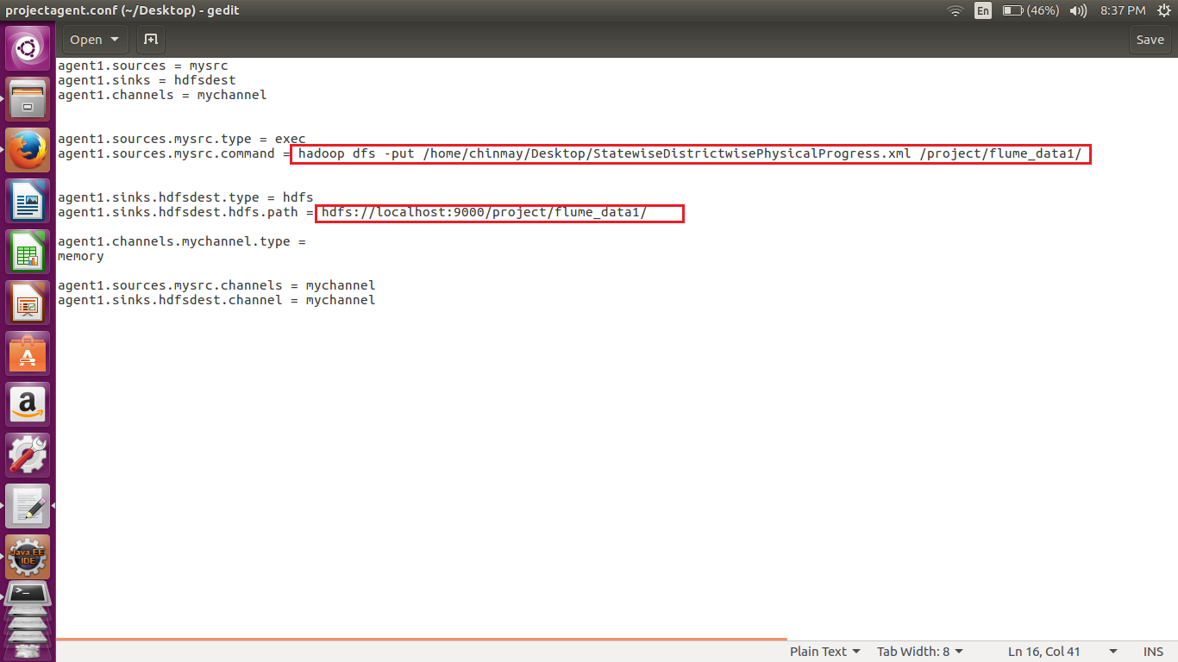

Above shows the flume agent that was used to extract the data from local file system to HDFS.

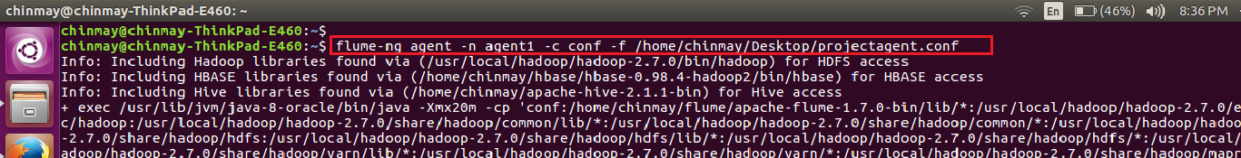

The command used to extract the file to HDFS . Above we have mentioned the location of the configuration file used.

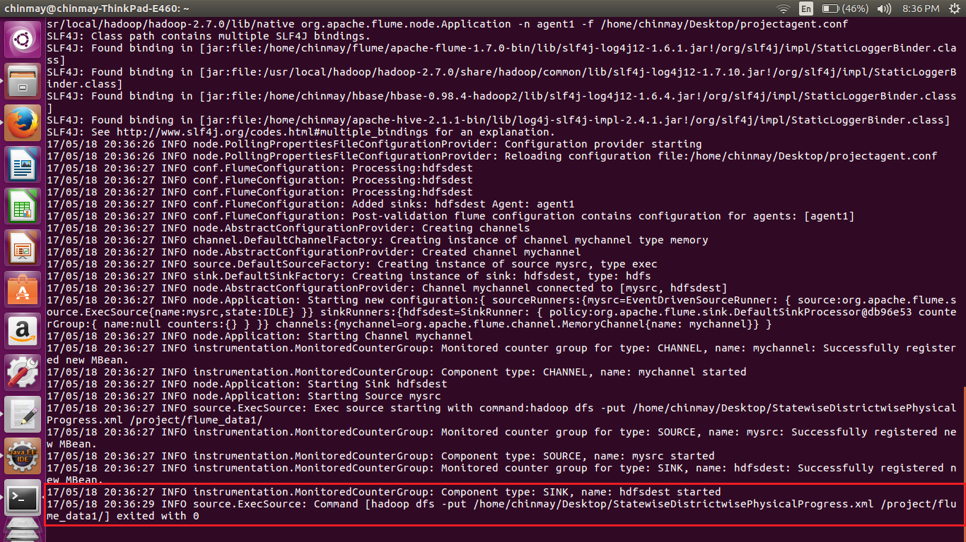

Here we can see that transfer of the file from local files system to HDFS is over. As flume is used for getting the streaming data hence it keeps the channels connected expecting the new input. Hence in order to stop it from listening on the channel Crlt-c has to be pressed.

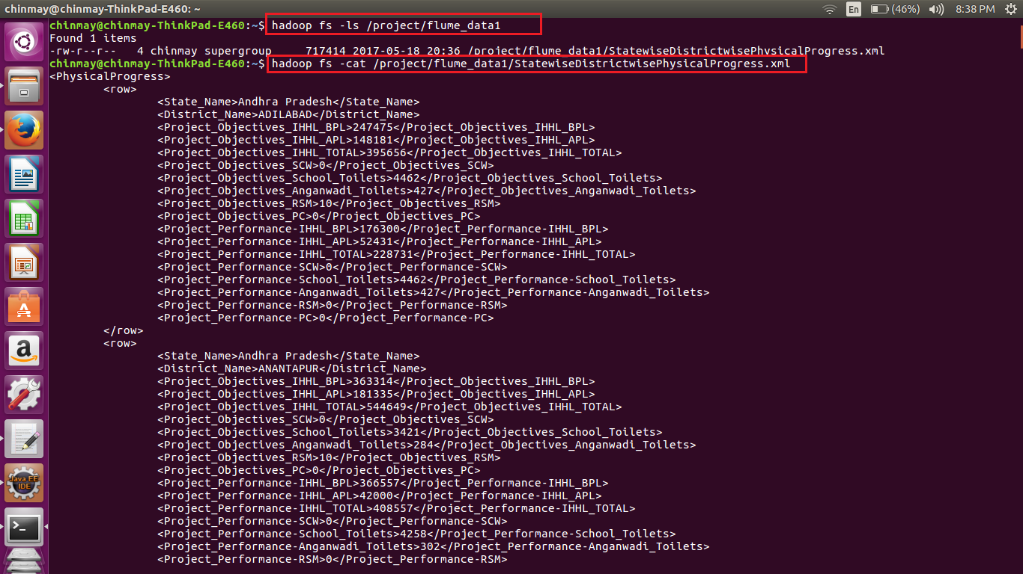

Successful extraction of data was possible.

**STEP TWO-**

Conversion of the XML to CSV file format.

In this part we are accomplishing the below part by using the mapreduce program.

Custom input format class

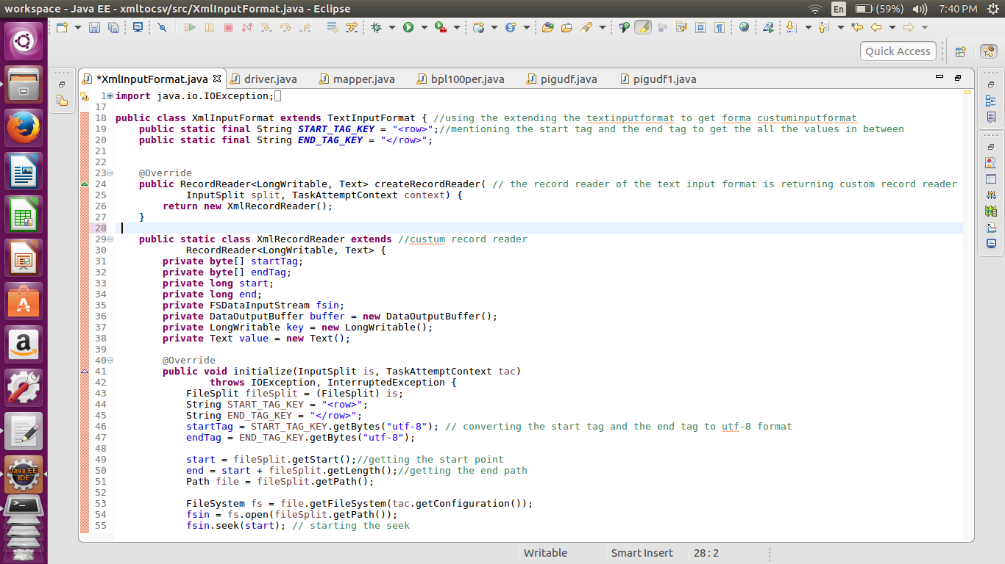

Here we are extending the Textinputformat class in order to create our own custom input format.

The record reader of the textinputformat class is returning a custom record reader (XMLRecorReader).

In the custom record reader we are mentioning the start point and the end point by using the methods getstart, and get length. Also we are starting the seek in the initialize method of the record reader.

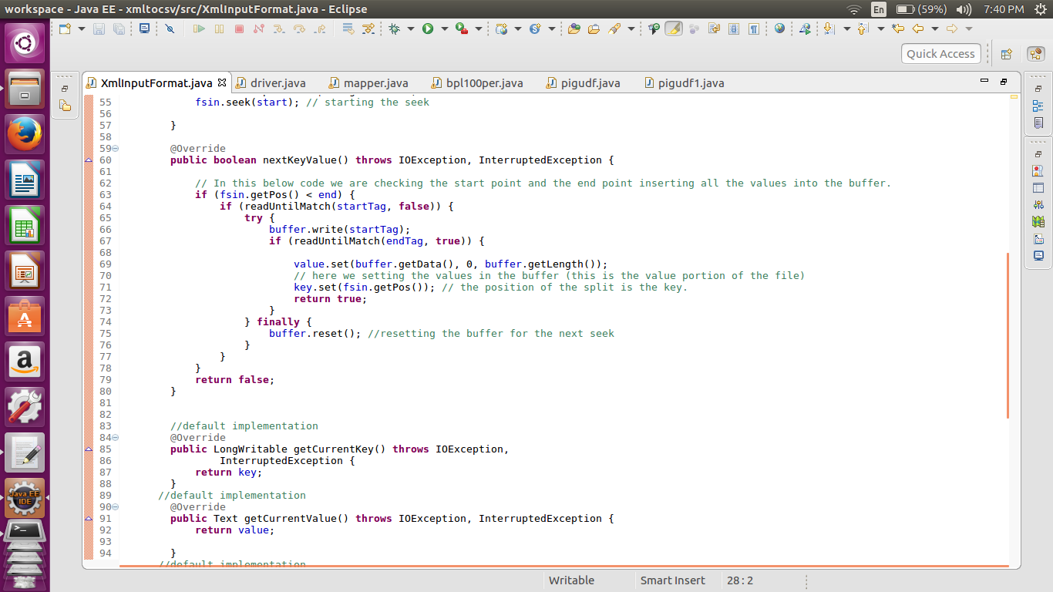

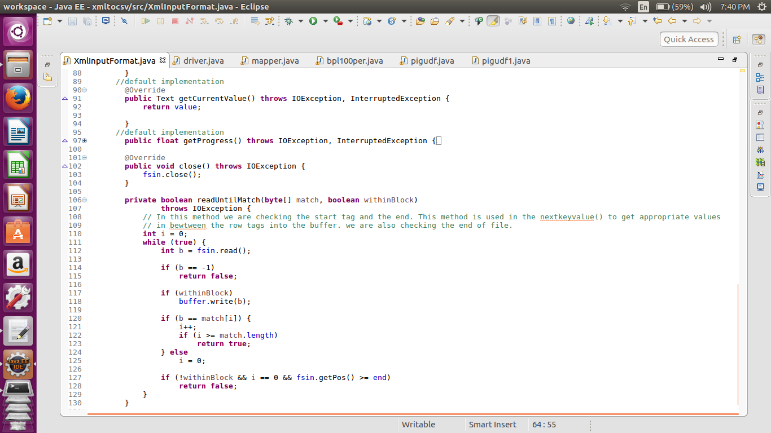

In the nextkeyvalue method of the record reader we are putting all the values in between the tag values <row> and </row>. In the above custom input format we are not actually getting values between tags. In the custom input format we are just setting what to take as single input in our case one single input related to on district is between <row> and </row> and hence nextkeyvalue will check the occurrence of the <row> and </row> and store all the values in between the tags in to buffer.

Mapper class

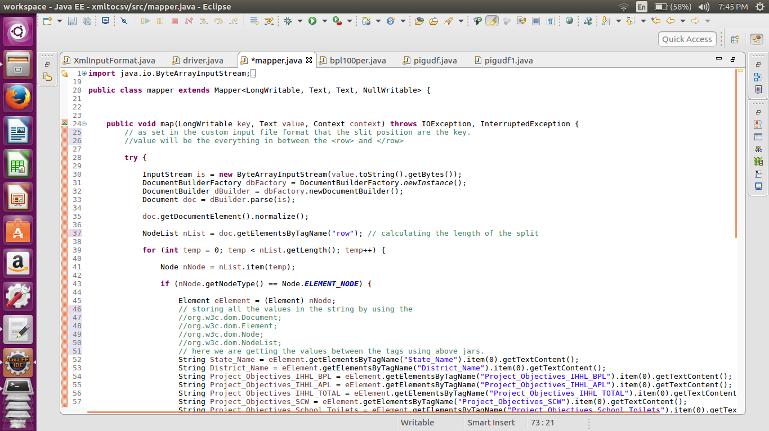

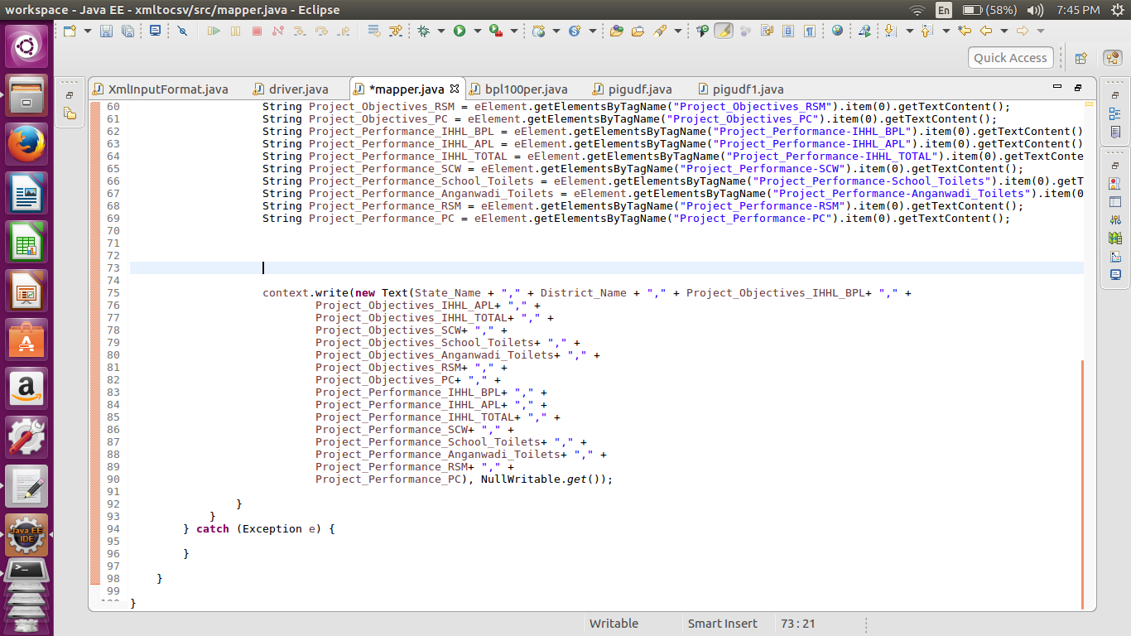

Once data into the buffer in the mapper class we are using the w3c jars in order to extract the values from different tags in between the row tag. In the end we are stitching the values to form a single string with commas in between. This whole String is passed as key and value from the mapper is kept nullwritable.

Driver class

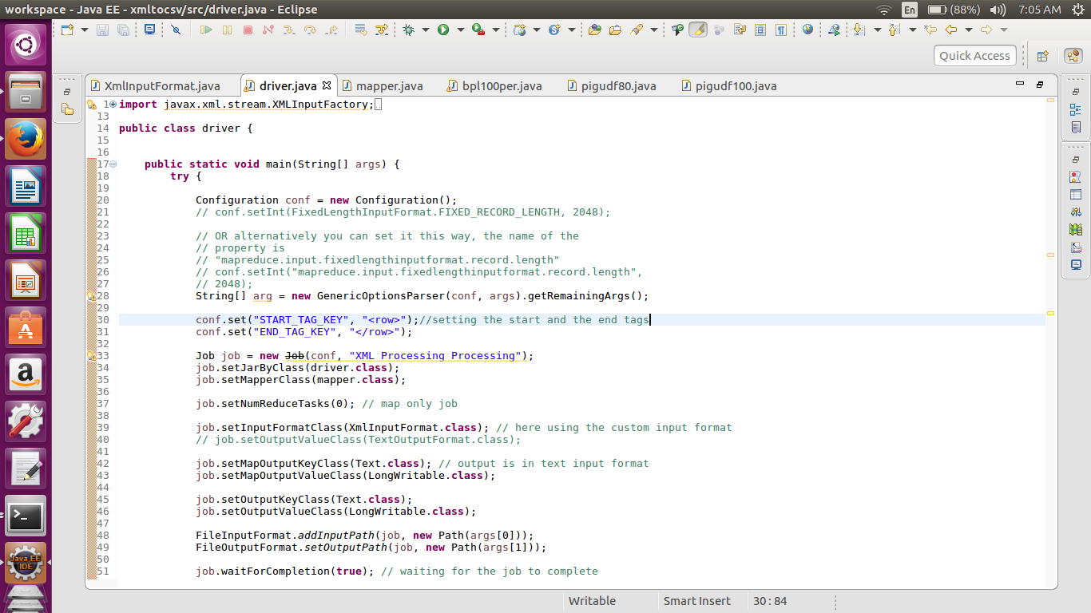

Here considered the input format as the XmlInputformat which we have created.

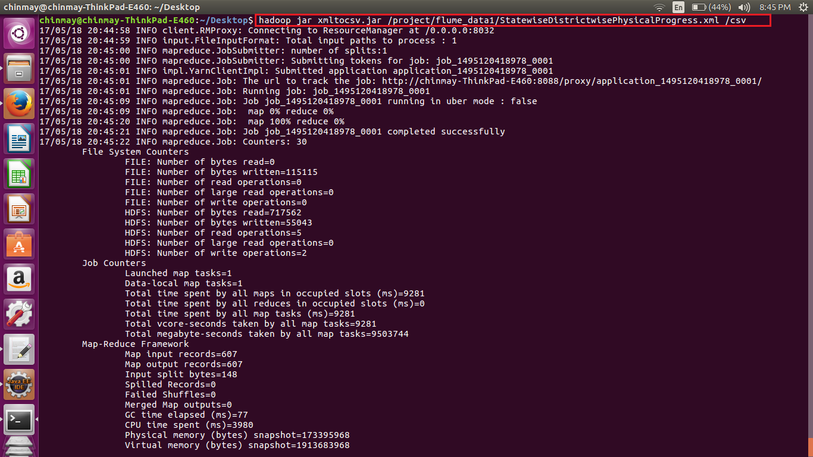

Sample output of the above execution

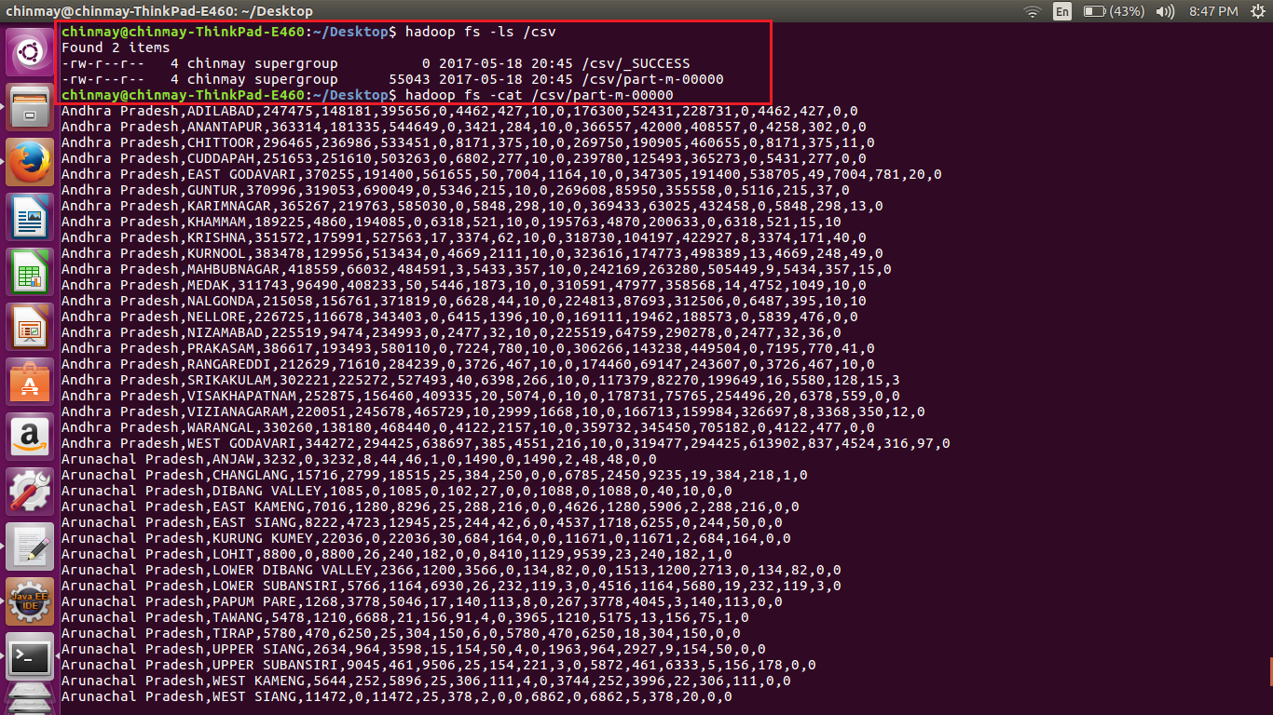

Individual execution of the above jar converts the file from XML to CSV format.

**STEP THREE-**

Getting the districts that are achieved the 100% in bpl cards

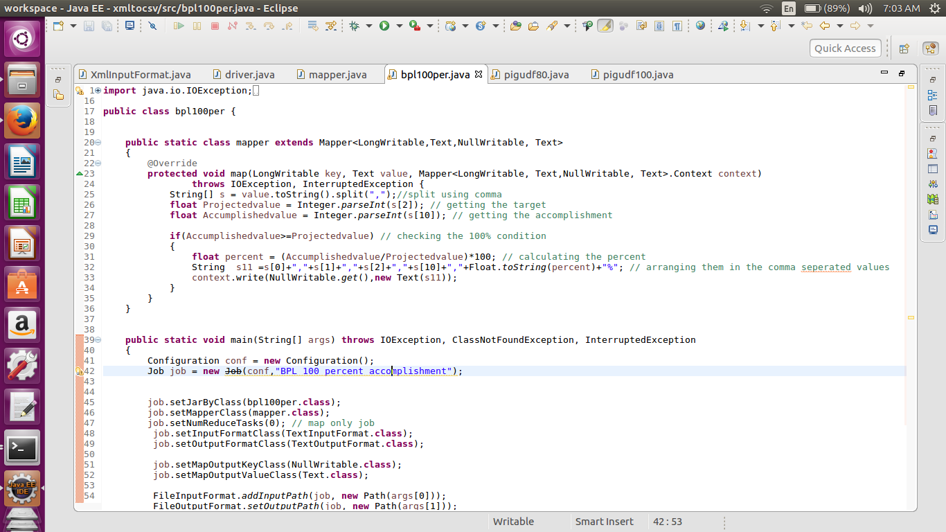

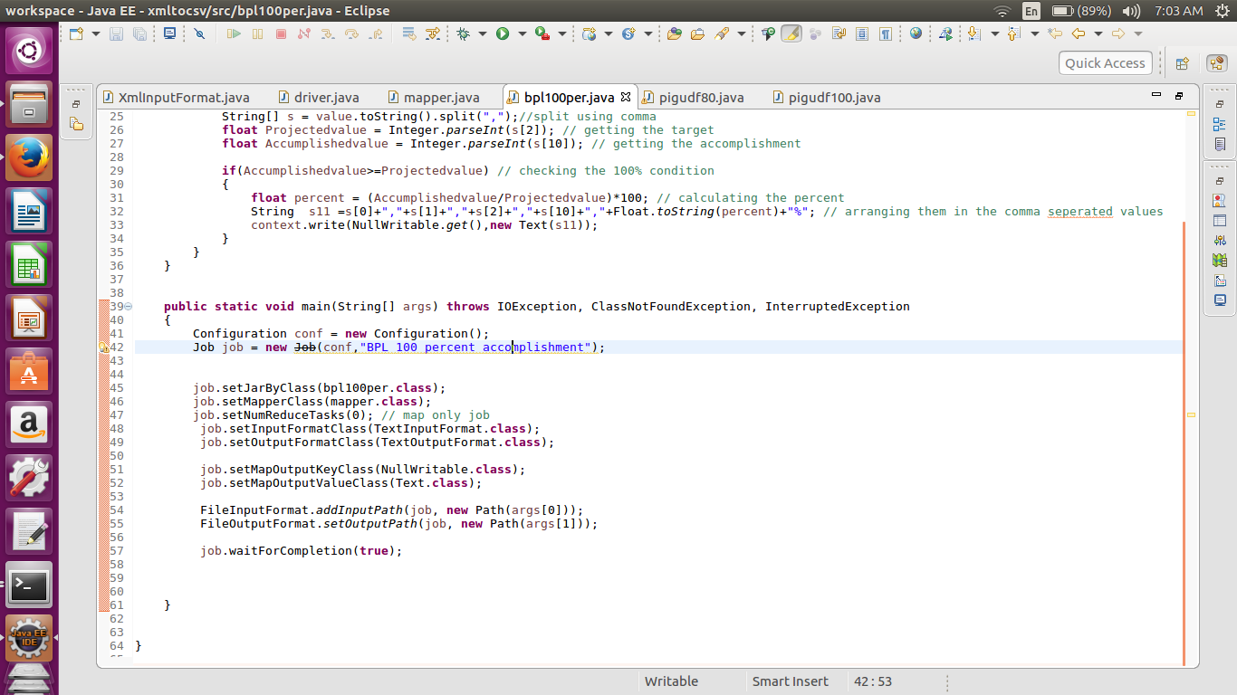

Above we can see that it is amp only job. Here we are taking the converted CSV file as the input and testing the condition 100% condition. After the segregation we are concatenating the State name, district name, target set, accomplished number, and percentage in order.

Execution of the job

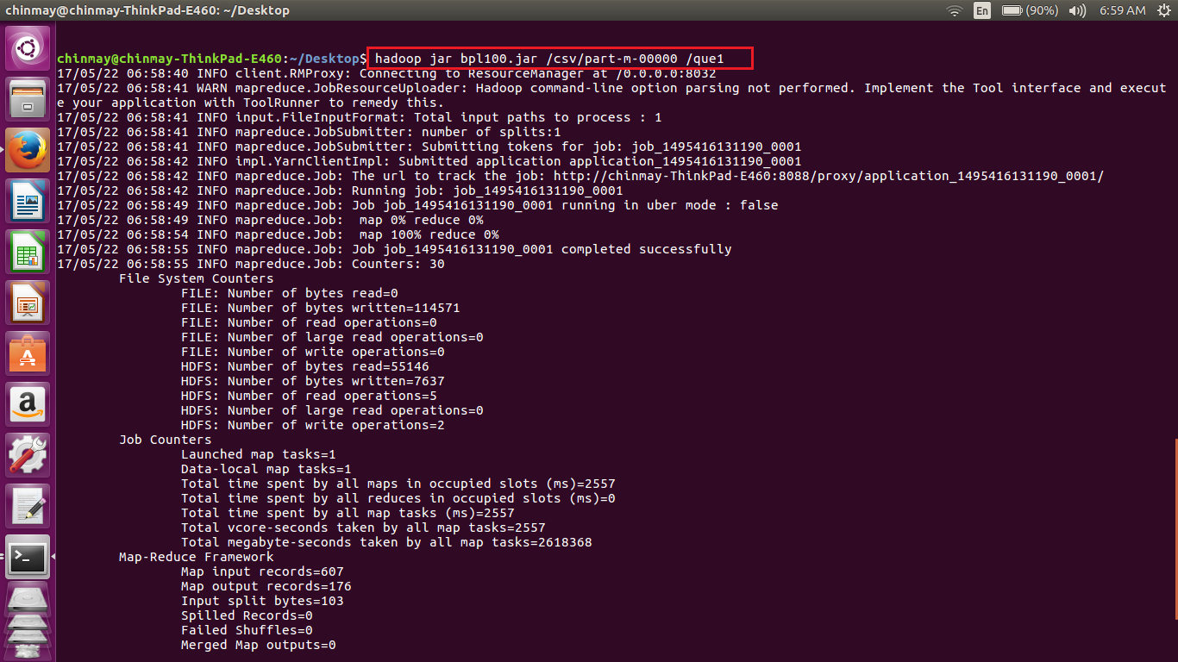

Sample output containing records which have achieved 100% mark or more.

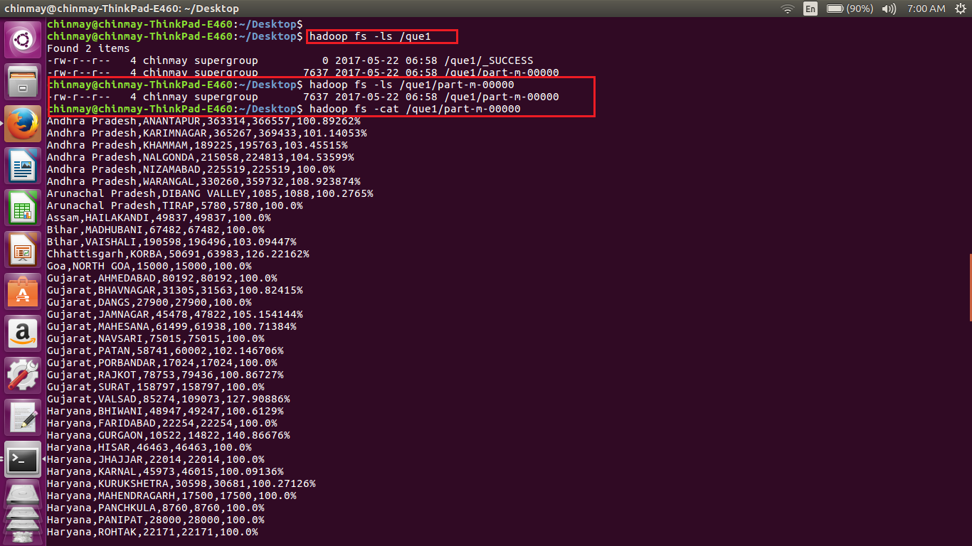

Now importing the this file into mysql db using Sqoop job.

Sqoop job implementation

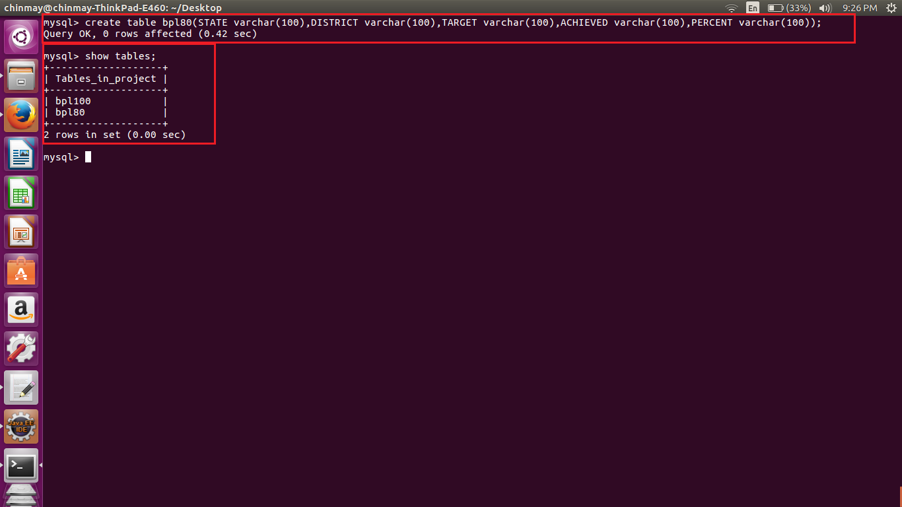

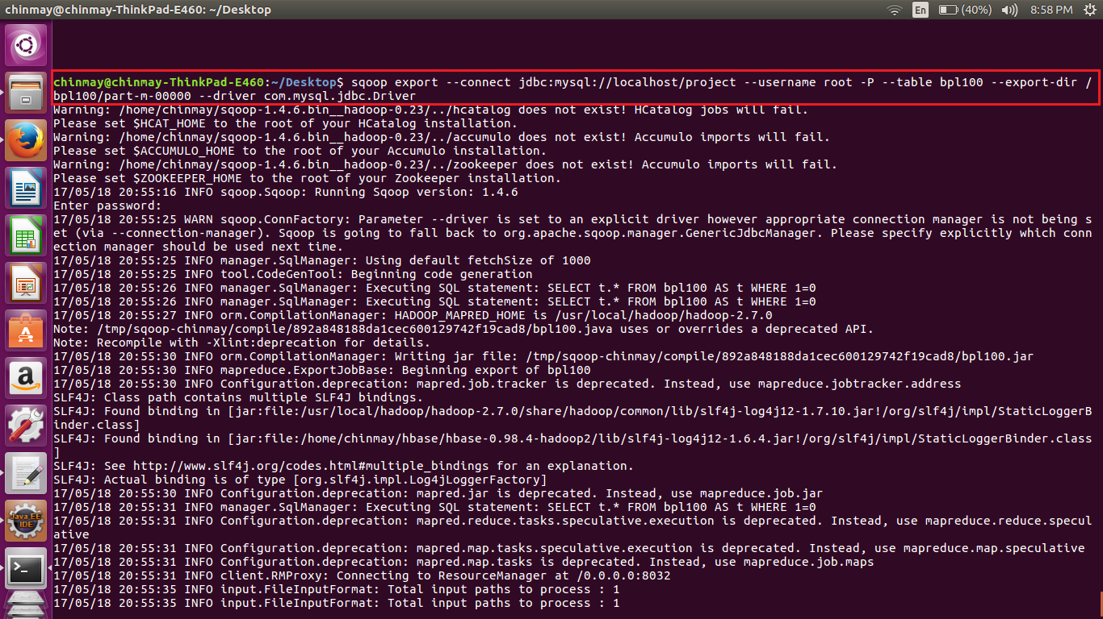

Completion of the Sqoop job

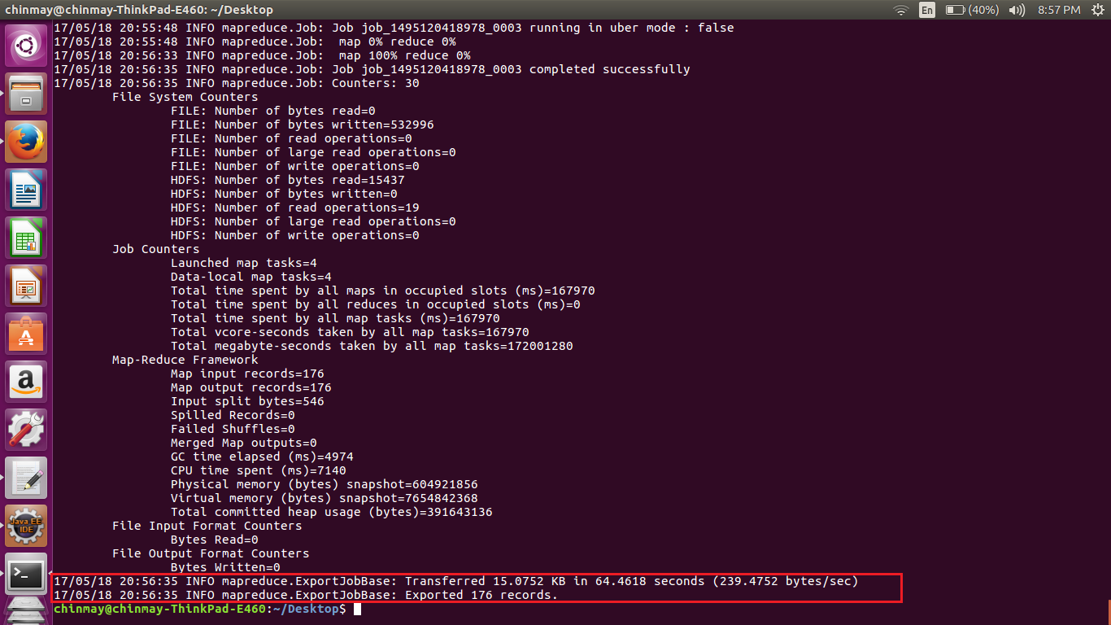

Sample Output from mysql db.

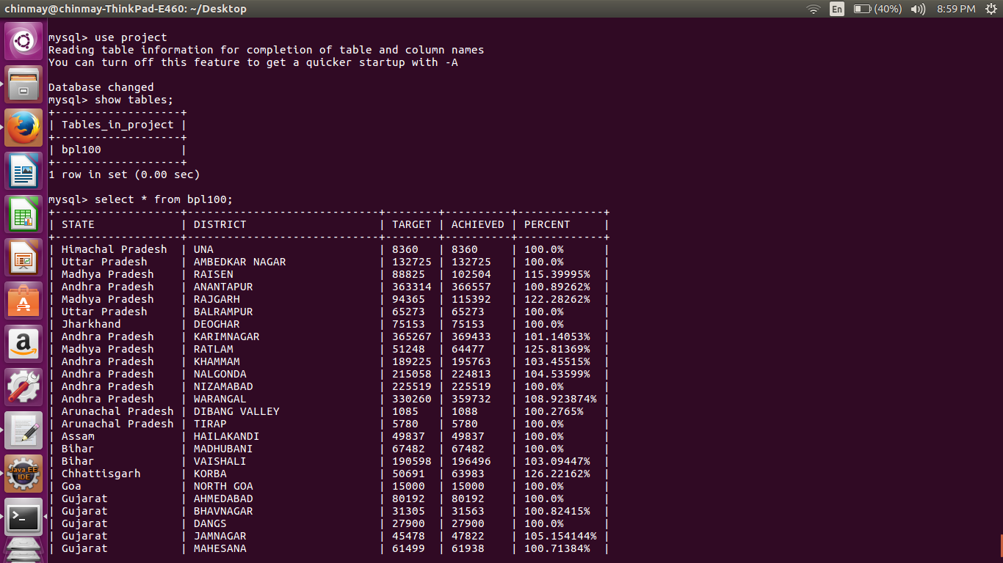

Full output from the terminal is as below

Database changed

mysql> show tables;

+-------------------+

| Tables_in_project |

+-------------------+

| bpl100 |

+-------------------+

1 row in set (0.00 sec)

mysql> select * from bpl100;

+-------------------+-----------------------------+--------+----------+-------------+

| STATE | DISTRICT | TARGET | ACHIEVED | PERCENT |

+-------------------+-----------------------------+--------+----------+-------------+

| Himachal Pradesh | UNA | 8360 | 8360 | 100.0% |

| Uttar Pradesh | AMBEDKAR NAGAR | 132725 | 132725 | 100.0% |

| Madhya Pradesh | RAISEN | 88825 | 102504 | 115.39995% |

| Andhra Pradesh | ANANTAPUR | 363314 | 366557 | 100.89262% |

| Madhya Pradesh | RAJGARH | 94365 | 115392 | 122.28262% |

| Uttar Pradesh | BALRAMPUR | 65273 | 65273 | 100.0% |

| Jharkhand | DEOGHAR | 75153 | 75153 | 100.0% |

| Andhra Pradesh | KARIMNAGAR | 365267 | 369433 | 101.14053% |

| Madhya Pradesh | RATLAM | 51248 | 64477 | 125.81369% |

| Andhra Pradesh | KHAMMAM | 189225 | 195763 | 103.45515% |

| Andhra Pradesh | NALGONDA | 215058 | 224813 | 104.53599% |

| Andhra Pradesh | NIZAMABAD | 225519 | 225519 | 100.0% |

| Andhra Pradesh | WARANGAL | 330260 | 359732 | 108.923874% |

| Arunachal Pradesh | DIBANG VALLEY | 1085 | 1088 | 100.2765% |

| Arunachal Pradesh | TIRAP | 5780 | 5780 | 100.0% |

| Assam | HAILAKANDI | 49837 | 49837 | 100.0% |

| Bihar | MADHUBANI | 67482 | 67482 | 100.0% |

| Bihar | VAISHALI | 190598 | 196496 | 103.09447% |

| Chhattisgarh | KORBA | 50691 | 63983 | 126.22162% |

| Goa | NORTH GOA | 15000 | 15000 | 100.0% |

| Gujarat | AHMEDABAD | 80192 | 80192 | 100.0% |

| Gujarat | BHAVNAGAR | 31305 | 31563 | 100.82415% |

| Gujarat | DANGS | 27900 | 27900 | 100.0% |

| Gujarat | JAMNAGAR | 45478 | 47822 | 105.154144% |

| Gujarat | MAHESANA | 61499 | 61938 | 100.71384% |

| Gujarat | NAVSARI | 75015 | 75015 | 100.0% |

| Gujarat | PATAN | 58741 | 60002 | 102.146706% |

| Uttar Pradesh | BARABANKI | 199542 | 202328 | 101.3962% |

| Gujarat | PORBANDAR | 17024 | 17024 | 100.0% |

| Gujarat | RAJKOT | 78753 | 79436 | 100.86727% |

| Gujarat | SURAT | 158797 | 158797 | 100.0% |

| Gujarat | VALSAD | 85274 | 109073 | 127.90886% |

| Haryana | BHIWANI | 48947 | 49247 | 100.6129% |

| Haryana | FARIDABAD | 22254 | 22254 | 100.0% |

| Haryana | GURGAON | 10522 | 14822 | 140.86676% |

| Haryana | HISAR | 46463 | 46463 | 100.0% |

| Haryana | JHAJJAR | 22014 | 22014 | 100.0% |

| Haryana | KARNAL | 45973 | 46015 | 100.09136% |

| Haryana | KURUKSHETRA | 30598 | 30681 | 100.27126% |

| Haryana | MAHENDRAGARH | 17500 | 17500 | 100.0% |

| Haryana | PANCHKULA | 8760 | 8760 | 100.0% |

| Haryana | PANIPAT | 28000 | 28000 | 100.0% |

| Haryana | ROHTAK | 22171 | 22171 | 100.0% |

| Haryana | SIRSA | 35400 | 35400 | 100.0% |

| Haryana | SONIPAT | 29808 | 30300 | 101.65056% |

| Himachal Pradesh | BILASPUR | 11931 | 13078 | 109.61361% |

| Himachal Pradesh | CHAMBA | 44429 | 58422 | 131.4952% |

| Himachal Pradesh | HAMIRPUR | 11593 | 11593 | 100.0% |

| Himachal Pradesh | KANGRA | 45000 | 61820 | 137.37778% |

| Himachal Pradesh | KINNAUR | 1560 | 1560 | 100.0% |

| Himachal Pradesh | KULLU | 9989 | 9989 | 100.0% |

| Himachal Pradesh | LAHAUL & SPITI | 2413 | 2413 | 100.0% |

| Himachal Pradesh | MANDI | 34407 | 34408 | 100.00291% |

| Himachal Pradesh | SHIMLA | 23874 | 23874 | 100.0% |

| Himachal Pradesh | SOLAN | 10858 | 10858 | 100.0% |

| Jharkhand | LOHARDAGA | 22626 | 22626 | 100.0% |

| Jharkhand | PURBI SINGHBHUM | 97196 | 126967 | 130.62987% |

| Karnataka | BANGALORE RURAL | 63044 | 87975 | 139.5454% |

| Karnataka | HASSAN | 64134 | 64134 | 100.0% |

| Karnataka | KOLAR | 43183 | 85744 | 198.55962% |

| Karnataka | MANGALORE(DAKSHINA KANNADA) | 59478 | 59478 | 100.0% |

| Karnataka | SHIMOGA | 99428 | 99996 | 100.571266% |

| Karnataka | UDUPI | 52348 | 52348 | 100.0% |

| Kerala | ALAPPUZHA | 114359 | 114359 | 100.0% |

| Kerala | ERNAKULAM | 54585 | 55916 | 102.4384% |

| Kerala | IDUKKI | 86535 | 89553 | 103.48761% |

| Kerala | KANNUR | 34121 | 37628 | 110.27813% |

| Kerala | KASARGOD | 56965 | 59153 | 103.84096% |

| Kerala | KOLLAM | 95130 | 95130 | 100.0% |

| Kerala | KOTTAYAM | 28118 | 28118 | 100.0% |

| Kerala | KOZHIKODE | 42285 | 42285 | 100.0% |

| Kerala | MALAPPURAM | 60592 | 61905 | 102.166954% |

| Kerala | PALAKKAD | 107018 | 107018 | 100.0% |

| Kerala | PATHANAMTHITTA | 53799 | 53799 | 100.0% |

| Kerala | THIRUVANANTHAPURAM | 129000 | 137004 | 106.20465% |

| Kerala | THRISSUR | 48669 | 51017 | 104.824425% |

| Kerala | WAYANAD | 50655 | 50655 | 100.0% |

| Madhya Pradesh | ALIRAJPUR | 38225 | 52971 | 138.57686% |

| Uttar Pradesh | BAREILLY | 110000 | 110000 | 100.0% |

| Madhya Pradesh | ANUPPUR | 39615 | 55336 | 139.68446% |

| Uttar Pradesh | BIJNOR | 110403 | 110403 | 100.0% |

| Uttar Pradesh | BUDAUN | 107603 | 107603 | 100.0% |

| Uttar Pradesh | BULANDSHAHR | 28885 | 31996 | 110.770294% |

| Uttar Pradesh | CHANDAULI | 92022 | 96318 | 104.66845% |

| Uttar Pradesh | CHITRAKOOT | 38082 | 42652 | 112.00042% |

| Uttar Pradesh | ETAH | 62001 | 69139 | 111.51272% |

| Uttar Pradesh | ETAWAH | 94097 | 94097 | 100.0% |

| Uttar Pradesh | FARRUKHABAD | 120471 | 120471 | 100.0% |

| Uttar Pradesh | FIROZABAD | 19843 | 19843 | 100.0% |

| Uttar Pradesh | GHAZIABAD | 10810 | 10810 | 100.0% |

| Uttar Pradesh | HARDOI | 199989 | 199989 | 100.0% |

| Uttar Pradesh | JAUNPUR | 250000 | 250924 | 100.3696% |

| Uttar Pradesh | JHANSI | 58826 | 59119 | 100.49808% |

| Uttar Pradesh | JYOTIBA PHULE NAGAR | 48008 | 48008 | 100.0% |

| Uttar Pradesh | KANNAUJ | 101497 | 101616 | 100.11724% |

| Uttar Pradesh | LAKHIMPUR KHERI | 73000 | 95742 | 131.15343% |

| Madhya Pradesh | BARWANI | 75695 | 84663 | 111.84754% |

| Madhya Pradesh | BETUL | 43427 | 43688 | 100.601006% |

| Madhya Pradesh | BHOPAL | 20010 | 31380 | 156.82158% |

| Madhya Pradesh | BURHANPUR | 41047 | 43340 | 105.58628% |

| Madhya Pradesh | DATIA | 11997 | 18386 | 153.25499% |

| Madhya Pradesh | DEWAS | 59245 | 79734 | 134.58351% |

| Madhya Pradesh | DHAR | 100281 | 119944 | 119.6079% |

| Madhya Pradesh | GWALIOR | 32128 | 39081 | 121.64156% |

| Madhya Pradesh | HARDA | 23589 | 31545 | 133.72758% |

| Madhya Pradesh | HOSHANGABAD | 50677 | 83469 | 164.70786% |

| Madhya Pradesh | INDORE | 48998 | 50152 | 102.355194% |

| Madhya Pradesh | JABALPUR | 106290 | 117804 | 110.832634% |

| Madhya Pradesh | JHABUA | 81491 | 94244 | 115.64958% |

| Madhya Pradesh | KATNI | 53000 | 68295 | 128.85849% |

| Uttar Pradesh | LUCKNOW | 113188 | 113188 | 100.0% |

| Uttar Pradesh | MAHAMAYA NAGAR(HATHRAS) | 25153 | 25277 | 100.49298% |

| Uttar Pradesh | MAHARAJGANJ | 145090 | 145090 | 100.0% |

| Uttar Pradesh | MAHOBA | 53117 | 53117 | 100.0% |

| Uttar Pradesh | MATHURA | 25005 | 25110 | 100.419914% |

| Uttar Pradesh | MIRZAPUR | 231315 | 233308 | 100.861595% |

| Madhya Pradesh | KHANDWA(EAST NIMAR) | 60123 | 82598 | 137.3817% |

| Madhya Pradesh | KHARGONE | 91083 | 91458 | 100.41171% |

| Uttar Pradesh | MORADABAD | 76018 | 76018 | 100.0% |

| Uttar Pradesh | MUZAFFARNAGAR | 51660 | 51660 | 100.0% |

| Uttar Pradesh | PILIBHIT | 95178 | 95178 | 100.0% |

| Uttar Pradesh | PRATAPGARH | 141368 | 143517 | 101.52014% |

| Uttar Pradesh | RAE BARELI | 190306 | 190430 | 100.06516% |

| Uttar Pradesh | SAHARANPUR | 49458 | 49586 | 100.258804% |

| Uttar Pradesh | SHAHJAHANPUR | 194645 | 194959 | 100.161316% |

| Madhya Pradesh | MANDSAUR | 46666 | 67848 | 145.39066% |

| Madhya Pradesh | REWA | 121538 | 147541 | 121.39496% |

| Madhya Pradesh | MORENA | 32478 | 39727 | 122.319725% |

| Madhya Pradesh | NEEMUCH | 27790 | 42843 | 154.16696% |

| Uttar Pradesh | SONBHADRA | 138370 | 138370 | 100.0% |

| Madhya Pradesh | SEHORE | 34355 | 77009 | 224.1566% |

| Uttar Pradesh | SULTANPUR | 168843 | 168843 | 100.0% |

| Madhya Pradesh | SHAHDOL | 84802 | 86586 | 102.10372% |

| Madhya Pradesh | SHAJAPUR | 65429 | 75217 | 114.95973% |

| Madhya Pradesh | SHEOPUR | 18198 | 28955 | 159.11089% |

| Madhya Pradesh | UJJAIN | 68225 | 77417 | 113.47307% |

| Madhya Pradesh | UMARIA | 40359 | 54150 | 134.17082% |

| Maharashtra | GADCHIROLI | 75900 | 75900 | 100.0% |

| Maharashtra | RATNAGIRI | 95726 | 102182 | 106.744255% |

| Uttarakhand | NAINITAL | 14314 | 18039 | 126.02347% |

| Uttarakhand | RUDRAPRAYAG | 13150 | 13810 | 105.01901% |

| West Bengal | DAKSHIN DINAJPUR | 182621 | 184153 | 100.8389% |

| Maharashtra | SINDHUDURG | 43874 | 43874 | 100.0% |

| West Bengal | MIDNAPUR EAST | 392371 | 527389 | 134.4108% |

| West Bengal | MIDNAPUR WEST | 509496 | 596291 | 117.03546% |

| Meghalaya | WEST GARO HILLS | 44385 | 44385 | 100.0% |

| Mizoram | CHAMPHAI | 11077 | 11077 | 100.0% |

| Mizoram | LAWNGTLAI | 16544 | 16544 | 100.0% |

| Punjab | BARNALA | 12137 | 12593 | 103.75711% |

| Punjab | FATEHGARH SAHIB | 2485 | 2630 | 105.83501% |

| Punjab | HOSHIARPUR | 11112 | 19094 | 171.83224% |

| Punjab | LUDHIANA | 45422 | 46920 | 103.29796% |

| Punjab | NAWANSHAHR | 7273 | 11581 | 159.23279% |

| Punjab | S.A.S Nagar | 4008 | 4025 | 100.42415% |

| Rajasthan | HANUMANGARH | 31621 | 31621 | 100.0% |

| Sikkim | EAST SIKKIM | 24109 | 26852 | 111.37749% |

| Sikkim | NORTH SIKKIM | 4978 | 5461 | 109.7027% |

| Sikkim | SOUTH SIKKIM | 8970 | 12446 | 138.75139% |

| Sikkim | WEST SIKKIM | 13245 | 13345 | 100.755% |

| Tamil Nadu | DHARMAPURI | 152872 | 152921 | 100.03206% |

| Tamil Nadu | ERODE | 165306 | 165306 | 100.0% |

| Tamil Nadu | KANCHIPURAM | 147350 | 154480 | 104.83882% |

| Tamil Nadu | KANYAKUMARI(NAGERCOIL) | 76233 | 84822 | 111.26678% |

| Tamil Nadu | KARUR | 105280 | 105280 | 100.0% |

| Tamil Nadu | NAMAKKAL | 117538 | 117538 | 100.0% |

| Tamil Nadu | PUDUKKOTTAI | 176710 | 198097 | 112.102875% |

| Tamil Nadu | RAMANATHAPURAM | 105000 | 156708 | 149.24571% |

| Tamil Nadu | TIRUCHIRAPPALLI | 77747 | 77747 | 100.0% |

| Tamil Nadu | TIRUNELVELI | 125763 | 139323 | 110.78218% |

| Tamil Nadu | TIRUVANNAMALAI | 209116 | 209116 | 100.0% |

| Tamil Nadu | TIRUVARUR | 80920 | 87918 | 108.64805% |

| Tripura | DHALAI | 53507 | 53507 | 100.0% |

| Tripura | SOUTH TRIPURA | 139456 | 139456 | 100.0% |

| Tripura | WEST TRIPURA | 183405 | 183405 | 100.0% |

| Uttar Pradesh | AGRA | 54188 | 54789 | 101.1091% |

| Uttar Pradesh | ALLAHABAD | 181370 | 195141 | 107.59276% |

+-------------------+-----------------------------+--------+----------+-------------+

176 rows in set (0.00 sec)

From above results we can see that all the percentages are equal or above 100%.

**STEP FOUR-**

Getting the districts that are achieved the 80% in bpl cards. Here as per the instructions I have implemented using pig

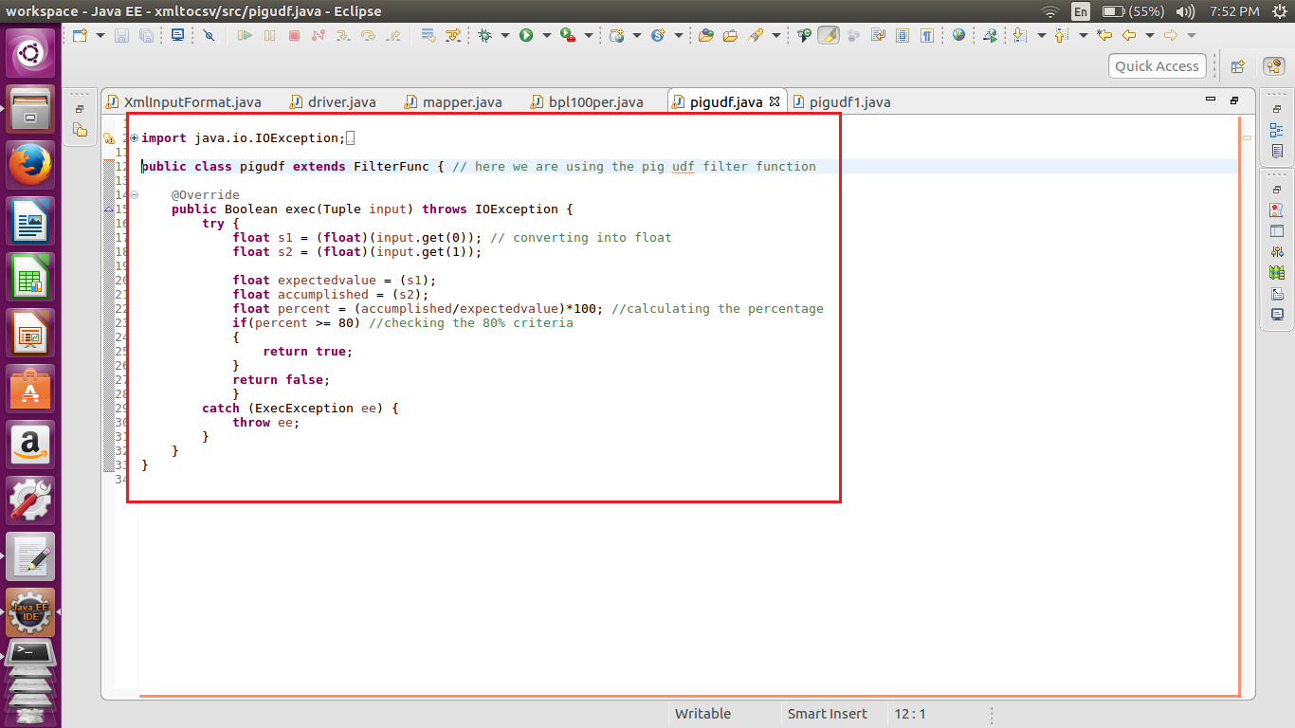

I have used the filter function of the pig in order to filter out the all the records who have achieved the 80% mark or above in bpl cards.

The function returns true if and only if the percentage is equal to 80 or above 80 percent, else it returns false.

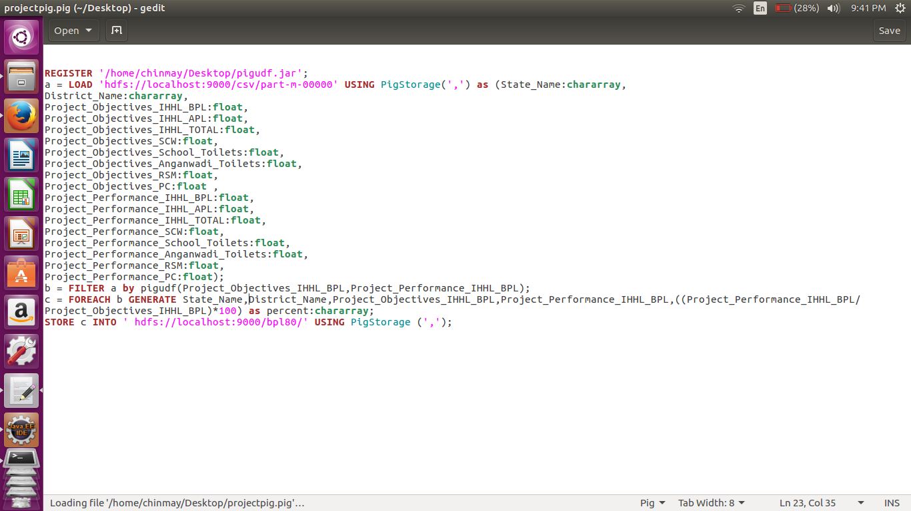

Here is the pig script written in order to get the records that have achieved the 80% or more in bpl cards.

-I have first registered the udf jar.

-Then loaded the data from the converted file with the above mentioned schema.

-Used my udf to filter out the records as needed.

-Then displayed only the state name, district name, target value , accomplished value, and percentage value.

Note – As mentioned in the requirements the task was to completed using the pig udf hence executed with pig Script.

Below are the screen shots of the implementation of the pig script.

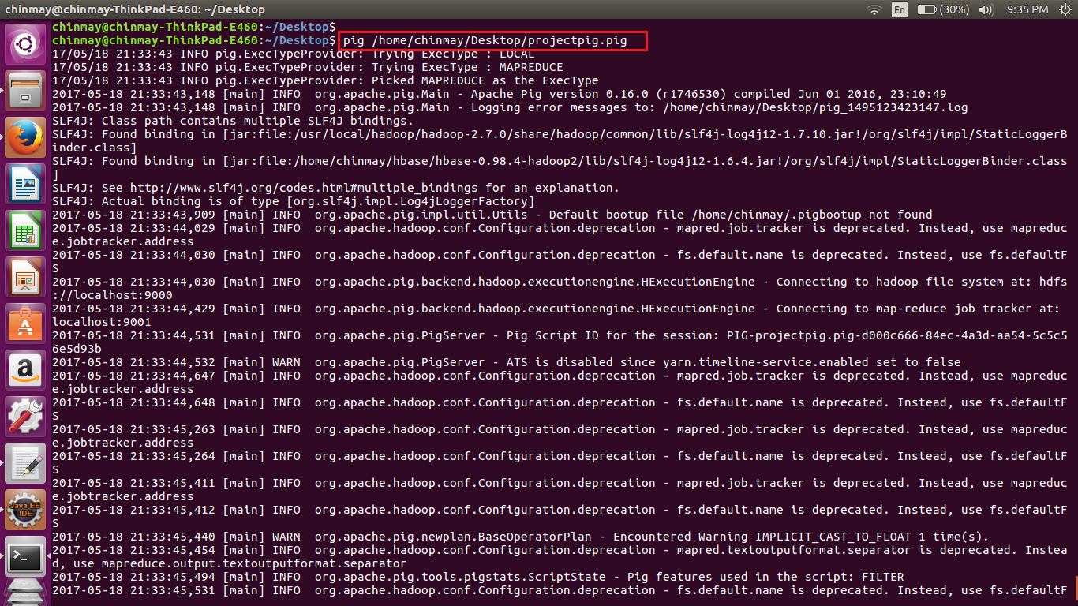

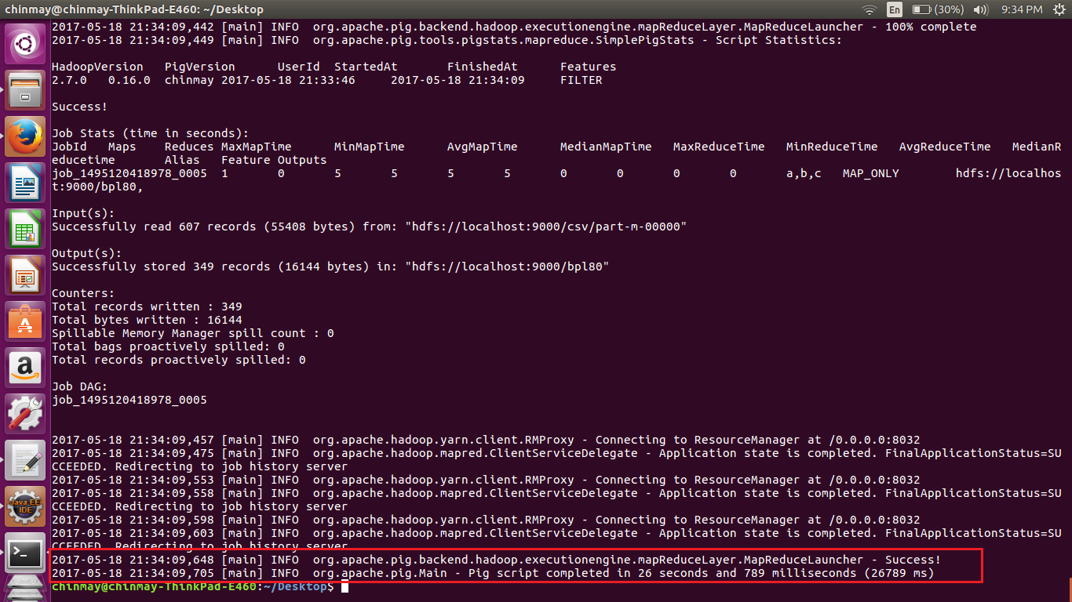

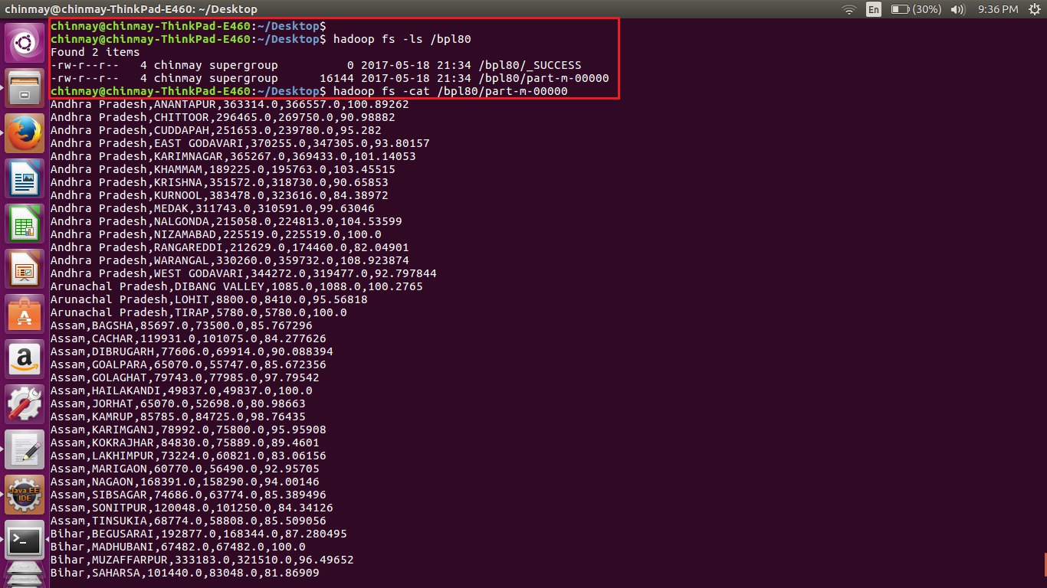

This is the final result of the pig script.

This value is put in mysql db using sqoop .

First created a table in the mysql bd in order to store the values into mysql db.



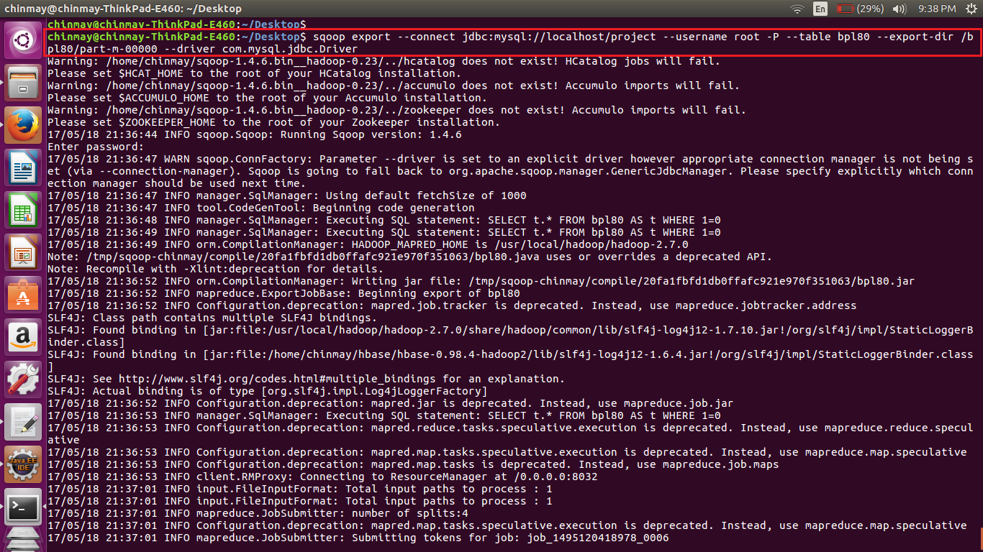

In the sqoop command we have connected to database where we created the database. Also mentioned the table name and the directed from which data is to be extracted.

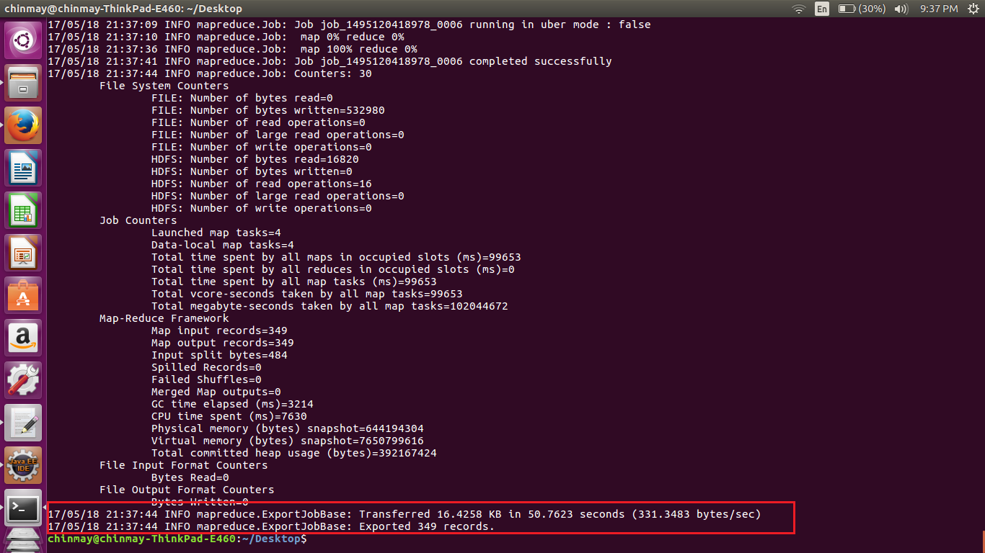Completion of the sqoop job.



This is the output what we get in the mysqldb after the sqoop job.

Below is the full output , copied from the terminal

mysql> use project;

Reading table information for completion of table and column names

You can turn off this feature to get a quicker startup with -A

Database changed

mysql> show tables;

+-------------------+

| Tables_in_project |

+-------------------+

| bpl100 |

| bpl80 |

+-------------------+

2 rows in set (0.00 sec)

mysql> selecT * from bpl80;

+-------------------+------------------------------------------+----------+----------+------------+

| STATE | DISTRICT | TARGET | ACHIEVED | PERCENT |

+-------------------+------------------------------------------+----------+----------+------------+

| Himachal Pradesh | KANGRA | 45000.0 | 61820.0 | 137.37778 |

| Maharashtra | DHULE | 106598.0 | 85846.0 | 80.53247 |

| Andhra Pradesh | ANANTAPUR | 363314.0 | 366557.0 | 100.89262 |

| Uttar Pradesh | BALRAMPUR | 65273.0 | 65273.0 | 100.0 |

| Maharashtra | GADCHIROLI | 75900.0 | 75900.0 | 100.0 |

| Uttar Pradesh | BANDA | 120620.0 | 111499.0 | 92.43823 |

| Uttar Pradesh | BARABANKI | 199542.0 | 202328.0 | 101.3962 |

| Uttar Pradesh | BAREILLY | 110000.0 | 110000.0 | 100.0 |

| Himachal Pradesh | KINNAUR | 1560.0 | 1560.0 | 100.0 |

| Uttar Pradesh | BASTI | 160480.0 | 130224.0 | 81.14656 |

| Uttar Pradesh | BIJNOR | 110403.0 | 110403.0 | 100.0 |

| Himachal Pradesh | KULLU | 9989.0 | 9989.0 | 100.0 |

| Himachal Pradesh | LAHAUL & SPITI | 2413.0 | 2413.0 | 100.0 |

| Himachal Pradesh | MANDI | 34407.0 | 34408.0 | 100.00291 |

| Himachal Pradesh | SHIMLA | 23874.0 | 23874.0 | 100.0 |

| Himachal Pradesh | SIRMAUR | 13753.0 | 13671.0 | 99.40377 |

| Himachal Pradesh | SOLAN | 10858.0 | 10858.0 | 100.0 |

| Himachal Pradesh | UNA | 8360.0 | 8360.0 | 100.0 |

| Jammu & Kashmir | ANANTNAG | 75476.0 | 61938.0 | 82.06317 |

| Uttar Pradesh | BUDAUN | 107603.0 | 107603.0 | 100.0 |

| Andhra Pradesh | CHITTOOR | 296465.0 | 269750.0 | 90.98882 |

| Jammu & Kashmir | LEH (LADAKH) | 6090.0 | 5296.0 | 86.962234 |

| Andhra Pradesh | CUDDAPAH | 251653.0 | 239780.0 | 95.282 |

| Uttar Pradesh | BULANDSHAHR | 28885.0 | 31996.0 | 110.770294 |

| Andhra Pradesh | EAST GODAVARI | 370255.0 | 347305.0 | 93.80157 |

| Andhra Pradesh | KARIMNAGAR | 365267.0 | 369433.0 | 101.14053 |

| Jharkhand | DEOGHAR | 75153.0 | 75153.0 | 100.0 |

| Andhra Pradesh | KHAMMAM | 189225.0 | 195763.0 | 103.45515 |

| Jharkhand | DUMKA | 148732.0 | 126910.0 | 85.32797 |

| Jharkhand | LATEHAR | 79635.0 | 66455.0 | 83.449486 |

| Uttar Pradesh | CHANDAULI | 92022.0 | 96318.0 | 104.66845 |

| Uttar Pradesh | CHITRAKOOT | 38082.0 | 42652.0 | 112.00042 |

| Jharkhand | LOHARDAGA | 22626.0 | 22626.0 | 100.0 |

| Uttar Pradesh | DEORIA | 181225.0 | 172222.0 | 95.03214 |

| Uttar Pradesh | ETAH | 62001.0 | 69139.0 | 111.51272 |

| Uttar Pradesh | ETAWAH | 94097.0 | 94097.0 | 100.0 |

| Andhra Pradesh | KRISHNA | 351572.0 | 318730.0 | 90.65853 |

| Andhra Pradesh | KURNOOL | 383478.0 | 323616.0 | 84.38972 |

| Maharashtra | GONDIA | 120714.0 | 113976.0 | 94.41821 |

| Andhra Pradesh | MEDAK | 311743.0 | 310591.0 | 99.63046 |

| Andhra Pradesh | NALGONDA | 215058.0 | 224813.0 | 104.53599 |

| Andhra Pradesh | NIZAMABAD | 225519.0 | 225519.0 | 100.0 |

| Andhra Pradesh | RANGAREDDI | 212629.0 | 174460.0 | 82.04901 |

| Andhra Pradesh | WARANGAL | 330260.0 | 359732.0 | 108.923874 |

| Andhra Pradesh | WEST GODAVARI | 344272.0 | 319477.0 | 92.797844 |

| Jharkhand | PAKUR | 72250.0 | 63110.0 | 87.34948 |

| Maharashtra | HINGOLI | 52157.0 | 47584.0 | 91.23224 |

| Arunachal Pradesh | DIBANG VALLEY | 1085.0 | 1088.0 | 100.2765 |

| Maharashtra | JALNA | 85470.0 | 83093.0 | 97.21891 |

| Arunachal Pradesh | LOHIT | 8800.0 | 8410.0 | 95.56818 |

| Jharkhand | PURBI SINGHBHUM | 97196.0 | 126967.0 | 130.62987 |

| Karnataka | BAGALKOT | 74926.0 | 68863.0 | 91.90801 |

| Maharashtra | KOLHAPUR | 75993.0 | 60990.0 | 80.25739 |

| Karnataka | BANGALORE RURAL | 63044.0 | 87975.0 | 139.5454 |

| Karnataka | CHICKMAGALUR | 67568.0 | 64863.0 | 95.99663 |

| Uttar Pradesh | FAIZABAD | 103376.0 | 101638.0 | 98.31876 |

| Karnataka | CHITRADURGA | 75400.0 | 73585.0 | 97.592834 |

| Maharashtra | NAGPUR | 67367.0 | 59513.0 | 88.34148 |

| Arunachal Pradesh | TIRAP | 5780.0 | 5780.0 | 100.0 |

| Maharashtra | OSMANABAD | 54312.0 | 54300.0 | 99.977905 |

| Karnataka | DHARWAD | 53596.0 | 49843.0 | 92.99761 |

| Karnataka | GADAG | 46821.0 | 39414.0 | 84.180176 |

| Maharashtra | PARBHANI | 53647.0 | 46765.0 | 87.1717 |

| Maharashtra | PUNE | 97302.0 | 95068.0 | 97.704056 |

| Assam | BAGSHA | 85697.0 | 73500.0 | 85.767296 |

| Karnataka | HASSAN | 64134.0 | 64134.0 | 100.0 |

| Karnataka | KODAGU | 38838.0 | 38638.0 | 99.48504 |

| Karnataka | KOLAR | 43183.0 | 85744.0 | 198.55962 |

| Karnataka | KOPPAL | 60869.0 | 53275.0 | 87.524025 |

| Assam | CACHAR | 119931.0 | 101075.0 | 84.277626 |

| Assam | DIBRUGARH | 77606.0 | 69914.0 | 90.088394 |

| Karnataka | MANDYA | 128782.0 | 116773.0 | 90.674934 |

| Maharashtra | RATNAGIRI | 95726.0 | 102182.0 | 106.744255 |

| Maharashtra | SANGLI | 50210.0 | 41669.0 | 82.98944 |

| Assam | GOALPARA | 65070.0 | 55747.0 | 85.672356 |

| Assam | GOLAGHAT | 79743.0 | 77985.0 | 97.79542 |

| Assam | HAILAKANDI | 49837.0 | 49837.0 | 100.0 |

| Maharashtra | SATARA | 83517.0 | 71679.0 | 85.82564 |

| Maharashtra | SINDHUDURG | 43874.0 | 43874.0 | 100.0 |

| Karnataka | MANGALORE(DAKSHINA KANNADA) | 59478.0 | 59478.0 | 100.0 |

| Maharashtra | THANE | 235922.0 | 225323.0 | 95.507416 |

| Uttar Pradesh | FARRUKHABAD | 120471.0 | 120471.0 | 100.0 |

| Maharashtra | WARDHA | 63339.0 | 58768.0 | 92.78328 |

| Manipur | BISHNUPUR | 12152.0 | 10580.0 | 87.06386 |

| Manipur | IMPHAL EAST | 13189.0 | 12550.0 | 95.15505 |

| Uttar Pradesh | FATEHPUR | 104414.0 | 99961.0 | 95.735245 |

| Assam | JORHAT | 65070.0 | 52698.0 | 80.98663 |

| Assam | KAMRUP | 85785.0 | 84725.0 | 98.76435 |

| Manipur | TAMENGLONG | 13380.0 | 11846.0 | 88.53513 |

| Karnataka | RAMANAGARA | 41876.0 | 37293.0 | 89.055786 |

| Meghalaya | RI BHOI | 16276.0 | 13741.0 | 84.42492 |

| Uttar Pradesh | FIROZABAD | 19843.0 | 19843.0 | 100.0 |

| Karnataka | SHIMOGA | 99428.0 | 99996.0 | 100.571266 |

| Uttar Pradesh | GAUTAM BUDDHA NAGAR | 14574.0 | 14302.0 | 98.13367 |

| Assam | KARIMGANJ | 78992.0 | 75800.0 | 95.95908 |

| Meghalaya | SOUTH GARO HILLS | 12891.0 | 11670.0 | 90.528275 |

| Meghalaya | WEST GARO HILLS | 44385.0 | 44385.0 | 100.0 |

| Mizoram | CHAMPHAI | 11077.0 | 11077.0 | 100.0 |

| Mizoram | KOLASIB | 8833.0 | 8664.0 | 98.08672 |

| Mizoram | LAWNGTLAI | 16544.0 | 16544.0 | 100.0 |

| Uttar Pradesh | GHAZIABAD | 10810.0 | 10810.0 | 100.0 |

| Assam | KOKRAJHAR | 84830.0 | 75889.0 | 89.4601 |

| Assam | LAKHIMPUR | 73224.0 | 60821.0 | 83.06156 |

| Uttar Pradesh | GHAZIPUR | 184061.0 | 182471.0 | 99.136154 |

| Uttar Pradesh | GONDA | 136500.0 | 118593.0 | 86.88132 |

| Uttar Pradesh | GORAKHPUR | 211033.0 | 211010.0 | 99.9891 |

| Uttar Pradesh | HAMIRPUR | 101382.0 | 85181.0 | 84.019844 |

| Assam | MARIGAON | 60770.0 | 56490.0 | 92.95705 |

| Assam | NAGAON | 168391.0 | 158290.0 | 94.00146 |

| Assam | SIBSAGAR | 74686.0 | 63774.0 | 85.389496 |

| Assam | SONITPUR | 120048.0 | 101250.0 | 84.34126 |

| Assam | TINSUKIA | 68774.0 | 58808.0 | 85.509056 |

| Bihar | BEGUSARAI | 192877.0 | 168344.0 | 87.280495 |

| Bihar | MADHUBANI | 67482.0 | 67482.0 | 100.0 |

| Karnataka | UDUPI | 52348.0 | 52348.0 | 100.0 |

| Kerala | ALAPPUZHA | 114359.0 | 114359.0 | 100.0 |

| Kerala | ERNAKULAM | 54585.0 | 55916.0 | 102.4384 |

| Bihar | MUZAFFARPUR | 333183.0 | 321510.0 | 96.49652 |

| Mizoram | LUNGLEI | 19280.0 | 17229.0 | 89.36203 |

| Mizoram | MAMIT | 5459.0 | 5334.0 | 97.710205 |

| Mizoram | SAIHA | 7238.0 | 6417.0 | 88.65709 |

| Uttar Pradesh | HARDOI | 199989.0 | 199989.0 | 100.0 |

| Uttar Pradesh | JALAUN | 101928.0 | 90824.0 | 89.10603 |

| Kerala | IDUKKI | 86535.0 | 89553.0 | 103.48761 |

| Bihar | SAHARSA | 101440.0 | 83048.0 | 81.86909 |

| Uttar Pradesh | JAUNPUR | 250000.0 | 250924.0 | 100.3696 |

| Bihar | VAISHALI | 190598.0 | 196496.0 | 103.09447 |

| Kerala | KANNUR | 34121.0 | 37628.0 | 110.27813 |

| Kerala | KASARGOD | 56965.0 | 59153.0 | 103.84096 |

| Uttar Pradesh | JHANSI | 58826.0 | 59119.0 | 100.49808 |

| Uttar Pradesh | JYOTIBA PHULE NAGAR | 48008.0 | 48008.0 | 100.0 |

| Uttar Pradesh | KANNAUJ | 101497.0 | 101616.0 | 100.11724 |

| Mizoram | SERCHHIP | 4947.0 | 4398.0 | 88.90237 |

| Nagaland | KOHIMA | 25610.0 | 23981.0 | 93.6392 |

| Nagaland | MOKOKCHUNG | 11000.0 | 10662.0 | 96.92728 |

| Kerala | KOLLAM | 95130.0 | 95130.0 | 100.0 |

| Kerala | KOTTAYAM | 28118.0 | 28118.0 | 100.0 |

| Kerala | KOZHIKODE | 42285.0 | 42285.0 | 100.0 |

| Kerala | MALAPPURAM | 60592.0 | 61905.0 | 102.166954 |

| Uttar Pradesh | KANPUR DEHAT | 126650.0 | 121414.0 | 95.865776 |

| Uttar Pradesh | KANPUR NAGAR | 87235.0 | 81750.0 | 93.71239 |

| Kerala | PALAKKAD | 107018.0 | 107018.0 | 100.0 |

| Kerala | PATHANAMTHITTA | 53799.0 | 53799.0 | 100.0 |

| Kerala | THIRUVANANTHAPURAM | 129000.0 | 137004.0 | 106.20465 |

| Kerala | THRISSUR | 48669.0 | 51017.0 | 104.824425 |

| Uttar Pradesh | KAUSHAMBI | 127875.0 | 123820.0 | 96.82893 |

| Kerala | WAYANAD | 50655.0 | 50655.0 | 100.0 |

| Madhya Pradesh | ALIRAJPUR | 38225.0 | 52971.0 | 138.57686 |

| Chhattisgarh | DHAMTARI | 38501.0 | 32195.0 | 83.6212 |

| Chhattisgarh | JASHPUR | 56623.0 | 56014.0 | 98.92446 |

| Chhattisgarh | KANKER | 50835.0 | 41245.0 | 81.13505 |

| Madhya Pradesh | ANUPPUR | 39615.0 | 55336.0 | 139.68446 |

| Uttar Pradesh | KUSHINAGAR | 287089.0 | 236062.0 | 82.22607 |

| Chhattisgarh | KORBA | 50691.0 | 63983.0 | 126.22162 |

| Uttar Pradesh | LAKHIMPUR KHERI | 73000.0 | 95742.0 | 131.15343 |

| Chhattisgarh | KORIYA | 38296.0 | 30664.0 | 80.07103 |

| Madhya Pradesh | BARWANI | 75695.0 | 84663.0 | 111.84754 |

| Chhattisgarh | SURGUJA | 168885.0 | 140083.0 | 82.94579 |

| Nagaland | PHEK | 18742.0 | 16299.0 | 86.96511 |

| Orissa | BALESWAR | 281636.0 | 255557.0 | 90.74017 |

| Goa | NORTH GOA | 15000.0 | 15000.0 | 100.0 |

| Madhya Pradesh | BETUL | 43427.0 | 43688.0 | 100.601006 |

| Madhya Pradesh | BHOPAL | 20010.0 | 31380.0 | 156.82158 |

| Madhya Pradesh | BURHANPUR | 41047.0 | 43340.0 | 105.58628 |

| Madhya Pradesh | DATIA | 11997.0 | 18386.0 | 153.25499 |

| Orissa | JAGATSINGHAPUR | 95623.0 | 91572.0 | 95.76357 |

| Gujarat | AHMEDABAD | 80192.0 | 80192.0 | 100.0 |

| Madhya Pradesh | DEWAS | 59245.0 | 79734.0 | 134.58351 |

| Madhya Pradesh | DHAR | 100281.0 | 119944.0 | 119.6079 |

| Madhya Pradesh | DINDORI | 63701.0 | 59880.0 | 94.00166 |

| Punjab | BARNALA | 12137.0 | 12593.0 | 103.75711 |

| Punjab | FATEHGARH SAHIB | 2485.0 | 2630.0 | 105.83501 |

| Madhya Pradesh | GUNA | 53901.0 | 43146.0 | 80.04675 |

| Madhya Pradesh | GWALIOR | 32128.0 | 39081.0 | 121.64156 |

| Uttar Pradesh | LALITPUR | 90107.0 | 89046.0 | 98.82251 |

| Uttar Pradesh | LUCKNOW | 113188.0 | 113188.0 | 100.0 |

| Punjab | HOSHIARPUR | 11112.0 | 19094.0 | 171.83224 |

| Madhya Pradesh | HARDA | 23589.0 | 31545.0 | 133.72758 |

| Gujarat | AMRELI | 67802.0 | 61990.0 | 91.42798 |

| Gujarat | ANAND | 72058.0 | 69832.0 | 96.91082 |

| Uttar Pradesh | MAHAMAYA NAGAR(HATHRAS) | 25153.0 | 25277.0 | 100.49298 |

| Uttar Pradesh | MAHARAJGANJ | 145090.0 | 145090.0 | 100.0 |

| Uttar Pradesh | MAHOBA | 53117.0 | 53117.0 | 100.0 |

| Uttar Pradesh | MAINPURI | 84258.0 | 77399.0 | 91.85953 |

| Madhya Pradesh | HOSHANGABAD | 50677.0 | 83469.0 | 164.70786 |

| Madhya Pradesh | INDORE | 48998.0 | 50152.0 | 102.355194 |

| Madhya Pradesh | JABALPUR | 106290.0 | 117804.0 | 110.832634 |

| Gujarat | BANAS KANTHA | 126536.0 | 125652.0 | 99.301384 |

| Uttar Pradesh | MATHURA | 25005.0 | 25110.0 | 100.419914 |

| Gujarat | BHARUCH | 78463.0 | 75199.0 | 95.84008 |

| Gujarat | BHAVNAGAR | 31305.0 | 31563.0 | 100.82415 |

| Punjab | JALANDHAR | 19885.0 | 19653.0 | 98.83329 |

| Madhya Pradesh | JHABUA | 81491.0 | 94244.0 | 115.64958 |

| Madhya Pradesh | KATNI | 53000.0 | 68295.0 | 128.85849 |

| Madhya Pradesh | KHANDWA(EAST NIMAR) | 60123.0 | 82598.0 | 137.3817 |

| Madhya Pradesh | KHARGONE | 91083.0 | 91458.0 | 100.41171 |

| Madhya Pradesh | MANDLA | 98650.0 | 81286.0 | 82.39838 |

| Madhya Pradesh | MANDSAUR | 46666.0 | 67848.0 | 145.39066 |

| Uttar Pradesh | MAU | 133766.0 | 108577.0 | 81.16936 |

| Madhya Pradesh | MORENA | 32478.0 | 39727.0 | 122.319725 |

| Madhya Pradesh | NARSINGHPUR | 67857.0 | 66714.0 | 98.315575 |

| Punjab | KAPURTHALA | 12617.0 | 12095.0 | 95.862724 |

| Madhya Pradesh | NEEMUCH | 27790.0 | 42843.0 | 154.16696 |

| Uttar Pradesh | MEERUT | 25514.0 | 25357.0 | 99.38465 |

| Gujarat | DAHOD | 134798.0 | 131790.0 | 97.76852 |

| Gujarat | DANGS | 27900.0 | 27900.0 | 100.0 |

| Gujarat | GANDHINAGAR | 13830.0 | 11290.0 | 81.634125 |

| Uttar Pradesh | MIRZAPUR | 231315.0 | 233308.0 | 100.861595 |

| Uttar Pradesh | MORADABAD | 76018.0 | 76018.0 | 100.0 |

| Uttar Pradesh | MUZAFFARNAGAR | 51660.0 | 51660.0 | 100.0 |

| Gujarat | JAMNAGAR | 45478.0 | 47822.0 | 105.154144 |

| Gujarat | JUNAGADH | 56444.0 | 55874.0 | 98.99015 |

| Gujarat | KACHCHH | 45596.0 | 37781.0 | 82.86034 |

| Uttar Pradesh | PILIBHIT | 95178.0 | 95178.0 | 100.0 |

| Gujarat | KHEDA | 140212.0 | 138896.0 | 99.061424 |

| Madhya Pradesh | RAISEN | 88825.0 | 102504.0 | 115.39995 |

| Madhya Pradesh | RAJGARH | 94365.0 | 115392.0 | 122.28262 |

| Punjab | LUDHIANA | 45422.0 | 46920.0 | 103.29796 |

| Madhya Pradesh | RATLAM | 51248.0 | 64477.0 | 125.81369 |

| Uttar Pradesh | PRATAPGARH | 141368.0 | 143517.0 | 101.52014 |

| Uttar Pradesh | RAE BARELI | 190306.0 | 190430.0 | 100.06516 |

| Gujarat | MAHESANA | 61499.0 | 61938.0 | 100.71384 |

| Uttar Pradesh | RAMPUR | 56948.0 | 51954.0 | 91.2306 |

| Punjab | MANSA | 25000.0 | 23398.0 | 93.592 |

| Punjab | NAWANSHAHR | 7273.0 | 11581.0 | 159.23279 |

| Madhya Pradesh | REWA | 121538.0 | 147541.0 | 121.39496 |

| Uttar Pradesh | SAHARANPUR | 49458.0 | 49586.0 | 100.258804 |

| Madhya Pradesh | SEHORE | 34355.0 | 77009.0 | 224.1566 |

| Gujarat | NARMADA | 58730.0 | 56924.0 | 96.92491 |

| Uttar Pradesh | SANT RAVIDAS NAGAR( BHADOHI) | 75119.0 | 69904.0 | 93.05768 |

| Punjab | S.A.S Nagar | 4008.0 | 4025.0 | 100.42415 |

| Rajasthan | AJMER | 27392.0 | 24512.0 | 89.48598 |

| Rajasthan | CHURU | 40000.0 | 37871.0 | 94.677505 |

| Rajasthan | DUNGARPUR | 130459.0 | 107920.0 | 82.723305 |

| Rajasthan | GANGANAGAR | 31756.0 | 31446.0 | 99.0238 |

| Madhya Pradesh | SEONI | 104769.0 | 92862.0 | 88.634995 |

| Rajasthan | HANUMANGARH | 31621.0 | 31621.0 | 100.0 |

| Uttar Pradesh | SHAHJAHANPUR | 194645.0 | 194959.0 | 100.161316 |

| Rajasthan | JAISALMER | 17497.0 | 16244.0 | 92.83877 |

| Uttar Pradesh | SHRAVASTI | 104902.0 | 98761.0 | 94.145966 |

| Gujarat | NAVSARI | 75015.0 | 75015.0 | 100.0 |

| Madhya Pradesh | SHAHDOL | 84802.0 | 86586.0 | 102.10372 |

| Uttar Pradesh | SIDDHARTHNAGAR | 139597.0 | 124597.0 | 89.25478 |

| Rajasthan | NAGAUR | 41537.0 | 40962.0 | 98.61569 |

| Gujarat | PANCH MAHALS | 156835.0 | 153720.0 | 98.01384 |

| Gujarat | PATAN | 58741.0 | 60002.0 | 102.146706 |

| Madhya Pradesh | SHAJAPUR | 65429.0 | 75217.0 | 114.95973 |

| Madhya Pradesh | SHEOPUR | 18198.0 | 28955.0 | 159.11089 |

| Gujarat | PORBANDAR | 17024.0 | 17024.0 | 100.0 |

| Gujarat | RAJKOT | 78753.0 | 79436.0 | 100.86727 |

| Uttar Pradesh | SITAPUR | 305299.0 | 273463.0 | 89.57219 |

| Rajasthan | SIKAR | 28460.0 | 23748.0 | 83.44343 |

| Uttar Pradesh | SONBHADRA | 138370.0 | 138370.0 | 100.0 |

| Uttar Pradesh | SULTANPUR | 168843.0 | 168843.0 | 100.0 |

| Uttar Pradesh | UNNAO | 229599.0 | 223630.0 | 97.400246 |

| Gujarat | SABAR KANTHA | 151382.0 | 151187.0 | 99.871185 |

| Gujarat | SURAT | 158797.0 | 158797.0 | 100.0 |

| Uttar Pradesh | VARANASI | 105408.0 | 102430.0 | 97.17479 |

| Uttarakhand | BAGESHWAR | 21447.0 | 17859.0 | 83.270386 |

| Uttarakhand | CHAMOLI | 27147.0 | 26043.0 | 95.93325 |

| Sikkim | EAST SIKKIM | 24109.0 | 26852.0 | 111.37749 |

| Uttarakhand | DEHRADUN | 37212.0 | 31724.0 | 85.25207 |

| Madhya Pradesh | SINGRAULI | 53722.0 | 53354.0 | 99.314995 |

| Madhya Pradesh | UJJAIN | 68225.0 | 77417.0 | 113.47307 |

| Gujarat | SURENDRANAGAR | 83235.0 | 69913.0 | 83.99471 |

| Sikkim | NORTH SIKKIM | 4978.0 | 5461.0 | 109.7027 |

| Madhya Pradesh | UMARIA | 40359.0 | 54150.0 | 134.17082 |

| Uttarakhand | HARIDWAR | 42500.0 | 38188.0 | 89.85412 |

| Uttarakhand | NAINITAL | 14314.0 | 18039.0 | 126.02347 |

| Sikkim | SOUTH SIKKIM | 8970.0 | 12446.0 | 138.75139 |

| Madhya Pradesh | VIDISHA | 96852.0 | 82923.0 | 85.61826 |

| Sikkim | WEST SIKKIM | 13245.0 | 13345.0 | 100.755 |

| Gujarat | VADODARA | 140958.0 | 129194.0 | 91.65425 |

| Gujarat | VALSAD | 85274.0 | 109073.0 | 127.90886 |

| Maharashtra | AHMEDNAGAR | 134247.0 | 132145.0 | 98.43423 |

| Maharashtra | BHANDARA | 93065.0 | 81460.0 | 87.53022 |

| Tamil Nadu | COIMBATORE | 190006.0 | 174618.0 | 91.901306 |

| Tamil Nadu | CUDDALORE | 242992.0 | 239221.0 | 98.4481 |

| Tamil Nadu | DHARMAPURI | 152872.0 | 152921.0 | 100.03206 |

| Haryana | AMBALA | 43428.0 | 39247.0 | 90.37257 |

| Haryana | BHIWANI | 48947.0 | 49247.0 | 100.6129 |

| Tamil Nadu | DINDIGUL | 131516.0 | 113525.0 | 86.32029 |

| Uttarakhand | PITHORAGARH | 41110.0 | 34597.0 | 84.15714 |

| Uttarakhand | RUDRAPRAYAG | 13150.0 | 13810.0 | 105.01901 |

| Haryana | FARIDABAD | 22254.0 | 22254.0 | 100.0 |

| Uttarakhand | TEHRI GARHWAL | 55173.0 | 46293.0 | 83.905174 |

| Uttarakhand | UDHAM SINGH NAGAR | 39427.0 | 37604.0 | 95.37627 |

| Tamil Nadu | ERODE | 165306.0 | 165306.0 | 100.0 |

| Tamil Nadu | KANCHIPURAM | 147350.0 | 154480.0 | 104.83882 |

| Tamil Nadu | KANYAKUMARI(NAGERCOIL) | 76233.0 | 84822.0 | 111.26678 |

| Haryana | FATEHABAD | 25642.0 | 25361.0 | 98.90414 |

| Haryana | GURGAON | 10522.0 | 14822.0 | 140.86676 |

| Haryana | HISAR | 46463.0 | 46463.0 | 100.0 |

| Tamil Nadu | KARUR | 105280.0 | 105280.0 | 100.0 |

| Tamil Nadu | MADURAI | 153151.0 | 127148.0 | 83.02133 |

| Uttarakhand | UTTARKASHI | 28189.0 | 25523.0 | 90.54241 |

| Haryana | JHAJJAR | 22014.0 | 22014.0 | 100.0 |

| Haryana | JIND | 58000.0 | 57039.0 | 98.3431 |

| West Bengal | BARDHAMAN | 700047.0 | 601906.0 | 85.9808 |

| West Bengal | DAKSHIN DINAJPUR | 182621.0 | 184153.0 | 100.8389 |

| West Bengal | HOOGHLY | 271737.0 | 269779.0 | 99.27945 |

| Haryana | KAITHAL | 37046.0 | 36566.0 | 98.704315 |

| West Bengal | HOWRAH | 231860.0 | 230190.0 | 99.27974 |

| Tamil Nadu | NAMAKKAL | 117538.0 | 117538.0 | 100.0 |

| Tamil Nadu | NILGIRIS(UDHAGAMANDALAM) | 43000.0 | 34543.0 | 80.33256 |

| Tamil Nadu | PERAMBALUR | 181496.0 | 174963.0 | 96.40047 |

| West Bengal | JALPAIGURI | 372999.0 | 337740.0 | 90.547165 |

| West Bengal | MIDNAPUR EAST | 392371.0 | 527389.0 | 134.4108 |

| West Bengal | MIDNAPUR WEST | 509496.0 | 596291.0 | 117.03546 |

| Haryana | KARNAL | 45973.0 | 46015.0 | 100.09136 |

| Haryana | KURUKSHETRA | 30598.0 | 30681.0 | 100.27126 |

| Tamil Nadu | PUDUKKOTTAI | 176710.0 | 198097.0 | 112.102875 |

| Tamil Nadu | RAMANATHAPURAM | 105000.0 | 156708.0 | 149.24571 |

| West Bengal | NADIA | 346696.0 | 321462.0 | 92.72157 |

| Tamil Nadu | SALEM | 232463.0 | 195327.0 | 84.02499 |

| Tamil Nadu | SIVAGANGA | 125730.0 | 118647.0 | 94.36649 |

| Haryana | MAHENDRAGARH | 17500.0 | 17500.0 | 100.0 |

| Haryana | MEWAT | 21875.0 | 19838.0 | 90.688 |

| Tamil Nadu | THENI | 73362.0 | 71599.0 | 97.59685 |

| West Bengal | NORTH 24 PARAGANAS | 361462.0 | 357960.0 | 99.03116 |

| West Bengal | SOUTH 24 PARAGANAS | 628712.0 | 593712.0 | 94.43306 |

| Tamil Nadu | THOOTHUKUDI | 91637.0 | 83855.0 | 91.5078 |

| Haryana | PANCHKULA | 8760.0 | 8760.0 | 100.0 |

| Haryana | PANIPAT | 28000.0 | 28000.0 | 100.0 |

| Tamil Nadu | TIRUCHIRAPPALLI | 77747.0 | 77747.0 | 100.0 |

| Haryana | REWARI | 30000.0 | 26548.0 | 88.49333 |

| Haryana | ROHTAK | 22171.0 | 22171.0 | 100.0 |

| Tamil Nadu | TIRUNELVELI | 125763.0 | 139323.0 | 110.78218 |

| Haryana | SIRSA | 35400.0 | 35400.0 | 100.0 |

| Tamil Nadu | TIRUVANNAMALAI | 209116.0 | 209116.0 | 100.0 |

| Haryana | SONIPAT | 29808.0 | 30300.0 | 101.65056 |

| Haryana | YAMUNANAGAR | 52539.0 | 51915.0 | 98.81231 |

| Tamil Nadu | TIRUVARUR | 80920.0 | 87918.0 | 108.64805 |

| Himachal Pradesh | BILASPUR | 11931.0 | 13078.0 | 109.61361 |

| Himachal Pradesh | CHAMBA | 44429.0 | 58422.0 | 131.4952 |

| Tamil Nadu | VELLORE | 207635.0 | 199906.0 | 96.2776 |

| Tamil Nadu | VIRUDHUNAGAR | 174967.0 | 153350.0 | 87.6451 |

| Tripura | DHALAI | 53507.0 | 53507.0 | 100.0 |

| Tripura | NORTH TRIPURA | 78389.0 | 73704.0 | 94.02339 |

| Tripura | SOUTH TRIPURA | 139456.0 | 139456.0 | 100.0 |

| Tripura | WEST TRIPURA | 183405.0 | 183405.0 | 100.0 |

| Himachal Pradesh | HAMIRPUR | 11593.0 | 11593.0 | 100.0 |

| Uttar Pradesh | AGRA | 54188.0 | 54789.0 | 101.1091 |

| Uttar Pradesh | ALIGARH | 73937.0 | 68096.0 | 92.10003 |

| Uttar Pradesh | ALLAHABAD | 181370.0 | 195141.0 | 107.59276 |

| Uttar Pradesh | AMBEDKAR NAGAR | 132725.0 | 132725.0 | 100.0 |

| Uttar Pradesh | AZAMGARH | 188141.0 | 162413.0 | 86.32515 |

| Uttar Pradesh | BAGPAT | 31467.0 | 26774.0 | 85.08597 |

| Uttar Pradesh | BALLIA | 172179.0 | 167490.0 | 97.27667 |

+-------------------+------------------------------------------+----------+----------+------------+

349 rows in set (0.00 sec)

From above results we can see that all the percentages are equal or above 80%.

1. **Using Mapreduce Program(Shell Script Execution)**

Here in this section we are going to implement the whole program in the shell script.

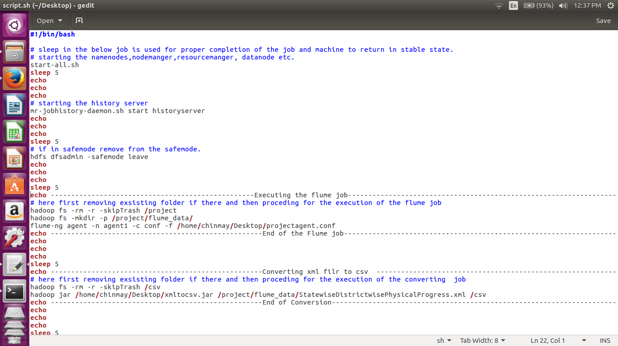

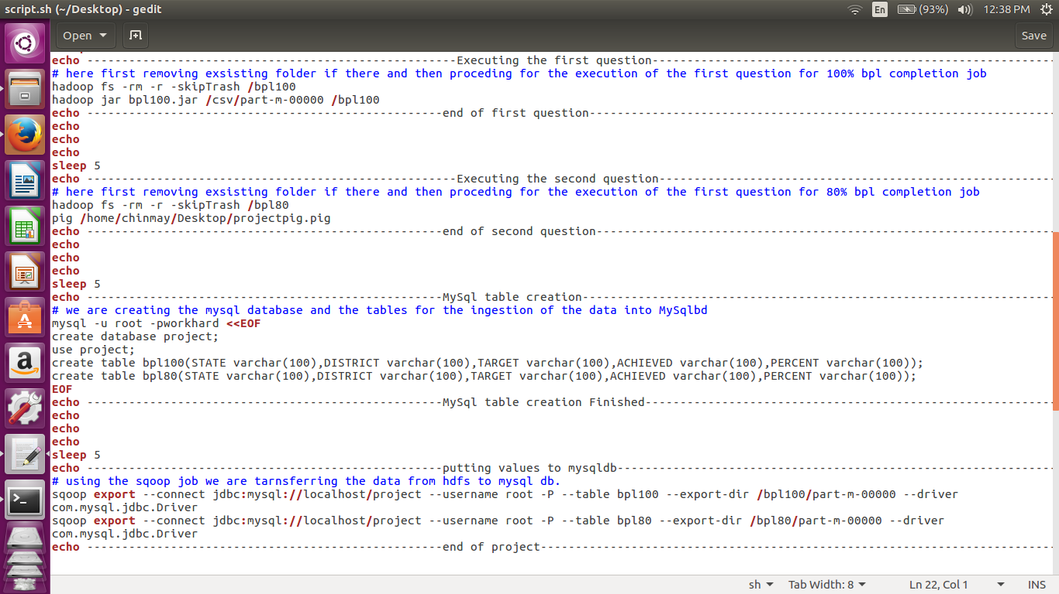

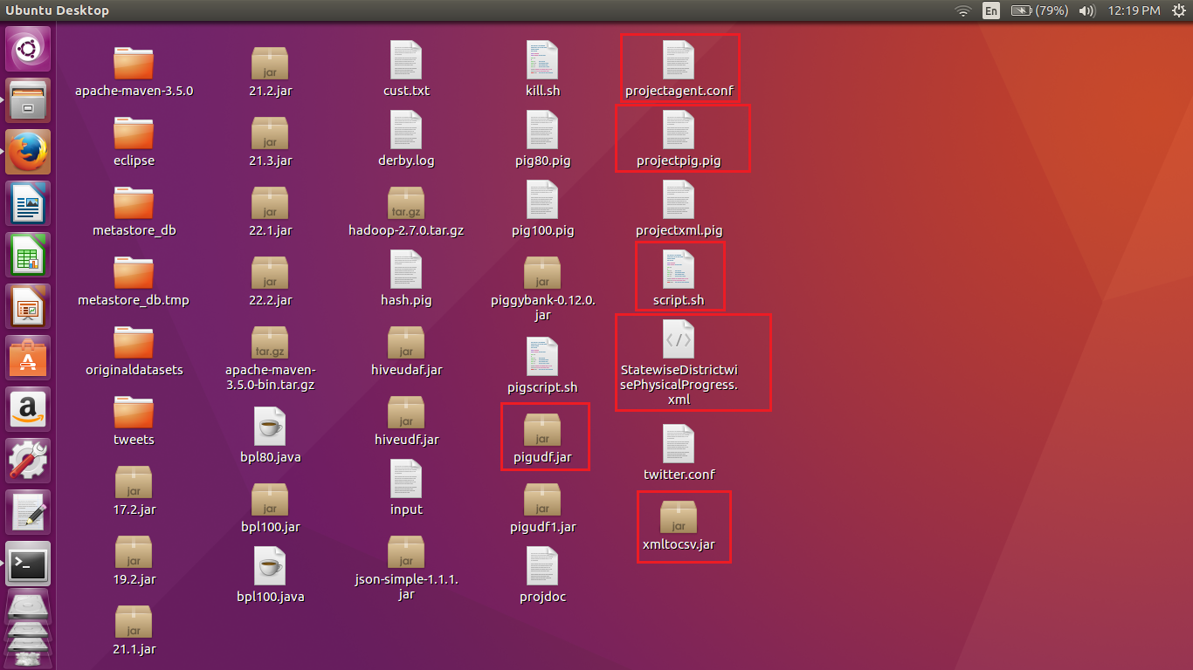

Here we can see that all the highlighted files are located on the desktop as mentioned in the shell script.

We are naming the file as script.sh.

The above shell script uses the same jars that were used while implementing the individually steps. Here in the shell script all the steps will be executed at once and the output will be stored in the mysqldb.

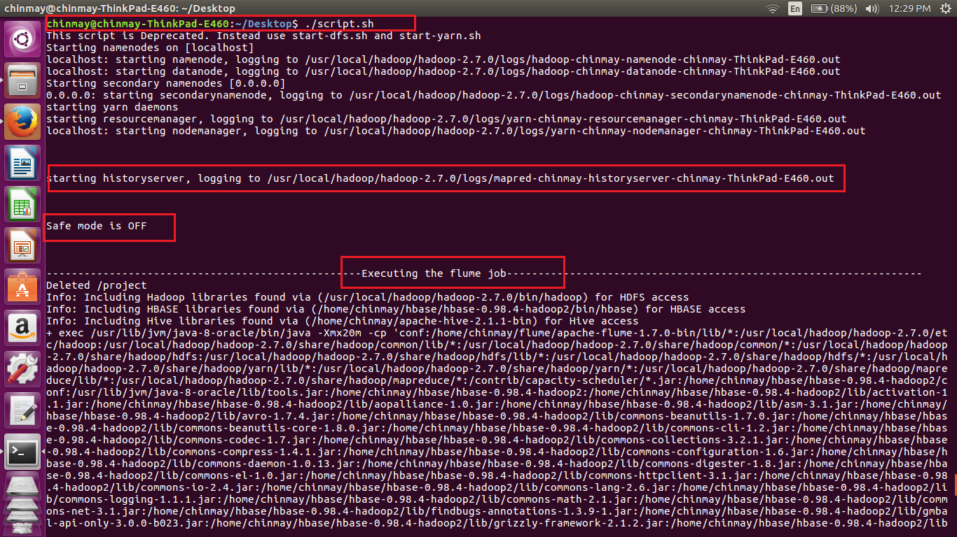

As we know that flume is continuously streaming hence after completion we are kill the flume job by using crlt-c.

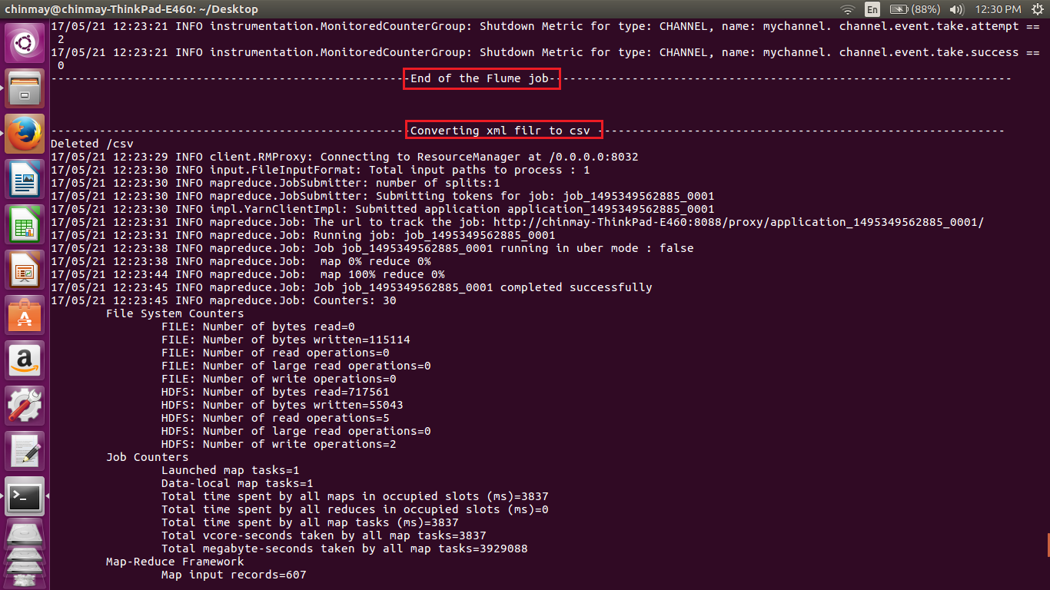

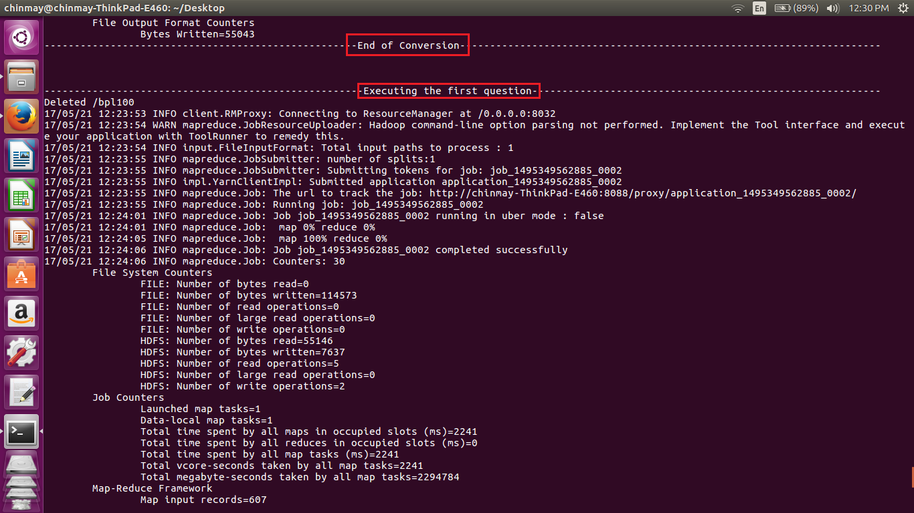

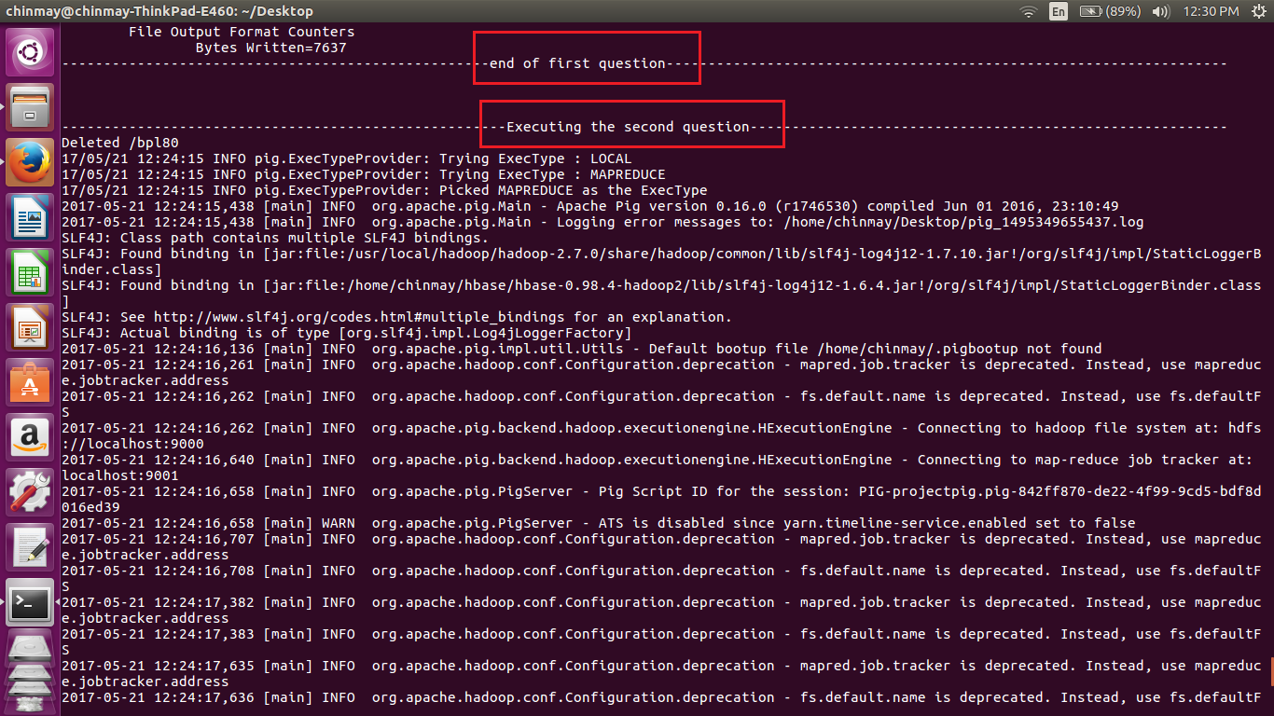

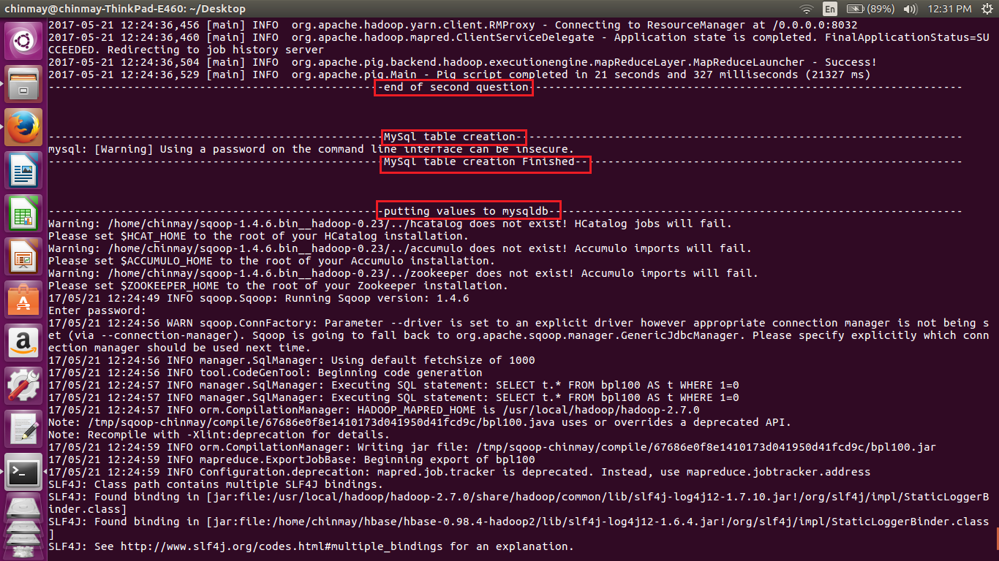

While executing the sqoop job it will ask for the password for mysql db user.

Also this can be hard coded by mentioning the password in the scoop job as

**-password \*\*\*\*\*\*\***

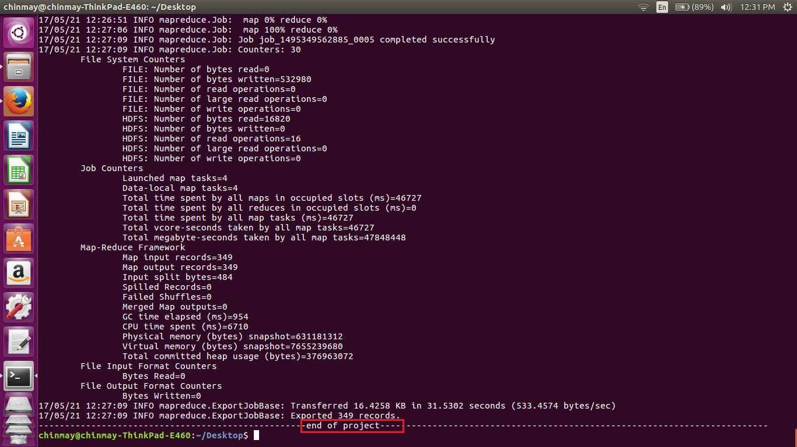

Here are sample screen shots of the outputs

Sample output of First question

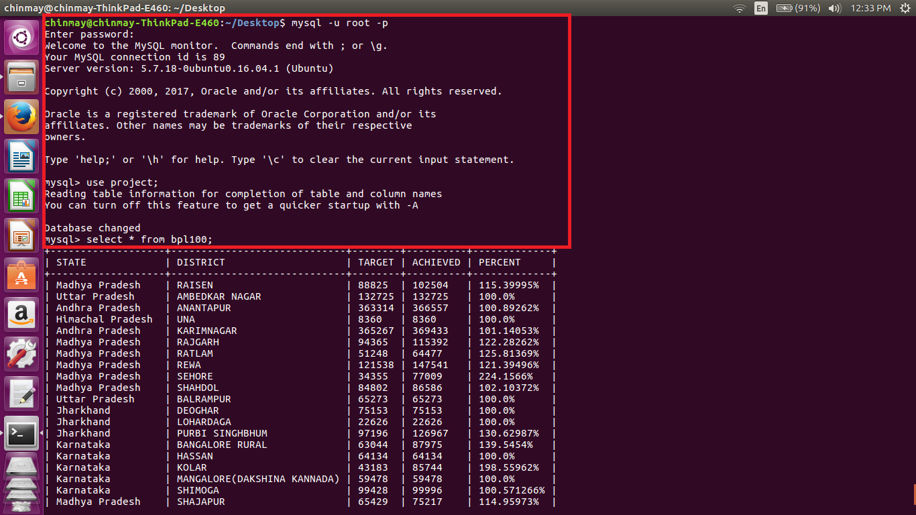

Sample output pf second question

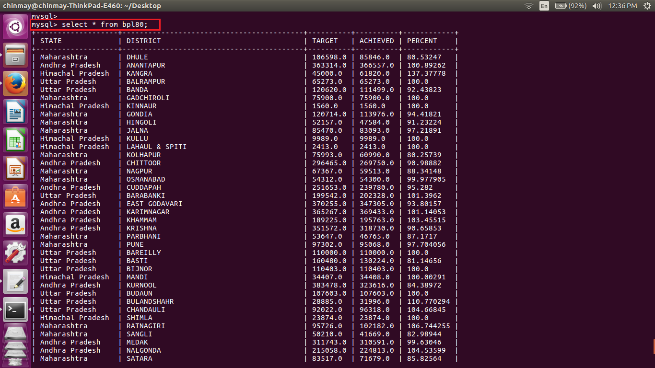

Total output of the both the tables from terminal is a below

chinmay@chinmay-ThinkPad-E460:~/Desktop$ mysql -u root -p

Enter password:

Welcome to the MySQL monitor. Commands end with ; or \g.

Your MySQL connection id is 89

Server version: 5.7.18-0ubuntu0.16.04.1 (Ubuntu)

Copyright (c) 2000, 2017, Oracle and/or its affiliates. All rights reserved.

Oracle is a registered trademark of Oracle Corporation and/or its

affiliates. Other names may be trademarks of their respective

owners.

Type 'help;' or '\h' for help. Type '\c' to clear the current input statement.

mysql> use project;

Reading table information for completion of table and column names

You can turn off this feature to get a quicker startup with -A

Database changed

mysql> select * from bpl100;

+-------------------+-----------------------------+--------+----------+-------------+

| STATE | DISTRICT | TARGET | ACHIEVED | PERCENT |

+-------------------+-----------------------------+--------+----------+-------------+

| Madhya Pradesh | RAISEN | 88825 | 102504 | 115.39995% |

| Uttar Pradesh | AMBEDKAR NAGAR | 132725 | 132725 | 100.0% |

| Andhra Pradesh | ANANTAPUR | 363314 | 366557 | 100.89262% |

| Himachal Pradesh | UNA | 8360 | 8360 | 100.0% |

| Andhra Pradesh | KARIMNAGAR | 365267 | 369433 | 101.14053% |

| Madhya Pradesh | RAJGARH | 94365 | 115392 | 122.28262% |

| Madhya Pradesh | RATLAM | 51248 | 64477 | 125.81369% |

| Madhya Pradesh | REWA | 121538 | 147541 | 121.39496% |

| Madhya Pradesh | SEHORE | 34355 | 77009 | 224.1566% |

| Madhya Pradesh | SHAHDOL | 84802 | 86586 | 102.10372% |

| Uttar Pradesh | BALRAMPUR | 65273 | 65273 | 100.0% |

| Jharkhand | DEOGHAR | 75153 | 75153 | 100.0% |

| Jharkhand | LOHARDAGA | 22626 | 22626 | 100.0% |

| Jharkhand | PURBI SINGHBHUM | 97196 | 126967 | 130.62987% |

| Karnataka | BANGALORE RURAL | 63044 | 87975 | 139.5454% |

| Karnataka | HASSAN | 64134 | 64134 | 100.0% |

| Karnataka | KOLAR | 43183 | 85744 | 198.55962% |

| Karnataka | MANGALORE(DAKSHINA KANNADA) | 59478 | 59478 | 100.0% |

| Karnataka | SHIMOGA | 99428 | 99996 | 100.571266% |

| Madhya Pradesh | SHAJAPUR | 65429 | 75217 | 114.95973% |

| Karnataka | UDUPI | 52348 | 52348 | 100.0% |

| Kerala | ALAPPUZHA | 114359 | 114359 | 100.0% |

| Kerala | ERNAKULAM | 54585 | 55916 | 102.4384% |

| Kerala | IDUKKI | 86535 | 89553 | 103.48761% |

| Kerala | KANNUR | 34121 | 37628 | 110.27813% |

| Kerala | KASARGOD | 56965 | 59153 | 103.84096% |

| Kerala | KOLLAM | 95130 | 95130 | 100.0% |

| Kerala | KOTTAYAM | 28118 | 28118 | 100.0% |

| Kerala | KOZHIKODE | 42285 | 42285 | 100.0% |

| Kerala | MALAPPURAM | 60592 | 61905 | 102.166954% |

| Kerala | PALAKKAD | 107018 | 107018 | 100.0% |

| Kerala | PATHANAMTHITTA | 53799 | 53799 | 100.0% |

| Kerala | THIRUVANANTHAPURAM | 129000 | 137004 | 106.20465% |

| Kerala | THRISSUR | 48669 | 51017 | 104.824425% |

| Kerala | WAYANAD | 50655 | 50655 | 100.0% |

| Madhya Pradesh | ALIRAJPUR | 38225 | 52971 | 138.57686% |

| Madhya Pradesh | ANUPPUR | 39615 | 55336 | 139.68446% |

| Madhya Pradesh | BARWANI | 75695 | 84663 | 111.84754% |

| Madhya Pradesh | BETUL | 43427 | 43688 | 100.601006% |

| Madhya Pradesh | BHOPAL | 20010 | 31380 | 156.82158% |

| Madhya Pradesh | BURHANPUR | 41047 | 43340 | 105.58628% |

| Madhya Pradesh | DATIA | 11997 | 18386 | 153.25499% |

| Madhya Pradesh | DEWAS | 59245 | 79734 | 134.58351% |

| Madhya Pradesh | DHAR | 100281 | 119944 | 119.6079% |

| Madhya Pradesh | GWALIOR | 32128 | 39081 | 121.64156% |

| Madhya Pradesh | HARDA | 23589 | 31545 | 133.72758% |

| Madhya Pradesh | HOSHANGABAD | 50677 | 83469 | 164.70786% |

| Madhya Pradesh | INDORE | 48998 | 50152 | 102.355194% |

| Madhya Pradesh | JABALPUR | 106290 | 117804 | 110.832634% |

| Madhya Pradesh | JHABUA | 81491 | 94244 | 115.64958% |

| Madhya Pradesh | KATNI | 53000 | 68295 | 128.85849% |

| Madhya Pradesh | KHANDWA(EAST NIMAR) | 60123 | 82598 | 137.3817% |

| Madhya Pradesh | KHARGONE | 91083 | 91458 | 100.41171% |

| Madhya Pradesh | MANDSAUR | 46666 | 67848 | 145.39066% |

| Madhya Pradesh | MORENA | 32478 | 39727 | 122.319725% |

| Madhya Pradesh | NEEMUCH | 27790 | 42843 | 154.16696% |

| Andhra Pradesh | KHAMMAM | 189225 | 195763 | 103.45515% |

| Uttar Pradesh | BARABANKI | 199542 | 202328 | 101.3962% |

| Uttar Pradesh | BAREILLY | 110000 | 110000 | 100.0% |

| Uttar Pradesh | BIJNOR | 110403 | 110403 | 100.0% |

| Uttar Pradesh | BUDAUN | 107603 | 107603 | 100.0% |

| Uttar Pradesh | BULANDSHAHR | 28885 | 31996 | 110.770294% |

| Uttar Pradesh | CHANDAULI | 92022 | 96318 | 104.66845% |

| Uttar Pradesh | CHITRAKOOT | 38082 | 42652 | 112.00042% |

| Uttar Pradesh | ETAH | 62001 | 69139 | 111.51272% |

| Uttar Pradesh | ETAWAH | 94097 | 94097 | 100.0% |

| Uttar Pradesh | FARRUKHABAD | 120471 | 120471 | 100.0% |

| Uttar Pradesh | FIROZABAD | 19843 | 19843 | 100.0% |

| Uttar Pradesh | GHAZIABAD | 10810 | 10810 | 100.0% |

| Uttar Pradesh | HARDOI | 199989 | 199989 | 100.0% |

| Uttar Pradesh | JAUNPUR | 250000 | 250924 | 100.3696% |

| Uttar Pradesh | JHANSI | 58826 | 59119 | 100.49808% |

| Uttar Pradesh | JYOTIBA PHULE NAGAR | 48008 | 48008 | 100.0% |

| Uttar Pradesh | KANNAUJ | 101497 | 101616 | 100.11724% |

| Uttar Pradesh | LAKHIMPUR KHERI | 73000 | 95742 | 131.15343% |

| Uttar Pradesh | LUCKNOW | 113188 | 113188 | 100.0% |

| Uttar Pradesh | MAHAMAYA NAGAR(HATHRAS) | 25153 | 25277 | 100.49298% |

| Uttar Pradesh | MAHARAJGANJ | 145090 | 145090 | 100.0% |

| Uttar Pradesh | MAHOBA | 53117 | 53117 | 100.0% |

| Uttar Pradesh | MATHURA | 25005 | 25110 | 100.419914% |

| Uttar Pradesh | MIRZAPUR | 231315 | 233308 | 100.861595% |

| Uttar Pradesh | MORADABAD | 76018 | 76018 | 100.0% |

| Uttar Pradesh | MUZAFFARNAGAR | 51660 | 51660 | 100.0% |

| Uttar Pradesh | PILIBHIT | 95178 | 95178 | 100.0% |

| Uttar Pradesh | PRATAPGARH | 141368 | 143517 | 101.52014% |

| Uttar Pradesh | RAE BARELI | 190306 | 190430 | 100.06516% |

| Uttar Pradesh | SAHARANPUR | 49458 | 49586 | 100.258804% |

| Uttar Pradesh | SHAHJAHANPUR | 194645 | 194959 | 100.161316% |

| Uttar Pradesh | SONBHADRA | 138370 | 138370 | 100.0% |

| Uttar Pradesh | SULTANPUR | 168843 | 168843 | 100.0% |

| Uttarakhand | NAINITAL | 14314 | 18039 | 126.02347% |

| Uttarakhand | RUDRAPRAYAG | 13150 | 13810 | 105.01901% |

| West Bengal | DAKSHIN DINAJPUR | 182621 | 184153 | 100.8389% |

| West Bengal | MIDNAPUR EAST | 392371 | 527389 | 134.4108% |

| West Bengal | MIDNAPUR WEST | 509496 | 596291 | 117.03546% |

| Madhya Pradesh | SHEOPUR | 18198 | 28955 | 159.11089% |

| Andhra Pradesh | NALGONDA | 215058 | 224813 | 104.53599% |

| Madhya Pradesh | UJJAIN | 68225 | 77417 | 113.47307% |

| Andhra Pradesh | NIZAMABAD | 225519 | 225519 | 100.0% |

| Madhya Pradesh | UMARIA | 40359 | 54150 | 134.17082% |

| Maharashtra | GADCHIROLI | 75900 | 75900 | 100.0% |

| Maharashtra | RATNAGIRI | 95726 | 102182 | 106.744255% |

| Maharashtra | SINDHUDURG | 43874 | 43874 | 100.0% |

| Meghalaya | WEST GARO HILLS | 44385 | 44385 | 100.0% |

| Mizoram | CHAMPHAI | 11077 | 11077 | 100.0% |

| Mizoram | LAWNGTLAI | 16544 | 16544 | 100.0% |

| Punjab | BARNALA | 12137 | 12593 | 103.75711% |

| Punjab | FATEHGARH SAHIB | 2485 | 2630 | 105.83501% |

| Punjab | HOSHIARPUR | 11112 | 19094 | 171.83224% |

| Punjab | LUDHIANA | 45422 | 46920 | 103.29796% |

| Punjab | NAWANSHAHR | 7273 | 11581 | 159.23279% |

| Punjab | S.A.S Nagar | 4008 | 4025 | 100.42415% |

| Rajasthan | HANUMANGARH | 31621 | 31621 | 100.0% |

| Sikkim | EAST SIKKIM | 24109 | 26852 | 111.37749% |

| Sikkim | NORTH SIKKIM | 4978 | 5461 | 109.7027% |

| Sikkim | SOUTH SIKKIM | 8970 | 12446 | 138.75139% |

| Sikkim | WEST SIKKIM | 13245 | 13345 | 100.755% |

| Tamil Nadu | DHARMAPURI | 152872 | 152921 | 100.03206% |

| Tamil Nadu | ERODE | 165306 | 165306 | 100.0% |

| Tamil Nadu | KANCHIPURAM | 147350 | 154480 | 104.83882% |

| Tamil Nadu | KANYAKUMARI(NAGERCOIL) | 76233 | 84822 | 111.26678% |

| Tamil Nadu | KARUR | 105280 | 105280 | 100.0% |

| Tamil Nadu | NAMAKKAL | 117538 | 117538 | 100.0% |

| Tamil Nadu | PUDUKKOTTAI | 176710 | 198097 | 112.102875% |

| Tamil Nadu | RAMANATHAPURAM | 105000 | 156708 | 149.24571% |

| Tamil Nadu | TIRUCHIRAPPALLI | 77747 | 77747 | 100.0% |

| Tamil Nadu | TIRUNELVELI | 125763 | 139323 | 110.78218% |

| Tamil Nadu | TIRUVANNAMALAI | 209116 | 209116 | 100.0% |

| Tamil Nadu | TIRUVARUR | 80920 | 87918 | 108.64805% |

| Tripura | DHALAI | 53507 | 53507 | 100.0% |

| Tripura | SOUTH TRIPURA | 139456 | 139456 | 100.0% |

| Tripura | WEST TRIPURA | 183405 | 183405 | 100.0% |

| Andhra Pradesh | WARANGAL | 330260 | 359732 | 108.923874% |

| Arunachal Pradesh | DIBANG VALLEY | 1085 | 1088 | 100.2765% |

| Uttar Pradesh | AGRA | 54188 | 54789 | 101.1091% |

| Uttar Pradesh | ALLAHABAD | 181370 | 195141 | 107.59276% |

| Arunachal Pradesh | TIRAP | 5780 | 5780 | 100.0% |

| Assam | HAILAKANDI | 49837 | 49837 | 100.0% |

| Bihar | MADHUBANI | 67482 | 67482 | 100.0% |

| Bihar | VAISHALI | 190598 | 196496 | 103.09447% |

| Chhattisgarh | KORBA | 50691 | 63983 | 126.22162% |

| Goa | NORTH GOA | 15000 | 15000 | 100.0% |

| Gujarat | AHMEDABAD | 80192 | 80192 | 100.0% |

| Gujarat | BHAVNAGAR | 31305 | 31563 | 100.82415% |

| Gujarat | DANGS | 27900 | 27900 | 100.0% |

| Gujarat | JAMNAGAR | 45478 | 47822 | 105.154144% |

| Gujarat | MAHESANA | 61499 | 61938 | 100.71384% |

| Gujarat | NAVSARI | 75015 | 75015 | 100.0% |

| Gujarat | PATAN | 58741 | 60002 | 102.146706% |

| Gujarat | PORBANDAR | 17024 | 17024 | 100.0% |

| Gujarat | RAJKOT | 78753 | 79436 | 100.86727% |

| Gujarat | SURAT | 158797 | 158797 | 100.0% |

| Gujarat | VALSAD | 85274 | 109073 | 127.90886% |

| Haryana | BHIWANI | 48947 | 49247 | 100.6129% |

| Haryana | FARIDABAD | 22254 | 22254 | 100.0% |

| Haryana | GURGAON | 10522 | 14822 | 140.86676% |

| Haryana | HISAR | 46463 | 46463 | 100.0% |

| Haryana | JHAJJAR | 22014 | 22014 | 100.0% |

| Haryana | KARNAL | 45973 | 46015 | 100.09136% |

| Haryana | KURUKSHETRA | 30598 | 30681 | 100.27126% |

| Haryana | MAHENDRAGARH | 17500 | 17500 | 100.0% |

| Haryana | PANCHKULA | 8760 | 8760 | 100.0% |

| Haryana | PANIPAT | 28000 | 28000 | 100.0% |

| Haryana | ROHTAK | 22171 | 22171 | 100.0% |

| Haryana | SIRSA | 35400 | 35400 | 100.0% |

| Haryana | SONIPAT | 29808 | 30300 | 101.65056% |

| Himachal Pradesh | BILASPUR | 11931 | 13078 | 109.61361% |

| Himachal Pradesh | CHAMBA | 44429 | 58422 | 131.4952% |

| Himachal Pradesh | HAMIRPUR | 11593 | 11593 | 100.0% |

| Himachal Pradesh | KANGRA | 45000 | 61820 | 137.37778% |

| Himachal Pradesh | KINNAUR | 1560 | 1560 | 100.0% |

| Himachal Pradesh | KULLU | 9989 | 9989 | 100.0% |

| Himachal Pradesh | LAHAUL & SPITI | 2413 | 2413 | 100.0% |

| Himachal Pradesh | MANDI | 34407 | 34408 | 100.00291% |

| Himachal Pradesh | SHIMLA | 23874 | 23874 | 100.0% |

| Himachal Pradesh | SOLAN | 10858 | 10858 | 100.0% |

+-------------------+-----------------------------+--------+----------+-------------+

176 rows in set (0.01 sec)

mysql>

mysql> select * from bpl80;

+-------------------+------------------------------------------+----------+----------+------------+

| STATE | DISTRICT | TARGET | ACHIEVED | PERCENT |

+-------------------+------------------------------------------+----------+----------+------------+

| Maharashtra | DHULE | 106598.0 | 85846.0 | 80.53247 |

| Andhra Pradesh | ANANTAPUR | 363314.0 | 366557.0 | 100.89262 |

| Himachal Pradesh | KANGRA | 45000.0 | 61820.0 | 137.37778 |

| Uttar Pradesh | BALRAMPUR | 65273.0 | 65273.0 | 100.0 |

| Uttar Pradesh | BANDA | 120620.0 | 111499.0 | 92.43823 |

| Maharashtra | GADCHIROLI | 75900.0 | 75900.0 | 100.0 |

| Himachal Pradesh | KINNAUR | 1560.0 | 1560.0 | 100.0 |

| Maharashtra | GONDIA | 120714.0 | 113976.0 | 94.41821 |

| Maharashtra | HINGOLI | 52157.0 | 47584.0 | 91.23224 |

| Maharashtra | JALNA | 85470.0 | 83093.0 | 97.21891 |

| Himachal Pradesh | KULLU | 9989.0 | 9989.0 | 100.0 |

| Himachal Pradesh | LAHAUL & SPITI | 2413.0 | 2413.0 | 100.0 |

| Maharashtra | KOLHAPUR | 75993.0 | 60990.0 | 80.25739 |

| Andhra Pradesh | CHITTOOR | 296465.0 | 269750.0 | 90.98882 |

| Maharashtra | NAGPUR | 67367.0 | 59513.0 | 88.34148 |

| Maharashtra | OSMANABAD | 54312.0 | 54300.0 | 99.977905 |

| Andhra Pradesh | CUDDAPAH | 251653.0 | 239780.0 | 95.282 |

| Uttar Pradesh | BARABANKI | 199542.0 | 202328.0 | 101.3962 |

| Andhra Pradesh | EAST GODAVARI | 370255.0 | 347305.0 | 93.80157 |

| Andhra Pradesh | KARIMNAGAR | 365267.0 | 369433.0 | 101.14053 |

| Andhra Pradesh | KHAMMAM | 189225.0 | 195763.0 | 103.45515 |

| Andhra Pradesh | KRISHNA | 351572.0 | 318730.0 | 90.65853 |

| Maharashtra | PARBHANI | 53647.0 | 46765.0 | 87.1717 |

| Maharashtra | PUNE | 97302.0 | 95068.0 | 97.704056 |

| Uttar Pradesh | BAREILLY | 110000.0 | 110000.0 | 100.0 |

| Uttar Pradesh | BASTI | 160480.0 | 130224.0 | 81.14656 |

| Uttar Pradesh | BIJNOR | 110403.0 | 110403.0 | 100.0 |

| Himachal Pradesh | MANDI | 34407.0 | 34408.0 | 100.00291 |

| Andhra Pradesh | KURNOOL | 383478.0 | 323616.0 | 84.38972 |

| Uttar Pradesh | BUDAUN | 107603.0 | 107603.0 | 100.0 |

| Uttar Pradesh | BULANDSHAHR | 28885.0 | 31996.0 | 110.770294 |

| Uttar Pradesh | CHANDAULI | 92022.0 | 96318.0 | 104.66845 |

| Himachal Pradesh | SHIMLA | 23874.0 | 23874.0 | 100.0 |

| Maharashtra | RATNAGIRI | 95726.0 | 102182.0 | 106.744255 |

| Maharashtra | SANGLI | 50210.0 | 41669.0 | 82.98944 |

| Andhra Pradesh | MEDAK | 311743.0 | 310591.0 | 99.63046 |

| Andhra Pradesh | NALGONDA | 215058.0 | 224813.0 | 104.53599 |

| Maharashtra | SATARA | 83517.0 | 71679.0 | 85.82564 |

| Maharashtra | SINDHUDURG | 43874.0 | 43874.0 | 100.0 |

| Uttar Pradesh | CHITRAKOOT | 38082.0 | 42652.0 | 112.00042 |

| Uttar Pradesh | DEORIA | 181225.0 | 172222.0 | 95.03214 |

| Maharashtra | THANE | 235922.0 | 225323.0 | 95.507416 |

| Maharashtra | WARDHA | 63339.0 | 58768.0 | 92.78328 |

| Manipur | BISHNUPUR | 12152.0 | 10580.0 | 87.06386 |

| Manipur | IMPHAL EAST | 13189.0 | 12550.0 | 95.15505 |

| Andhra Pradesh | NIZAMABAD | 225519.0 | 225519.0 | 100.0 |

| Himachal Pradesh | SIRMAUR | 13753.0 | 13671.0 | 99.40377 |

| Manipur | TAMENGLONG | 13380.0 | 11846.0 | 88.53513 |

| Meghalaya | RI BHOI | 16276.0 | 13741.0 | 84.42492 |

| Uttar Pradesh | ETAH | 62001.0 | 69139.0 | 111.51272 |

| Andhra Pradesh | RANGAREDDI | 212629.0 | 174460.0 | 82.04901 |

| Andhra Pradesh | WARANGAL | 330260.0 | 359732.0 | 108.923874 |

| Uttar Pradesh | ETAWAH | 94097.0 | 94097.0 | 100.0 |

| Uttar Pradesh | FAIZABAD | 103376.0 | 101638.0 | 98.31876 |

| Uttar Pradesh | FARRUKHABAD | 120471.0 | 120471.0 | 100.0 |

| Andhra Pradesh | WEST GODAVARI | 344272.0 | 319477.0 | 92.797844 |

| Himachal Pradesh | SOLAN | 10858.0 | 10858.0 | 100.0 |

| Meghalaya | SOUTH GARO HILLS | 12891.0 | 11670.0 | 90.528275 |

| Meghalaya | WEST GARO HILLS | 44385.0 | 44385.0 | 100.0 |

| Mizoram | CHAMPHAI | 11077.0 | 11077.0 | 100.0 |

| Arunachal Pradesh | DIBANG VALLEY | 1085.0 | 1088.0 | 100.2765 |

| Arunachal Pradesh | LOHIT | 8800.0 | 8410.0 | 95.56818 |

| Arunachal Pradesh | TIRAP | 5780.0 | 5780.0 | 100.0 |

| Uttar Pradesh | FATEHPUR | 104414.0 | 99961.0 | 95.735245 |

| Uttar Pradesh | FIROZABAD | 19843.0 | 19843.0 | 100.0 |

| Uttar Pradesh | GAUTAM BUDDHA NAGAR | 14574.0 | 14302.0 | 98.13367 |

| Assam | BAGSHA | 85697.0 | 73500.0 | 85.767296 |

| Himachal Pradesh | UNA | 8360.0 | 8360.0 | 100.0 |

| Jammu & Kashmir | ANANTNAG | 75476.0 | 61938.0 | 82.06317 |

| Jammu & Kashmir | LEH (LADAKH) | 6090.0 | 5296.0 | 86.962234 |

| Uttar Pradesh | GHAZIABAD | 10810.0 | 10810.0 | 100.0 |

| Uttar Pradesh | GHAZIPUR | 184061.0 | 182471.0 | 99.136154 |

| Mizoram | KOLASIB | 8833.0 | 8664.0 | 98.08672 |

| Mizoram | LAWNGTLAI | 16544.0 | 16544.0 | 100.0 |

| Jharkhand | DEOGHAR | 75153.0 | 75153.0 | 100.0 |

| Jharkhand | DUMKA | 148732.0 | 126910.0 | 85.32797 |

| Jharkhand | LATEHAR | 79635.0 | 66455.0 | 83.449486 |

| Mizoram | LUNGLEI | 19280.0 | 17229.0 | 89.36203 |

| Mizoram | MAMIT | 5459.0 | 5334.0 | 97.710205 |

| Mizoram | SAIHA | 7238.0 | 6417.0 | 88.65709 |

| Jharkhand | LOHARDAGA | 22626.0 | 22626.0 | 100.0 |

| Assam | CACHAR | 119931.0 | 101075.0 | 84.277626 |

| Assam | DIBRUGARH | 77606.0 | 69914.0 | 90.088394 |

| Assam | GOALPARA | 65070.0 | 55747.0 | 85.672356 |

| Assam | GOLAGHAT | 79743.0 | 77985.0 | 97.79542 |

| Mizoram | SERCHHIP | 4947.0 | 4398.0 | 88.90237 |

| Uttar Pradesh | GONDA | 136500.0 | 118593.0 | 86.88132 |

| Uttar Pradesh | GORAKHPUR | 211033.0 | 211010.0 | 99.9891 |

| Uttar Pradesh | HAMIRPUR | 101382.0 | 85181.0 | 84.019844 |

| Uttar Pradesh | HARDOI | 199989.0 | 199989.0 | 100.0 |

| Jharkhand | PAKUR | 72250.0 | 63110.0 | 87.34948 |

| Jharkhand | PURBI SINGHBHUM | 97196.0 | 126967.0 | 130.62987 |

| Karnataka | BAGALKOT | 74926.0 | 68863.0 | 91.90801 |

| Nagaland | KOHIMA | 25610.0 | 23981.0 | 93.6392 |

| Karnataka | BANGALORE RURAL | 63044.0 | 87975.0 | 139.5454 |

| Nagaland | MOKOKCHUNG | 11000.0 | 10662.0 | 96.92728 |

| Assam | HAILAKANDI | 49837.0 | 49837.0 | 100.0 |

| Assam | JORHAT | 65070.0 | 52698.0 | 80.98663 |

| Karnataka | CHICKMAGALUR | 67568.0 | 64863.0 | 95.99663 |

| Uttar Pradesh | JALAUN | 101928.0 | 90824.0 | 89.10603 |

| Nagaland | PHEK | 18742.0 | 16299.0 | 86.96511 |

| Assam | KAMRUP | 85785.0 | 84725.0 | 98.76435 |

| Orissa | BALESWAR | 281636.0 | 255557.0 | 90.74017 |

| Orissa | JAGATSINGHAPUR | 95623.0 | 91572.0 | 95.76357 |

| Punjab | BARNALA | 12137.0 | 12593.0 | 103.75711 |

| Punjab | FATEHGARH SAHIB | 2485.0 | 2630.0 | 105.83501 |

| Assam | KARIMGANJ | 78992.0 | 75800.0 | 95.95908 |

| Assam | KOKRAJHAR | 84830.0 | 75889.0 | 89.4601 |

| Karnataka | CHITRADURGA | 75400.0 | 73585.0 | 97.592834 |

| Punjab | HOSHIARPUR | 11112.0 | 19094.0 | 171.83224 |

| Uttar Pradesh | JAUNPUR | 250000.0 | 250924.0 | 100.3696 |

| Punjab | JALANDHAR | 19885.0 | 19653.0 | 98.83329 |

| Punjab | KAPURTHALA | 12617.0 | 12095.0 | 95.862724 |

| Punjab | LUDHIANA | 45422.0 | 46920.0 | 103.29796 |

| Uttar Pradesh | JHANSI | 58826.0 | 59119.0 | 100.49808 |

| Uttar Pradesh | JYOTIBA PHULE NAGAR | 48008.0 | 48008.0 | 100.0 |

| Karnataka | DHARWAD | 53596.0 | 49843.0 | 92.99761 |

| Karnataka | GADAG | 46821.0 | 39414.0 | 84.180176 |

| Punjab | MANSA | 25000.0 | 23398.0 | 93.592 |

| Assam | LAKHIMPUR | 73224.0 | 60821.0 | 83.06156 |

| Karnataka | HASSAN | 64134.0 | 64134.0 | 100.0 |

| Karnataka | KODAGU | 38838.0 | 38638.0 | 99.48504 |

| Uttar Pradesh | KANNAUJ | 101497.0 | 101616.0 | 100.11724 |

| Uttar Pradesh | KANPUR DEHAT | 126650.0 | 121414.0 | 95.865776 |

| Uttar Pradesh | KANPUR NAGAR | 87235.0 | 81750.0 | 93.71239 |

| Assam | MARIGAON | 60770.0 | 56490.0 | 92.95705 |

| Uttar Pradesh | KAUSHAMBI | 127875.0 | 123820.0 | 96.82893 |

| Assam | NAGAON | 168391.0 | 158290.0 | 94.00146 |

| Assam | SIBSAGAR | 74686.0 | 63774.0 | 85.389496 |

| Assam | SONITPUR | 120048.0 | 101250.0 | 84.34126 |

| Assam | TINSUKIA | 68774.0 | 58808.0 | 85.509056 |

| Karnataka | KOLAR | 43183.0 | 85744.0 | 198.55962 |

| Karnataka | KOPPAL | 60869.0 | 53275.0 | 87.524025 |

| Karnataka | MANDYA | 128782.0 | 116773.0 | 90.674934 |

| Bihar | BEGUSARAI | 192877.0 | 168344.0 | 87.280495 |

| Bihar | MADHUBANI | 67482.0 | 67482.0 | 100.0 |

| Uttar Pradesh | KUSHINAGAR | 287089.0 | 236062.0 | 82.22607 |

| Punjab | NAWANSHAHR | 7273.0 | 11581.0 | 159.23279 |

| Punjab | S.A.S Nagar | 4008.0 | 4025.0 | 100.42415 |

| Rajasthan | AJMER | 27392.0 | 24512.0 | 89.48598 |

| Bihar | MUZAFFARPUR | 333183.0 | 321510.0 | 96.49652 |

| Karnataka | MANGALORE(DAKSHINA KANNADA) | 59478.0 | 59478.0 | 100.0 |

| Bihar | SAHARSA | 101440.0 | 83048.0 | 81.86909 |

| Rajasthan | CHURU | 40000.0 | 37871.0 | 94.677505 |

| Uttar Pradesh | LAKHIMPUR KHERI | 73000.0 | 95742.0 | 131.15343 |

| Uttar Pradesh | LALITPUR | 90107.0 | 89046.0 | 98.82251 |

| Bihar | VAISHALI | 190598.0 | 196496.0 | 103.09447 |

| Uttar Pradesh | LUCKNOW | 113188.0 | 113188.0 | 100.0 |

| Uttar Pradesh | MAHAMAYA NAGAR(HATHRAS) | 25153.0 | 25277.0 | 100.49298 |

| Uttar Pradesh | MAHARAJGANJ | 145090.0 | 145090.0 | 100.0 |

| Rajasthan | DUNGARPUR | 130459.0 | 107920.0 | 82.723305 |

| Karnataka | RAMANAGARA | 41876.0 | 37293.0 | 89.055786 |

| Karnataka | SHIMOGA | 99428.0 | 99996.0 | 100.571266 |

| Uttar Pradesh | MAHOBA | 53117.0 | 53117.0 | 100.0 |

| Rajasthan | GANGANAGAR | 31756.0 | 31446.0 | 99.0238 |

| Karnataka | UDUPI | 52348.0 | 52348.0 | 100.0 |

| Rajasthan | HANUMANGARH | 31621.0 | 31621.0 | 100.0 |

| Rajasthan | JAISALMER | 17497.0 | 16244.0 | 92.83877 |

| Rajasthan | NAGAUR | 41537.0 | 40962.0 | 98.61569 |

| Rajasthan | SIKAR | 28460.0 | 23748.0 | 83.44343 |

| Kerala | ALAPPUZHA | 114359.0 | 114359.0 | 100.0 |

| Kerala | ERNAKULAM | 54585.0 | 55916.0 | 102.4384 |

| Uttar Pradesh | MAINPURI | 84258.0 | 77399.0 | 91.85953 |

| Sikkim | EAST SIKKIM | 24109.0 | 26852.0 | 111.37749 |

| Chhattisgarh | DHAMTARI | 38501.0 | 32195.0 | 83.6212 |

| Chhattisgarh | JASHPUR | 56623.0 | 56014.0 | 98.92446 |

| Uttar Pradesh | MATHURA | 25005.0 | 25110.0 | 100.419914 |

| Uttar Pradesh | MAU | 133766.0 | 108577.0 | 81.16936 |

| Sikkim | NORTH SIKKIM | 4978.0 | 5461.0 | 109.7027 |

| Sikkim | SOUTH SIKKIM | 8970.0 | 12446.0 | 138.75139 |

| Kerala | IDUKKI | 86535.0 | 89553.0 | 103.48761 |

| Kerala | KANNUR | 34121.0 | 37628.0 | 110.27813 |

| Uttar Pradesh | MEERUT | 25514.0 | 25357.0 | 99.38465 |

| Uttar Pradesh | MIRZAPUR | 231315.0 | 233308.0 | 100.861595 |

| Chhattisgarh | KANKER | 50835.0 | 41245.0 | 81.13505 |

| Uttar Pradesh | MORADABAD | 76018.0 | 76018.0 | 100.0 |

| Kerala | KASARGOD | 56965.0 | 59153.0 | 103.84096 |

| Sikkim | WEST SIKKIM | 13245.0 | 13345.0 | 100.755 |

| Tamil Nadu | COIMBATORE | 190006.0 | 174618.0 | 91.901306 |

| Tamil Nadu | CUDDALORE | 242992.0 | 239221.0 | 98.4481 |

| Uttar Pradesh | MUZAFFARNAGAR | 51660.0 | 51660.0 | 100.0 |

| Uttar Pradesh | PILIBHIT | 95178.0 | 95178.0 | 100.0 |

| Uttar Pradesh | PRATAPGARH | 141368.0 | 143517.0 | 101.52014 |

| Tamil Nadu | DHARMAPURI | 152872.0 | 152921.0 | 100.03206 |

| Tamil Nadu | DINDIGUL | 131516.0 | 113525.0 | 86.32029 |

| Kerala | KOLLAM | 95130.0 | 95130.0 | 100.0 |

| Chhattisgarh | KORBA | 50691.0 | 63983.0 | 126.22162 |

| Kerala | KOTTAYAM | 28118.0 | 28118.0 | 100.0 |

| Kerala | KOZHIKODE | 42285.0 | 42285.0 | 100.0 |

| Chhattisgarh | KORIYA | 38296.0 | 30664.0 | 80.07103 |

| Uttar Pradesh | RAE BARELI | 190306.0 | 190430.0 | 100.06516 |

| Chhattisgarh | SURGUJA | 168885.0 | 140083.0 | 82.94579 |

| Goa | NORTH GOA | 15000.0 | 15000.0 | 100.0 |

| Gujarat | AHMEDABAD | 80192.0 | 80192.0 | 100.0 |

| Gujarat | AMRELI | 67802.0 | 61990.0 | 91.42798 |

| Tamil Nadu | ERODE | 165306.0 | 165306.0 | 100.0 |

| Kerala | MALAPPURAM | 60592.0 | 61905.0 | 102.166954 |

| Uttar Pradesh | RAMPUR | 56948.0 | 51954.0 | 91.2306 |

| Gujarat | ANAND | 72058.0 | 69832.0 | 96.91082 |

| Gujarat | BANAS KANTHA | 126536.0 | 125652.0 | 99.301384 |

| Gujarat | BHARUCH | 78463.0 | 75199.0 | 95.84008 |

| Uttar Pradesh | SAHARANPUR | 49458.0 | 49586.0 | 100.258804 |

| Gujarat | BHAVNAGAR | 31305.0 | 31563.0 | 100.82415 |

| Kerala | PALAKKAD | 107018.0 | 107018.0 | 100.0 |

| Kerala | PATHANAMTHITTA | 53799.0 | 53799.0 | 100.0 |

| Kerala | THIRUVANANTHAPURAM | 129000.0 | 137004.0 | 106.20465 |

| Gujarat | DAHOD | 134798.0 | 131790.0 | 97.76852 |

| Gujarat | DANGS | 27900.0 | 27900.0 | 100.0 |

| Gujarat | GANDHINAGAR | 13830.0 | 11290.0 | 81.634125 |

| Uttar Pradesh | SANT RAVIDAS NAGAR( BHADOHI) | 75119.0 | 69904.0 | 93.05768 |

| Uttar Pradesh | SHAHJAHANPUR | 194645.0 | 194959.0 | 100.161316 |

| Tamil Nadu | KANCHIPURAM | 147350.0 | 154480.0 | 104.83882 |

| Kerala | THRISSUR | 48669.0 | 51017.0 | 104.824425 |

| Gujarat | JAMNAGAR | 45478.0 | 47822.0 | 105.154144 |

| Tamil Nadu | KANYAKUMARI(NAGERCOIL) | 76233.0 | 84822.0 | 111.26678 |

| Uttar Pradesh | SHRAVASTI | 104902.0 | 98761.0 | 94.145966 |

| Uttar Pradesh | SIDDHARTHNAGAR | 139597.0 | 124597.0 | 89.25478 |

| Tamil Nadu | KARUR | 105280.0 | 105280.0 | 100.0 |

| Tamil Nadu | MADURAI | 153151.0 | 127148.0 | 83.02133 |

| Tamil Nadu | NAMAKKAL | 117538.0 | 117538.0 | 100.0 |

| Tamil Nadu | NILGIRIS(UDHAGAMANDALAM) | 43000.0 | 34543.0 | 80.33256 |

| Tamil Nadu | PERAMBALUR | 181496.0 | 174963.0 | 96.40047 |

| Tamil Nadu | PUDUKKOTTAI | 176710.0 | 198097.0 | 112.102875 |

| Tamil Nadu | RAMANATHAPURAM | 105000.0 | 156708.0 | 149.24571 |

| Tamil Nadu | SALEM | 232463.0 | 195327.0 | 84.02499 |

| Tamil Nadu | SIVAGANGA | 125730.0 | 118647.0 | 94.36649 |

| Tamil Nadu | THENI | 73362.0 | 71599.0 | 97.59685 |

| Tamil Nadu | THOOTHUKUDI | 91637.0 | 83855.0 | 91.5078 |

| Tamil Nadu | TIRUCHIRAPPALLI | 77747.0 | 77747.0 | 100.0 |

| Tamil Nadu | TIRUNELVELI | 125763.0 | 139323.0 | 110.78218 |

| Tamil Nadu | TIRUVANNAMALAI | 209116.0 | 209116.0 | 100.0 |

| Tamil Nadu | TIRUVARUR | 80920.0 | 87918.0 | 108.64805 |

| Tamil Nadu | VELLORE | 207635.0 | 199906.0 | 96.2776 |

| Tamil Nadu | VIRUDHUNAGAR | 174967.0 | 153350.0 | 87.6451 |

| Tripura | DHALAI | 53507.0 | 53507.0 | 100.0 |

| Tripura | NORTH TRIPURA | 78389.0 | 73704.0 | 94.02339 |

| Tripura | SOUTH TRIPURA | 139456.0 | 139456.0 | 100.0 |

| Tripura | WEST TRIPURA | 183405.0 | 183405.0 | 100.0 |

| Uttar Pradesh | AGRA | 54188.0 | 54789.0 | 101.1091 |

| Uttar Pradesh | ALIGARH | 73937.0 | 68096.0 | 92.10003 |

| Uttar Pradesh | ALLAHABAD | 181370.0 | 195141.0 | 107.59276 |

| Uttar Pradesh | AMBEDKAR NAGAR | 132725.0 | 132725.0 | 100.0 |

| Uttar Pradesh | AZAMGARH | 188141.0 | 162413.0 | 86.32515 |

| Uttar Pradesh | BAGPAT | 31467.0 | 26774.0 | 85.08597 |

| Uttar Pradesh | BALLIA | 172179.0 | 167490.0 | 97.27667 |

| Gujarat | JUNAGADH | 56444.0 | 55874.0 | 98.99015 |

| Uttar Pradesh | SITAPUR | 305299.0 | 273463.0 | 89.57219 |

| Gujarat | KACHCHH | 45596.0 | 37781.0 | 82.86034 |

| Gujarat | KHEDA | 140212.0 | 138896.0 | 99.061424 |

| Uttar Pradesh | SONBHADRA | 138370.0 | 138370.0 | 100.0 |

| Gujarat | MAHESANA | 61499.0 | 61938.0 | 100.71384 |

| Gujarat | NARMADA | 58730.0 | 56924.0 | 96.92491 |

| Gujarat | NAVSARI | 75015.0 | 75015.0 | 100.0 |

| Gujarat | PANCH MAHALS | 156835.0 | 153720.0 | 98.01384 |

| Uttar Pradesh | SULTANPUR | 168843.0 | 168843.0 | 100.0 |

| Gujarat | PATAN | 58741.0 | 60002.0 | 102.146706 |

| Gujarat | PORBANDAR | 17024.0 | 17024.0 | 100.0 |

| Uttar Pradesh | UNNAO | 229599.0 | 223630.0 | 97.400246 |

| Uttar Pradesh | VARANASI | 105408.0 | 102430.0 | 97.17479 |

| Uttarakhand | BAGESHWAR | 21447.0 | 17859.0 | 83.270386 |

| Uttarakhand | CHAMOLI | 27147.0 | 26043.0 | 95.93325 |

| Uttarakhand | DEHRADUN | 37212.0 | 31724.0 | 85.25207 |

| Uttarakhand | HARIDWAR | 42500.0 | 38188.0 | 89.85412 |

| Gujarat | RAJKOT | 78753.0 | 79436.0 | 100.86727 |

| Gujarat | SABAR KANTHA | 151382.0 | 151187.0 | 99.871185 |

| Gujarat | SURAT | 158797.0 | 158797.0 | 100.0 |

| Uttarakhand | NAINITAL | 14314.0 | 18039.0 | 126.02347 |

| Uttarakhand | PITHORAGARH | 41110.0 | 34597.0 | 84.15714 |

| Uttarakhand | RUDRAPRAYAG | 13150.0 | 13810.0 | 105.01901 |

| Gujarat | SURENDRANAGAR | 83235.0 | 69913.0 | 83.99471 |

| Gujarat | VADODARA | 140958.0 | 129194.0 | 91.65425 |

| Uttarakhand | TEHRI GARHWAL | 55173.0 | 46293.0 | 83.905174 |

| Uttarakhand | UDHAM SINGH NAGAR | 39427.0 | 37604.0 | 95.37627 |

| Gujarat | VALSAD | 85274.0 | 109073.0 | 127.90886 |

| Uttarakhand | UTTARKASHI | 28189.0 | 25523.0 | 90.54241 |

| West Bengal | BARDHAMAN | 700047.0 | 601906.0 | 85.9808 |

| West Bengal | DAKSHIN DINAJPUR | 182621.0 | 184153.0 | 100.8389 |

| Haryana | AMBALA | 43428.0 | 39247.0 | 90.37257 |

| Haryana | BHIWANI | 48947.0 | 49247.0 | 100.6129 |

| Haryana | FARIDABAD | 22254.0 | 22254.0 | 100.0 |

| Haryana | FATEHABAD | 25642.0 | 25361.0 | 98.90414 |

| West Bengal | HOOGHLY | 271737.0 | 269779.0 | 99.27945 |

| West Bengal | HOWRAH | 231860.0 | 230190.0 | 99.27974 |

| West Bengal | JALPAIGURI | 372999.0 | 337740.0 | 90.547165 |

| Haryana | GURGAON | 10522.0 | 14822.0 | 140.86676 |

| Haryana | HISAR | 46463.0 | 46463.0 | 100.0 |

| Haryana | JHAJJAR | 22014.0 | 22014.0 | 100.0 |

| Haryana | JIND | 58000.0 | 57039.0 | 98.3431 |

| Haryana | KAITHAL | 37046.0 | 36566.0 | 98.704315 |

| Haryana | KARNAL | 45973.0 | 46015.0 | 100.09136 |

| West Bengal | MIDNAPUR EAST | 392371.0 | 527389.0 | 134.4108 |

| West Bengal | MIDNAPUR WEST | 509496.0 | 596291.0 | 117.03546 |

| Haryana | KURUKSHETRA | 30598.0 | 30681.0 | 100.27126 |

| Haryana | MAHENDRAGARH | 17500.0 | 17500.0 | 100.0 |

| Haryana | MEWAT | 21875.0 | 19838.0 | 90.688 |

| West Bengal | NADIA | 346696.0 | 321462.0 | 92.72157 |

| West Bengal | NORTH 24 PARAGANAS | 361462.0 | 357960.0 | 99.03116 |

| Haryana | PANCHKULA | 8760.0 | 8760.0 | 100.0 |

| Haryana | PANIPAT | 28000.0 | 28000.0 | 100.0 |

| Haryana | REWARI | 30000.0 | 26548.0 | 88.49333 |

| West Bengal | SOUTH 24 PARAGANAS | 628712.0 | 593712.0 | 94.43306 |

| Haryana | ROHTAK | 22171.0 | 22171.0 | 100.0 |

| Haryana | SIRSA | 35400.0 | 35400.0 | 100.0 |

| Haryana | SONIPAT | 29808.0 | 30300.0 | 101.65056 |

| Haryana | YAMUNANAGAR | 52539.0 | 51915.0 | 98.81231 |

| Kerala | WAYANAD | 50655.0 | 50655.0 | 100.0 |

| Madhya Pradesh | ALIRAJPUR | 38225.0 | 52971.0 | 138.57686 |

| Madhya Pradesh | ANUPPUR | 39615.0 | 55336.0 | 139.68446 |

| Madhya Pradesh | BARWANI | 75695.0 | 84663.0 | 111.84754 |

| Madhya Pradesh | BETUL | 43427.0 | 43688.0 | 100.601006 |

| Madhya Pradesh | BHOPAL | 20010.0 | 31380.0 | 156.82158 |

| Madhya Pradesh | BURHANPUR | 41047.0 | 43340.0 | 105.58628 |

| Madhya Pradesh | DATIA | 11997.0 | 18386.0 | 153.25499 |

| Madhya Pradesh | DEWAS | 59245.0 | 79734.0 | 134.58351 |

| Madhya Pradesh | DHAR | 100281.0 | 119944.0 | 119.6079 |

| Madhya Pradesh | DINDORI | 63701.0 | 59880.0 | 94.00166 |

| Madhya Pradesh | GUNA | 53901.0 | 43146.0 | 80.04675 |

| Madhya Pradesh | GWALIOR | 32128.0 | 39081.0 | 121.64156 |

| Madhya Pradesh | HARDA | 23589.0 | 31545.0 | 133.72758 |

| Madhya Pradesh | HOSHANGABAD | 50677.0 | 83469.0 | 164.70786 |

| Himachal Pradesh | BILASPUR | 11931.0 | 13078.0 | 109.61361 |

| Madhya Pradesh | INDORE | 48998.0 | 50152.0 | 102.355194 |

| Himachal Pradesh | CHAMBA | 44429.0 | 58422.0 | 131.4952 |

| Himachal Pradesh | HAMIRPUR | 11593.0 | 11593.0 | 100.0 |

| Madhya Pradesh | JABALPUR | 106290.0 | 117804.0 | 110.832634 |

| Madhya Pradesh | JHABUA | 81491.0 | 94244.0 | 115.64958 |

| Madhya Pradesh | KATNI | 53000.0 | 68295.0 | 128.85849 |

| Madhya Pradesh | KHANDWA(EAST NIMAR) | 60123.0 | 82598.0 | 137.3817 |

| Madhya Pradesh | KHARGONE | 91083.0 | 91458.0 | 100.41171 |

| Madhya Pradesh | MANDLA | 98650.0 | 81286.0 | 82.39838 |

| Madhya Pradesh | MANDSAUR | 46666.0 | 67848.0 | 145.39066 |

| Madhya Pradesh | MORENA | 32478.0 | 39727.0 | 122.319725 |

| Madhya Pradesh | NARSINGHPUR | 67857.0 | 66714.0 | 98.315575 |

| Madhya Pradesh | NEEMUCH | 27790.0 | 42843.0 | 154.16696 |

| Madhya Pradesh | RAISEN | 88825.0 | 102504.0 | 115.39995 |

| Madhya Pradesh | RAJGARH | 94365.0 | 115392.0 | 122.28262 |

| Madhya Pradesh | RATLAM | 51248.0 | 64477.0 | 125.81369 |

| Madhya Pradesh | REWA | 121538.0 | 147541.0 | 121.39496 |

| Madhya Pradesh | SEHORE | 34355.0 | 77009.0 | 224.1566 |

| Madhya Pradesh | SEONI | 104769.0 | 92862.0 | 88.634995 |

| Madhya Pradesh | SHAHDOL | 84802.0 | 86586.0 | 102.10372 |

| Madhya Pradesh | SHAJAPUR | 65429.0 | 75217.0 | 114.95973 |

| Madhya Pradesh | SHEOPUR | 18198.0 | 28955.0 | 159.11089 |

| Madhya Pradesh | SINGRAULI | 53722.0 | 53354.0 | 99.314995 |

| Madhya Pradesh | UJJAIN | 68225.0 | 77417.0 | 113.47307 |

| Madhya Pradesh | UMARIA | 40359.0 | 54150.0 | 134.17082 |

| Madhya Pradesh | VIDISHA | 96852.0 | 82923.0 | 85.61826 |

| Maharashtra | AHMEDNAGAR | 134247.0 | 132145.0 | 98.43423 |

| Maharashtra | BHANDARA | 93065.0 | 81460.0 | 87.53022 |

+-------------------+------------------------------------------+----------+----------+------------+

349 rows in set (0.00 sec)

mysql>

1. **Using Pig Script(Individual Execution of Scripts)**

In this section I have addressed the above problem using the pig scripts.

Note – In both section execution of the question 2 is done using the pig udf as mentioned in the question.

Load command

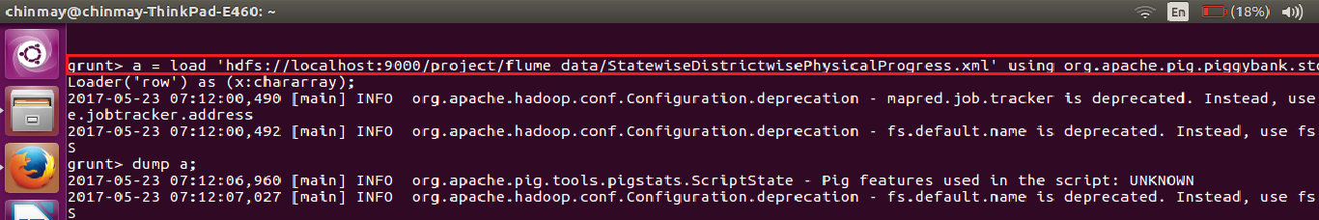

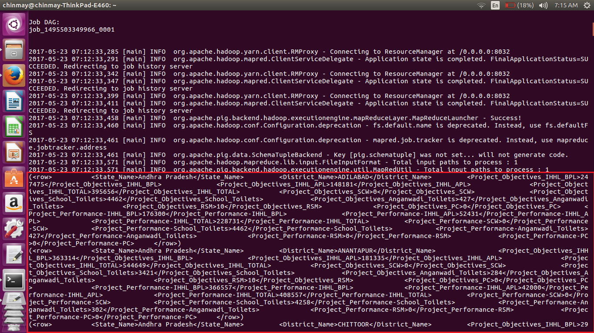

Flatten command

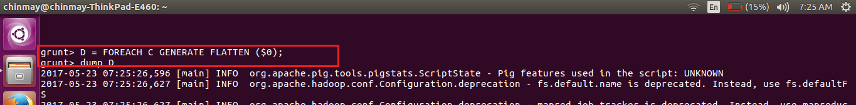

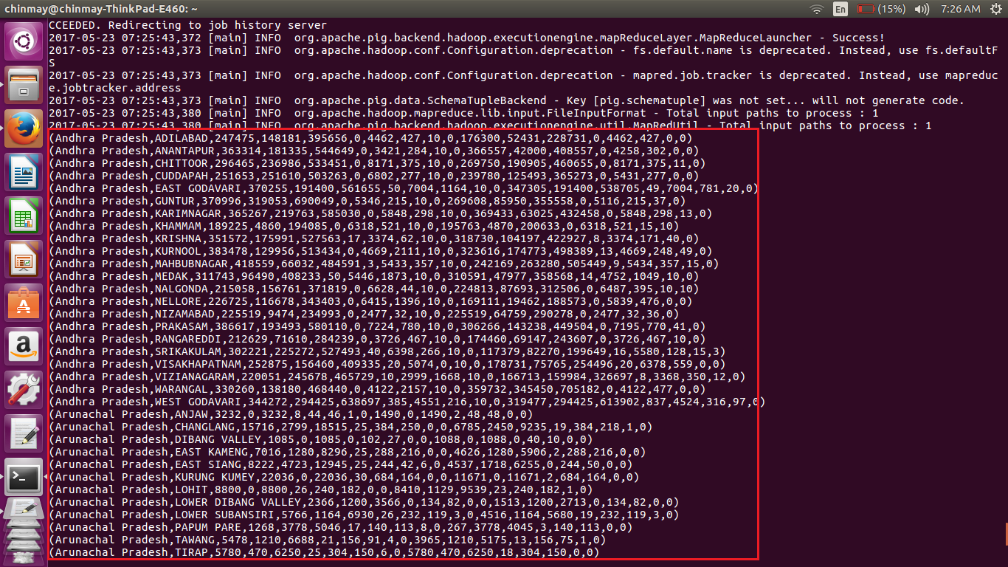

***Making a pig script comprising of all the relation to convert from XML to CSV***

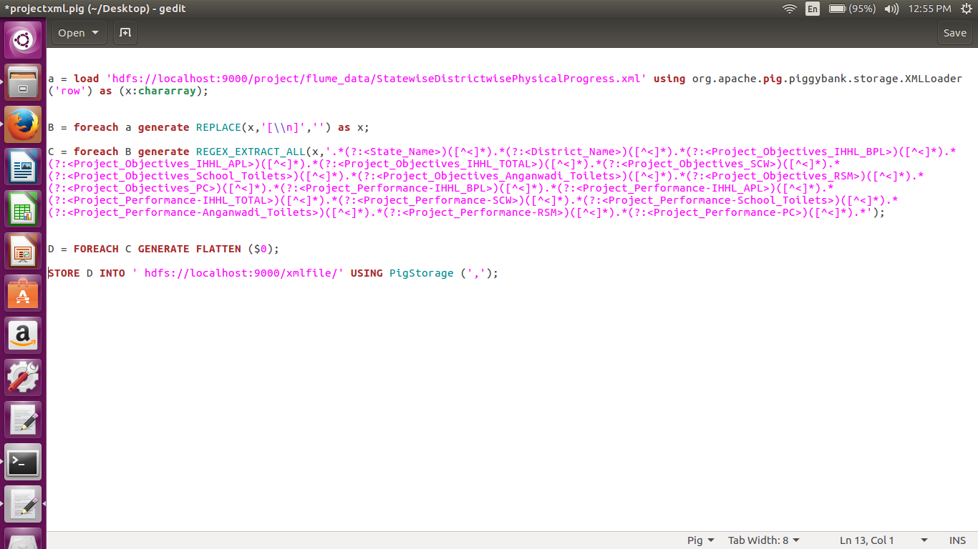

* Here we will load the xml file using the default XML loader available in pig, inside the XML loader we are specifying that our root element is **row** and we are storing the whole thing with an alias name x as chararray.
* Here we are bringing the contents between the**row** tag in one line
* Now removing the brackets using the regex expression.
* Using the flatten command to get individual output.

Query execution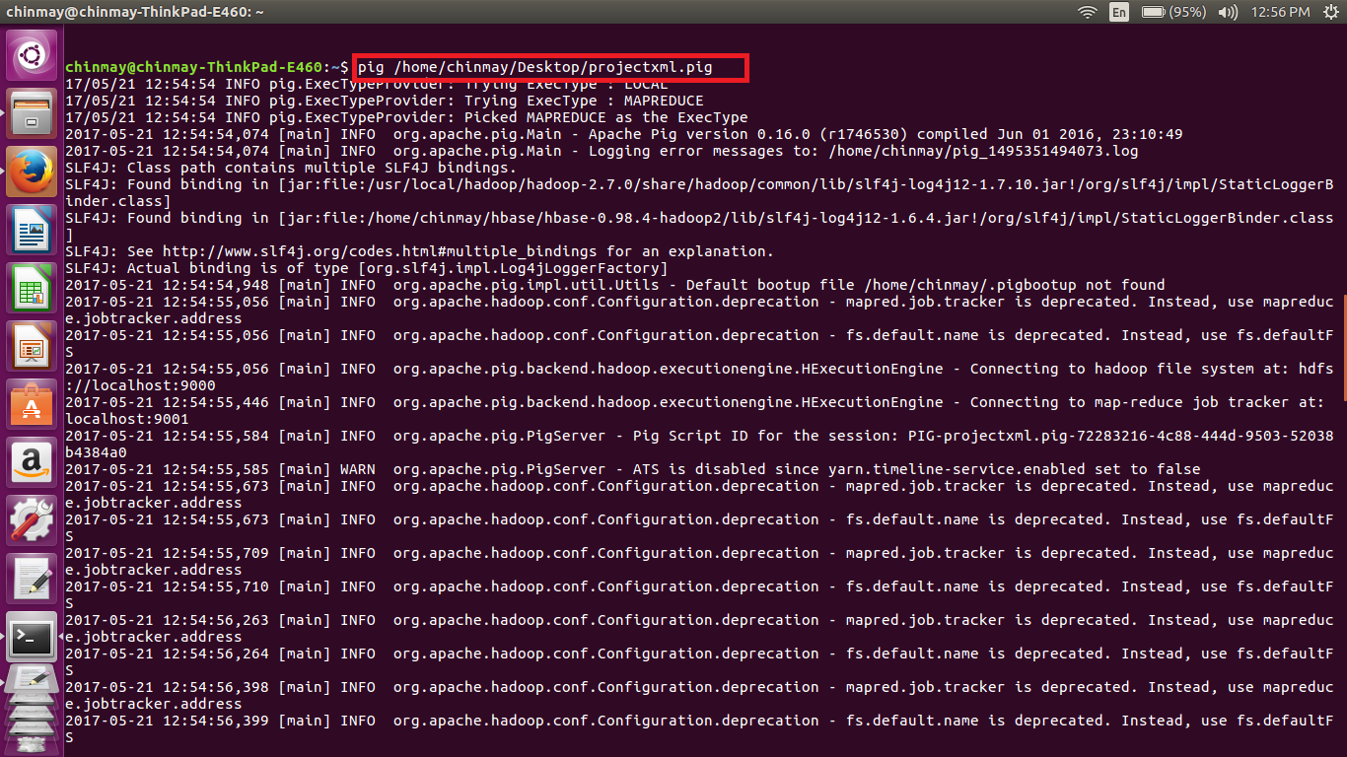

Completion of the execution

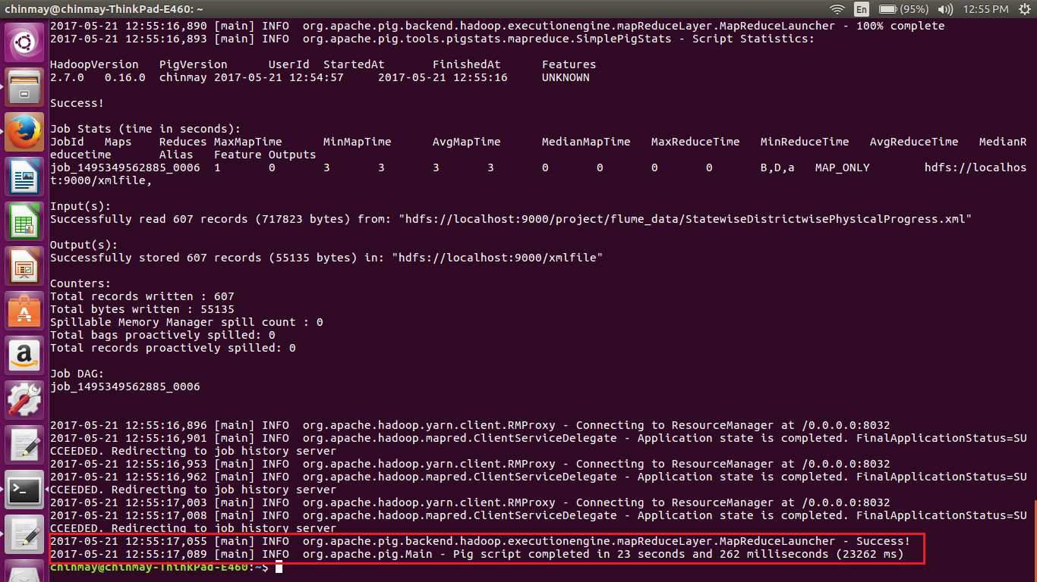

Sample Output of the converted file form XML to CSV

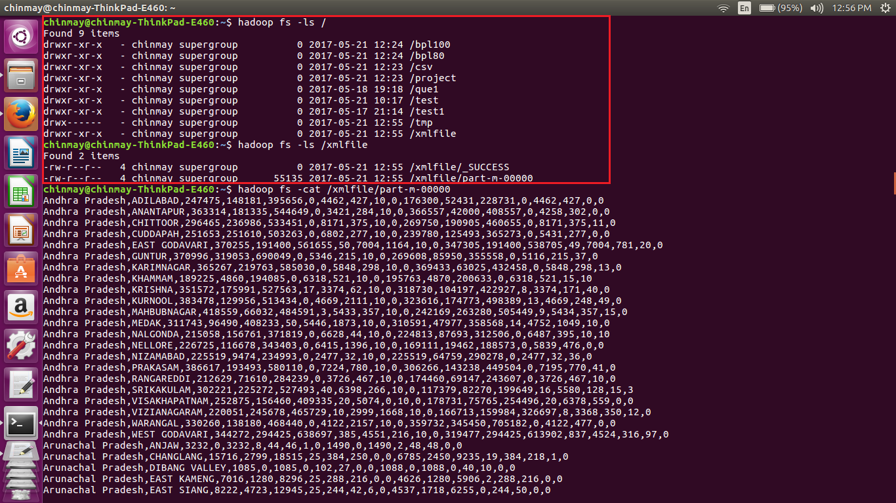

We can see from the above output that the xml file was converted to the comma separated values.

In further execution I have taken output of above file.

***Below is the pig script used for getting the records for 100% accomplishment***

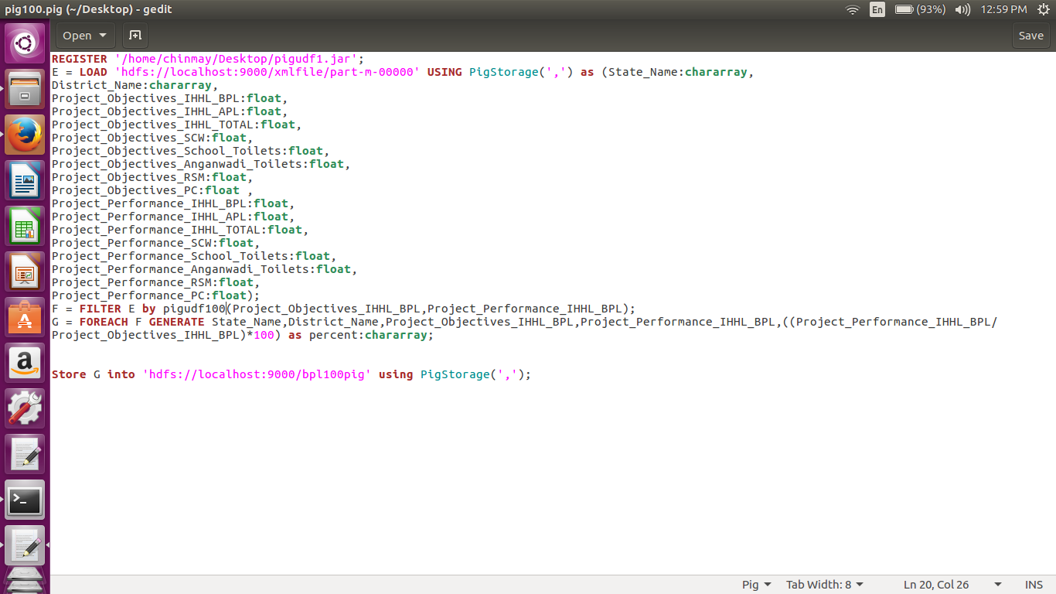

Here is the pig script written in order to get the records that have achieved the 100% or more in bpl cards.

-I have first registered the udf jar.

-Then loaded the data from the converted file(here xmlfile/part-m-00000) with the above mentioned schema.

-Used my udf to filter out the records as needed.

-Then displayed only the state name, district name, target value , accomplished value, and percentage value.

-The values are stored in the file named **bpl100pig**

Execution of the pig script.

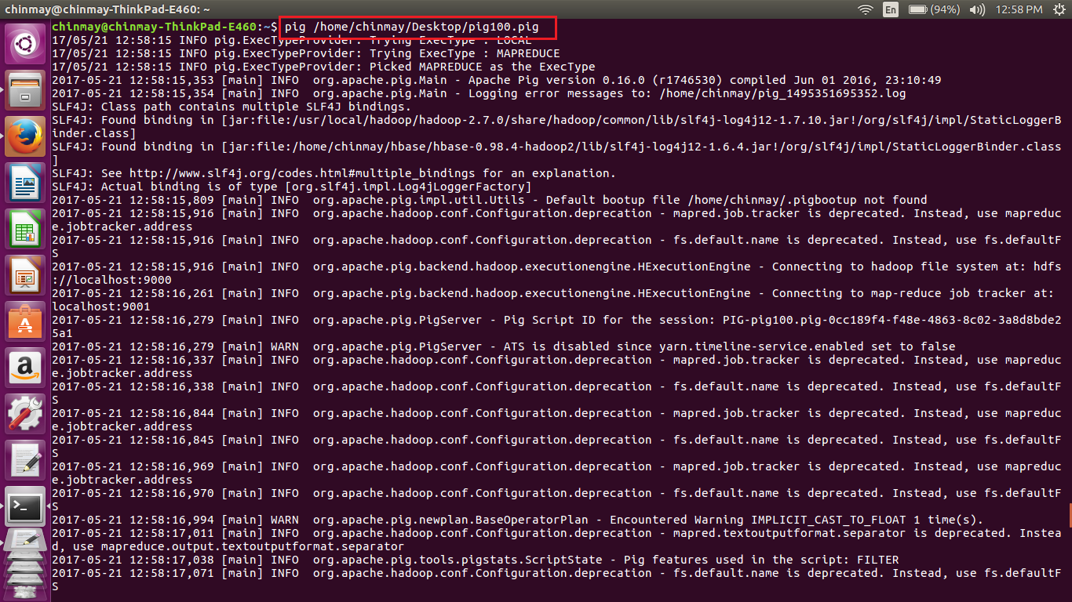

Completion of the above script.

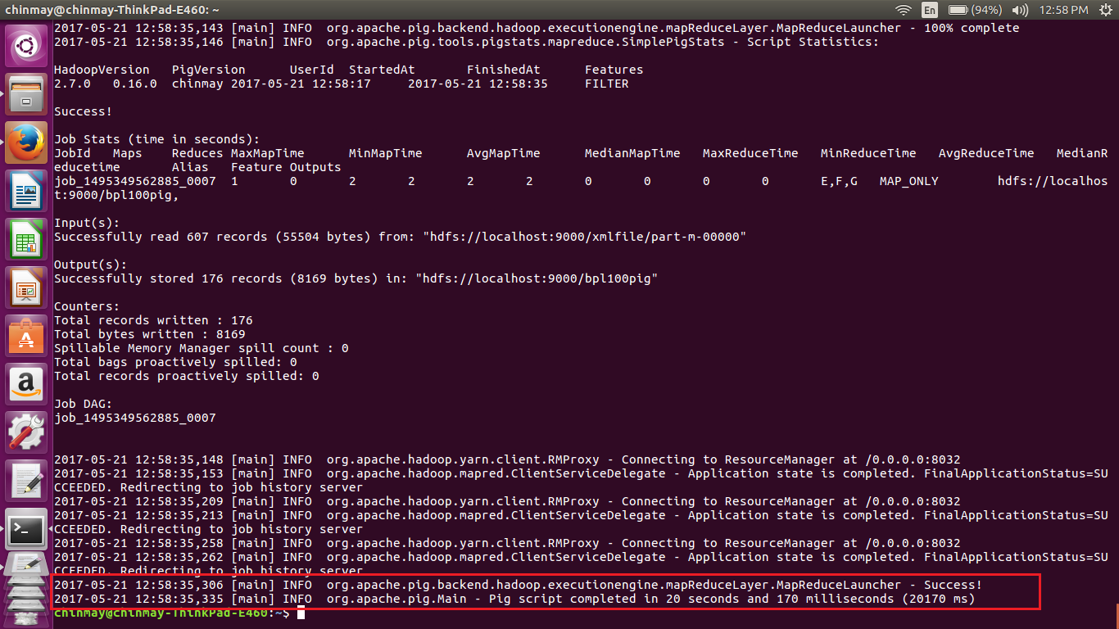

Sample output of the job

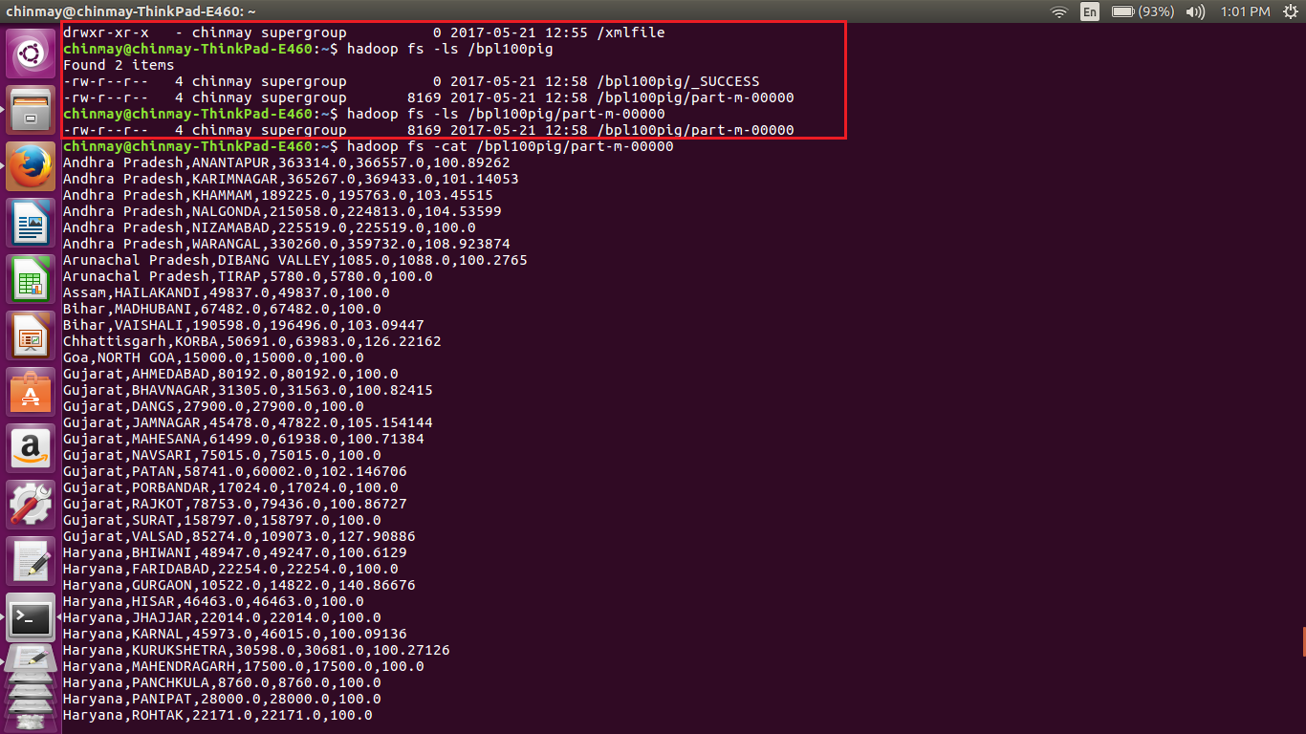

Full output from the terminal for 100% accomplishment

chinmay@chinmay-ThinkPad-E460:~$

chinmay@chinmay-ThinkPad-E460:~$ hadoop fs -ls /

Found 10 items

drwxr-xr-x - chinmay supergroup 0 2017-05-21 12:24 /bpl100

drwxr-xr-x - chinmay supergroup 0 2017-05-21 12:58 /bpl100pig

drwxr-xr-x - chinmay supergroup 0 2017-05-21 12:24 /bpl80

drwxr-xr-x - chinmay supergroup 0 2017-05-21 12:23 /csv

drwxr-xr-x - chinmay supergroup 0 2017-05-21 12:23 /project

drwxr-xr-x - chinmay supergroup 0 2017-05-18 19:18 /que1

drwxr-xr-x - chinmay supergroup 0 2017-05-21 10:17 /test

drwxr-xr-x - chinmay supergroup 0 2017-05-17 21:14 /test1

drwx------ - chinmay supergroup 0 2017-05-21 12:58 /tmp

drwxr-xr-x - chinmay supergroup 0 2017-05-21 12:55 /xmlfile

chinmay@chinmay-ThinkPad-E460:~$ hadoop fs -ls /bpl100pig

Found 2 items

-rw-r--r-- 4 chinmay supergroup 0 2017-05-21 12:58 /bpl100pig/_SUCCESS

-rw-r--r-- 4 chinmay supergroup 8169 2017-05-21 12:58 /bpl100pig/part-m-00000

chinmay@chinmay-ThinkPad-E460:~$ hadoop fs -ls /bpl100pig/part-m-00000

-rw-r--r-- 4 chinmay supergroup 8169 2017-05-21 12:58 /bpl100pig/part-m-00000

chinmay@chinmay-ThinkPad-E460:~$ hadoop fs -cat /bpl100pig/part-m-00000

Andhra Pradesh,ANANTAPUR,363314.0,366557.0,100.89262

Andhra Pradesh,KARIMNAGAR,365267.0,369433.0,101.14053

Andhra Pradesh,KHAMMAM,189225.0,195763.0,103.45515

Andhra Pradesh,NALGONDA,215058.0,224813.0,104.53599

Andhra Pradesh,NIZAMABAD,225519.0,225519.0,100.0

Andhra Pradesh,WARANGAL,330260.0,359732.0,108.923874

Arunachal Pradesh,DIBANG VALLEY,1085.0,1088.0,100.2765

Arunachal Pradesh,TIRAP,5780.0,5780.0,100.0

Assam,HAILAKANDI,49837.0,49837.0,100.0

Bihar,MADHUBANI,67482.0,67482.0,100.0

Bihar,VAISHALI,190598.0,196496.0,103.09447

Chhattisgarh,KORBA,50691.0,63983.0,126.22162

Goa,NORTH GOA,15000.0,15000.0,100.0

Gujarat,AHMEDABAD,80192.0,80192.0,100.0

Gujarat,BHAVNAGAR,31305.0,31563.0,100.82415

Gujarat,DANGS,27900.0,27900.0,100.0

Gujarat,JAMNAGAR,45478.0,47822.0,105.154144

Gujarat,MAHESANA,61499.0,61938.0,100.71384

Gujarat,NAVSARI,75015.0,75015.0,100.0

Gujarat,PATAN,58741.0,60002.0,102.146706

Gujarat,PORBANDAR,17024.0,17024.0,100.0

Gujarat,RAJKOT,78753.0,79436.0,100.86727

Gujarat,SURAT,158797.0,158797.0,100.0

Gujarat,VALSAD,85274.0,109073.0,127.90886

Haryana,BHIWANI,48947.0,49247.0,100.6129

Haryana,FARIDABAD,22254.0,22254.0,100.0

Haryana,GURGAON,10522.0,14822.0,140.86676

Haryana,HISAR,46463.0,46463.0,100.0

Haryana,JHAJJAR,22014.0,22014.0,100.0

Haryana,KARNAL,45973.0,46015.0,100.09136

Haryana,KURUKSHETRA,30598.0,30681.0,100.27126

Haryana,MAHENDRAGARH,17500.0,17500.0,100.0

Haryana,PANCHKULA,8760.0,8760.0,100.0

Haryana,PANIPAT,28000.0,28000.0,100.0

Haryana,ROHTAK,22171.0,22171.0,100.0

Haryana,SIRSA,35400.0,35400.0,100.0

Haryana,SONIPAT,29808.0,30300.0,101.65056

Himachal Pradesh,BILASPUR,11931.0,13078.0,109.61361

Himachal Pradesh,CHAMBA,44429.0,58422.0,131.4952

Himachal Pradesh,HAMIRPUR,11593.0,11593.0,100.0

Himachal Pradesh,KANGRA,45000.0,61820.0,137.37778

Himachal Pradesh,KINNAUR,1560.0,1560.0,100.0

Himachal Pradesh,KULLU,9989.0,9989.0,100.0

Himachal Pradesh,LAHAUL &amp; SPITI,2413.0,2413.0,100.0

Himachal Pradesh,MANDI,34407.0,34408.0,100.00291

Himachal Pradesh,SHIMLA,23874.0,23874.0,100.0

Himachal Pradesh,SOLAN,10858.0,10858.0,100.0

Himachal Pradesh,UNA,8360.0,8360.0,100.0

Jharkhand,DEOGHAR,75153.0,75153.0,100.0

Jharkhand,LOHARDAGA,22626.0,22626.0,100.0

Jharkhand,PURBI SINGHBHUM,97196.0,126967.0,130.62987

Karnataka,BANGALORE RURAL,63044.0,87975.0,139.5454

Karnataka,HASSAN,64134.0,64134.0,100.0

Karnataka,KOLAR,43183.0,85744.0,198.55962

Karnataka,MANGALORE(DAKSHINA KANNADA),59478.0,59478.0,100.0

Karnataka,SHIMOGA,99428.0,99996.0,100.571266

Karnataka,UDUPI,52348.0,52348.0,100.0

Kerala,ALAPPUZHA,114359.0,114359.0,100.0

Kerala,ERNAKULAM,54585.0,55916.0,102.4384

Kerala,IDUKKI,86535.0,89553.0,103.48761

Kerala,KANNUR,34121.0,37628.0,110.27813

Kerala,KASARGOD,56965.0,59153.0,103.84096

Kerala,KOLLAM,95130.0,95130.0,100.0

Kerala,KOTTAYAM,28118.0,28118.0,100.0

Kerala,KOZHIKODE,42285.0,42285.0,100.0

Kerala,MALAPPURAM,60592.0,61905.0,102.166954

Kerala,PALAKKAD,107018.0,107018.0,100.0

Kerala,PATHANAMTHITTA,53799.0,53799.0,100.0

Kerala,THIRUVANANTHAPURAM,129000.0,137004.0,106.20465

Kerala,THRISSUR,48669.0,51017.0,104.824425

Kerala,WAYANAD,50655.0,50655.0,100.0

Madhya Pradesh,ALIRAJPUR,38225.0,52971.0,138.57686

Madhya Pradesh,ANUPPUR,39615.0,55336.0,139.68446

Madhya Pradesh,BARWANI,75695.0,84663.0,111.84754

Madhya Pradesh,BETUL,43427.0,43688.0,100.601006

Madhya Pradesh,BHOPAL,20010.0,31380.0,156.82158

Madhya Pradesh,BURHANPUR,41047.0,43340.0,105.58628

Madhya Pradesh,DATIA,11997.0,18386.0,153.25499

Madhya Pradesh,DEWAS,59245.0,79734.0,134.58351

Madhya Pradesh,DHAR,100281.0,119944.0,119.6079

Madhya Pradesh,GWALIOR,32128.0,39081.0,121.64156

Madhya Pradesh,HARDA,23589.0,31545.0,133.72758

Madhya Pradesh,HOSHANGABAD,50677.0,83469.0,164.70786

Madhya Pradesh,INDORE,48998.0,50152.0,102.355194

Madhya Pradesh,JABALPUR,106290.0,117804.0,110.832634

Madhya Pradesh,JHABUA,81491.0,94244.0,115.64958

Madhya Pradesh,KATNI,53000.0,68295.0,128.85849

Madhya Pradesh,KHANDWA(EAST NIMAR),60123.0,82598.0,137.3817

Madhya Pradesh,KHARGONE,91083.0,91458.0,100.41171

Madhya Pradesh,MANDSAUR,46666.0,67848.0,145.39066

Madhya Pradesh,MORENA,32478.0,39727.0,122.319725

Madhya Pradesh,NEEMUCH,27790.0,42843.0,154.16696

Madhya Pradesh,RAISEN,88825.0,102504.0,115.39995

Madhya Pradesh,RAJGARH,94365.0,115392.0,122.28262

Madhya Pradesh,RATLAM,51248.0,64477.0,125.81369

Madhya Pradesh,REWA,121538.0,147541.0,121.39496

Madhya Pradesh,SEHORE,34355.0,77009.0,224.1566

Madhya Pradesh,SHAHDOL,84802.0,86586.0,102.10372

Madhya Pradesh,SHAJAPUR,65429.0,75217.0,114.95973

Madhya Pradesh,SHEOPUR,18198.0,28955.0,159.11089

Madhya Pradesh,UJJAIN,68225.0,77417.0,113.47307

Madhya Pradesh,UMARIA,40359.0,54150.0,134.17082

Maharashtra,GADCHIROLI,75900.0,75900.0,100.0

Maharashtra,RATNAGIRI,95726.0,102182.0,106.744255

Maharashtra,SINDHUDURG,43874.0,43874.0,100.0

Meghalaya,WEST GARO HILLS,44385.0,44385.0,100.0

Mizoram,CHAMPHAI,11077.0,11077.0,100.0

Mizoram,LAWNGTLAI,16544.0,16544.0,100.0

Punjab,BARNALA,12137.0,12593.0,103.75711

Punjab,FATEHGARH SAHIB,2485.0,2630.0,105.83501

Punjab,HOSHIARPUR,11112.0,19094.0,171.83224

Punjab,LUDHIANA,45422.0,46920.0,103.29796

Punjab,NAWANSHAHR,7273.0,11581.0,159.23279

Punjab,S.A.S Nagar,4008.0,4025.0,100.42415

Rajasthan,HANUMANGARH,31621.0,31621.0,100.0

Sikkim,EAST SIKKIM,24109.0,26852.0,111.37749

Sikkim,NORTH SIKKIM,4978.0,5461.0,109.7027

Sikkim,SOUTH SIKKIM,8970.0,12446.0,138.75139

Sikkim,WEST SIKKIM,13245.0,13345.0,100.755

Tamil Nadu,DHARMAPURI,152872.0,152921.0,100.03206

Tamil Nadu,ERODE,165306.0,165306.0,100.0

Tamil Nadu,KANCHIPURAM,147350.0,154480.0,104.83882

Tamil Nadu,KANYAKUMARI(NAGERCOIL),76233.0,84822.0,111.26678

Tamil Nadu,KARUR,105280.0,105280.0,100.0

Tamil Nadu,NAMAKKAL,117538.0,117538.0,100.0

Tamil Nadu,PUDUKKOTTAI,176710.0,198097.0,112.102875

Tamil Nadu,RAMANATHAPURAM,105000.0,156708.0,149.24571

Tamil Nadu,TIRUCHIRAPPALLI,77747.0,77747.0,100.0

Tamil Nadu,TIRUNELVELI,125763.0,139323.0,110.78218

Tamil Nadu,TIRUVANNAMALAI,209116.0,209116.0,100.0

Tamil Nadu,TIRUVARUR,80920.0,87918.0,108.64805

Tripura,DHALAI,53507.0,53507.0,100.0

Tripura,SOUTH TRIPURA,139456.0,139456.0,100.0

Tripura,WEST TRIPURA,183405.0,183405.0,100.0

Uttar Pradesh,AGRA,54188.0,54789.0,101.1091

Uttar Pradesh,ALLAHABAD,181370.0,195141.0,107.59276

Uttar Pradesh,AMBEDKAR NAGAR,132725.0,132725.0,100.0

Uttar Pradesh,BALRAMPUR,65273.0,65273.0,100.0

Uttar Pradesh,BARABANKI,199542.0,202328.0,101.3962

Uttar Pradesh,BAREILLY,110000.0,110000.0,100.0

Uttar Pradesh,BIJNOR,110403.0,110403.0,100.0

Uttar Pradesh,BUDAUN,107603.0,107603.0,100.0

Uttar Pradesh,BULANDSHAHR,28885.0,31996.0,110.770294

Uttar Pradesh,CHANDAULI,92022.0,96318.0,104.66845

Uttar Pradesh,CHITRAKOOT,38082.0,42652.0,112.00042

Uttar Pradesh,ETAH,62001.0,69139.0,111.51272

Uttar Pradesh,ETAWAH,94097.0,94097.0,100.0

Uttar Pradesh,FARRUKHABAD,120471.0,120471.0,100.0

Uttar Pradesh,FIROZABAD,19843.0,19843.0,100.0

Uttar Pradesh,GHAZIABAD,10810.0,10810.0,100.0

Uttar Pradesh,HARDOI,199989.0,199989.0,100.0

Uttar Pradesh,JAUNPUR,250000.0,250924.0,100.3696

Uttar Pradesh,JHANSI,58826.0,59119.0,100.49808

Uttar Pradesh,JYOTIBA PHULE NAGAR,48008.0,48008.0,100.0

Uttar Pradesh,KANNAUJ,101497.0,101616.0,100.11724

Uttar Pradesh,LAKHIMPUR KHERI,73000.0,95742.0,131.15343

Uttar Pradesh,LUCKNOW,113188.0,113188.0,100.0

Uttar Pradesh,MAHAMAYA NAGAR(HATHRAS),25153.0,25277.0,100.49298

Uttar Pradesh,MAHARAJGANJ,145090.0,145090.0,100.0

Uttar Pradesh,MAHOBA,53117.0,53117.0,100.0

Uttar Pradesh,MATHURA,25005.0,25110.0,100.419914

Uttar Pradesh,MIRZAPUR,231315.0,233308.0,100.861595

Uttar Pradesh,MORADABAD,76018.0,76018.0,100.0

Uttar Pradesh,MUZAFFARNAGAR,51660.0,51660.0,100.0

Uttar Pradesh,PILIBHIT,95178.0,95178.0,100.0

Uttar Pradesh,PRATAPGARH,141368.0,143517.0,101.52014

Uttar Pradesh,RAE BARELI,190306.0,190430.0,100.06516

Uttar Pradesh,SAHARANPUR,49458.0,49586.0,100.258804

Uttar Pradesh,SHAHJAHANPUR,194645.0,194959.0,100.161316

Uttar Pradesh,SONBHADRA,138370.0,138370.0,100.0

Uttar Pradesh,SULTANPUR,168843.0,168843.0,100.0

Uttarakhand,NAINITAL,14314.0,18039.0,126.02347

Uttarakhand,RUDRAPRAYAG,13150.0,13810.0,105.01901

West Bengal,DAKSHIN DINAJPUR,182621.0,184153.0,100.8389

West Bengal,MIDNAPUR EAST,392371.0,527389.0,134.4108

West Bengal,MIDNAPUR WEST,509496.0,596291.0,117.03546

chinmay@chinmay-ThinkPad-E460:~$ ^C

chinmay@chinmay-ThinkPad-E460:~$

Sqoop job implementation for 100% accomplishment of the job

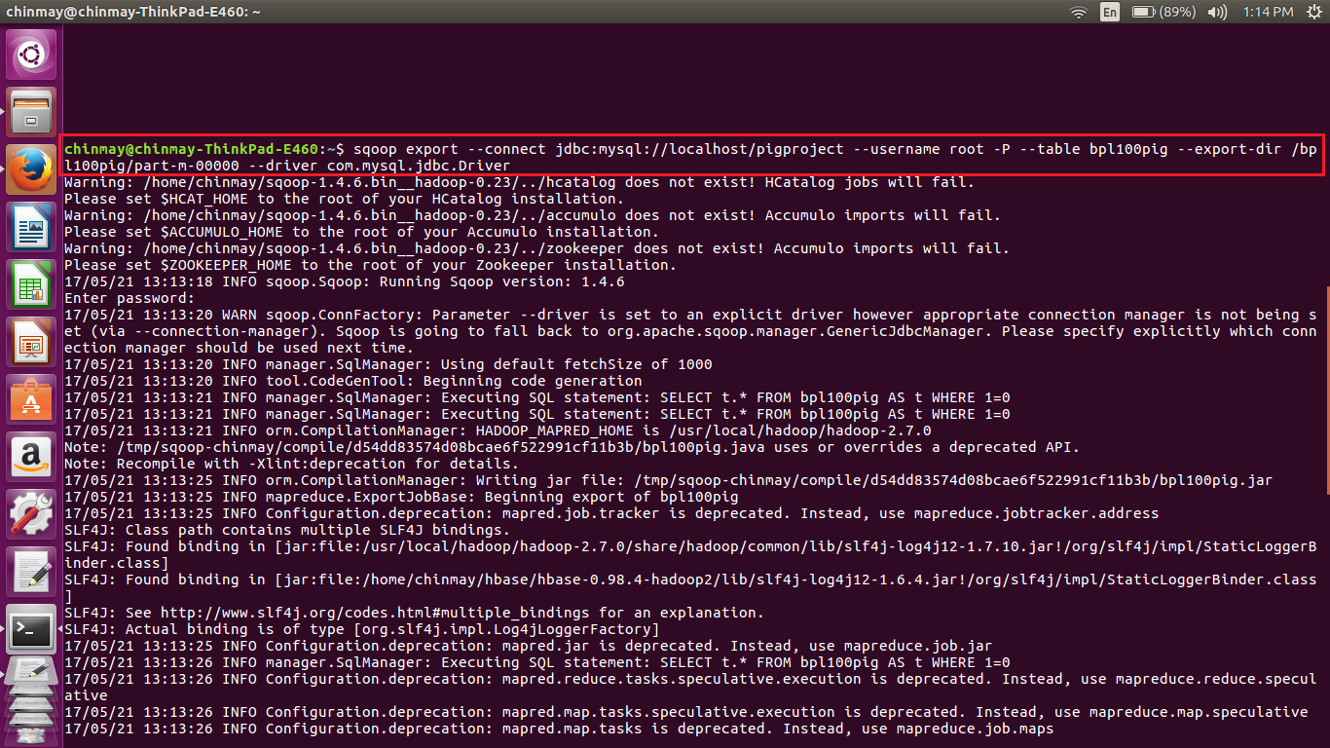

Completion of the sqoop job

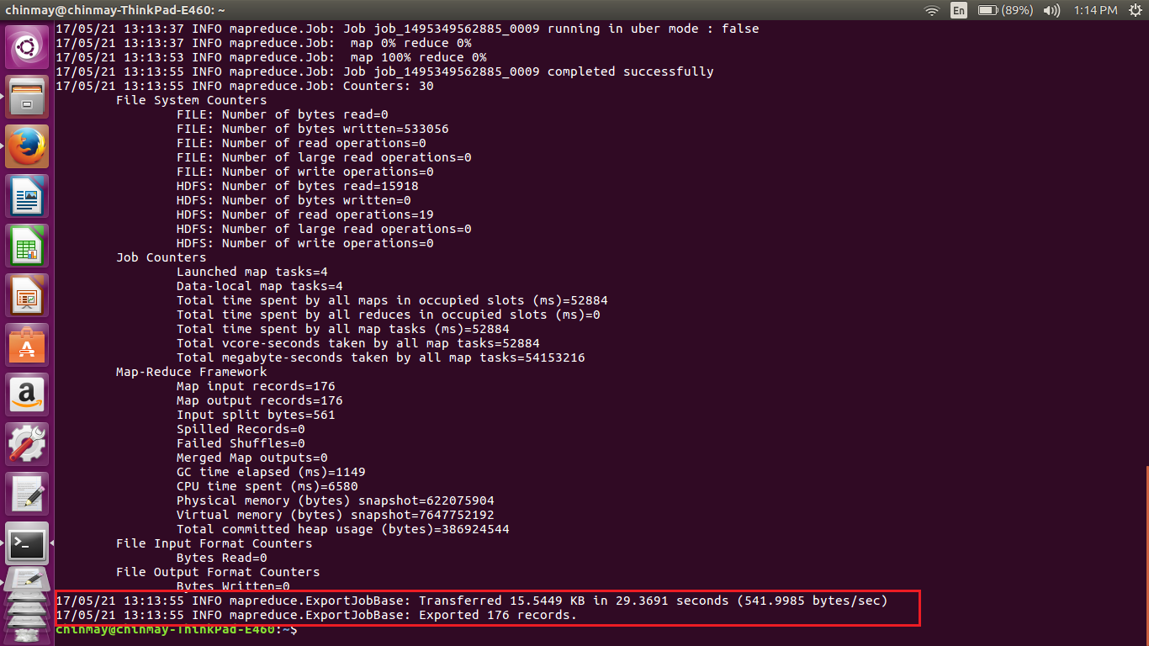

Sample output of the sqoop job in mysql db

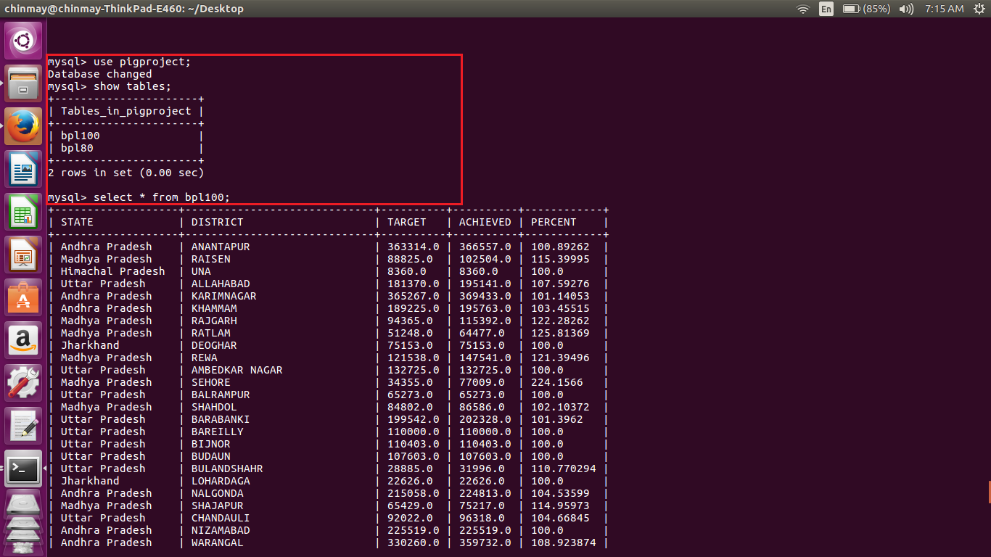

***Below is the pig script used for getting the records for 80% accomplishment***

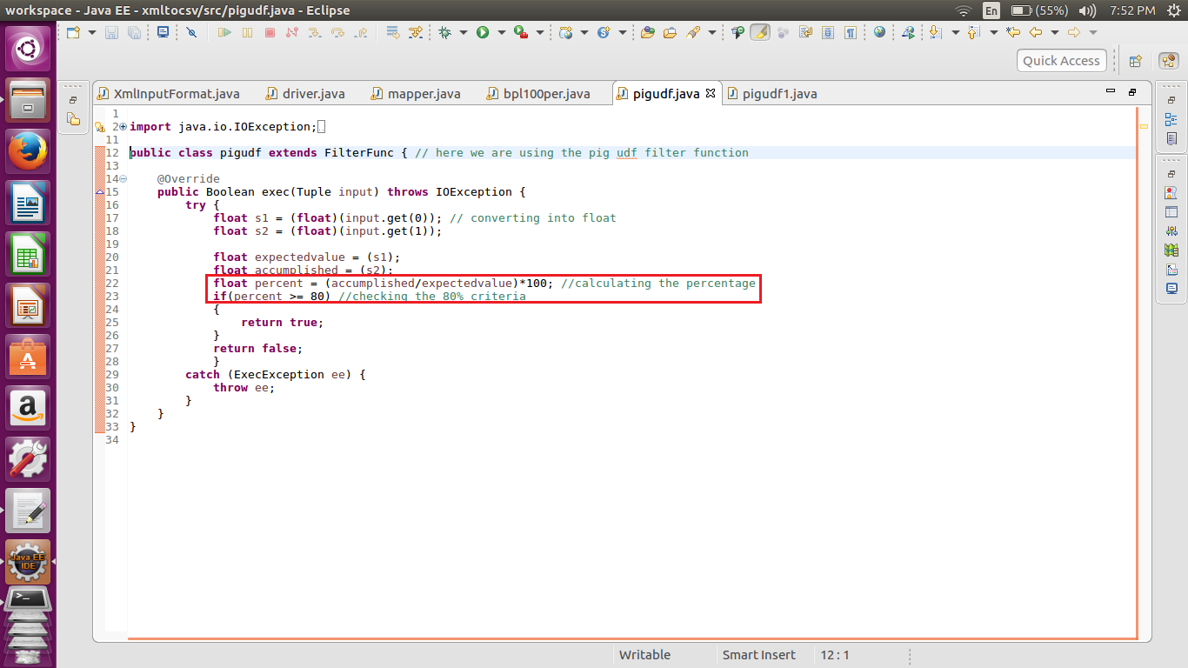

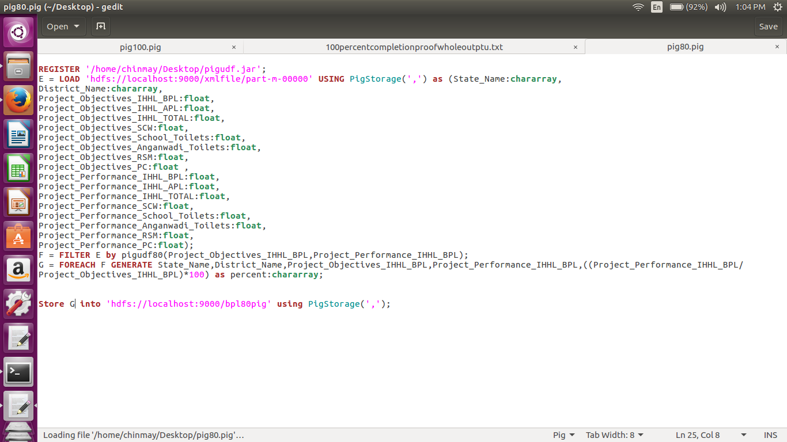

Here is the pig script written in order to get the records that have achieved the 80% or more in bpl cards.

-I have first registered the udf jar.

-Then loaded the data from the converted file(here xmlfile/part-m-00000) with the above mentioned schema.

-Used my udf to filter out the records as needed.

-Then displayed only the state name, district name, target value , accomplished value, and percentage value.

-The values are stored in the file named **bpl80pig**

Execution of the pig Script

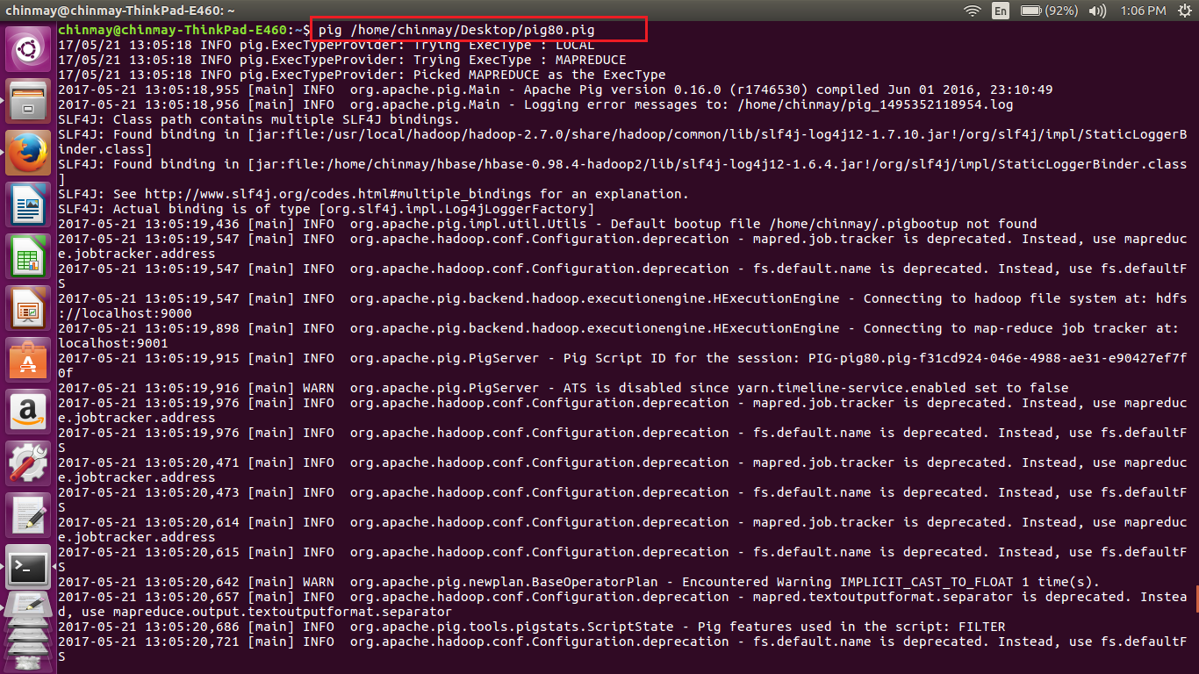

Completion of the execution

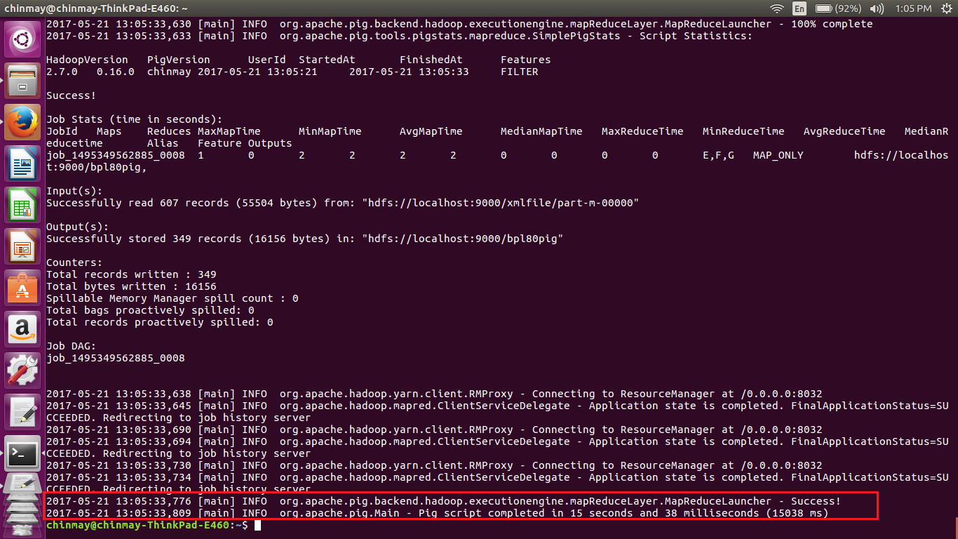

Sample output for the records having 80% or above

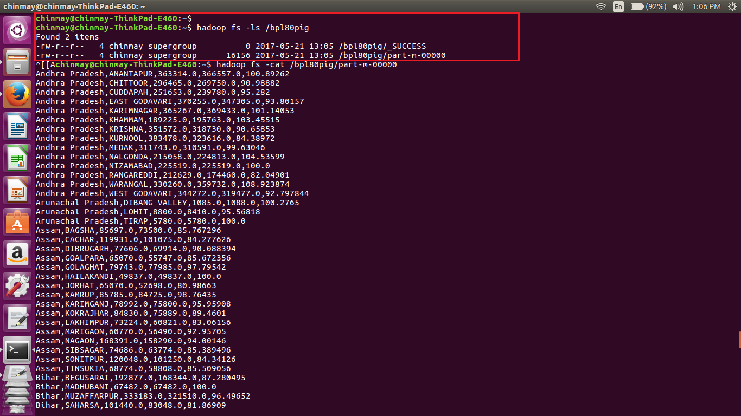

Full output

chinmay@chinmay-ThinkPad-E460:~$

chinmay@chinmay-ThinkPad-E460:~$ hadoop fs -ls /bpl80pig

Found 2 items

-rw-r--r-- 4 chinmay supergroup 0 2017-05-21 13:05 /bpl80pig/_SUCCESS

-rw-r--r-- 4 chinmay supergroup 16156 2017-05-21 13:05 /bpl80pig/part-m-00000

^[[Achinmay@chinmay-ThinkPad-E460:~$ hadoop fs -cat /bpl80pig/part-m-00000

Andhra Pradesh,ANANTAPUR,363314.0,366557.0,100.89262

Andhra Pradesh,CHITTOOR,296465.0,269750.0,90.98882

Andhra Pradesh,CUDDAPAH,251653.0,239780.0,95.282

Andhra Pradesh,EAST GODAVARI,370255.0,347305.0,93.80157

Andhra Pradesh,KARIMNAGAR,365267.0,369433.0,101.14053

Andhra Pradesh,KHAMMAM,189225.0,195763.0,103.45515

Andhra Pradesh,KRISHNA,351572.0,318730.0,90.65853

Andhra Pradesh,KURNOOL,383478.0,323616.0,84.38972

Andhra Pradesh,MEDAK,311743.0,310591.0,99.63046

Andhra Pradesh,NALGONDA,215058.0,224813.0,104.53599

Andhra Pradesh,NIZAMABAD,225519.0,225519.0,100.0

Andhra Pradesh,RANGAREDDI,212629.0,174460.0,82.04901

Andhra Pradesh,WARANGAL,330260.0,359732.0,108.923874

Andhra Pradesh,WEST GODAVARI,344272.0,319477.0,92.797844

Arunachal Pradesh,DIBANG VALLEY,1085.0,1088.0,100.2765

Arunachal Pradesh,LOHIT,8800.0,8410.0,95.56818

Arunachal Pradesh,TIRAP,5780.0,5780.0,100.0

Assam,BAGSHA,85697.0,73500.0,85.767296

Assam,CACHAR,119931.0,101075.0,84.277626

Assam,DIBRUGARH,77606.0,69914.0,90.088394

Assam,GOALPARA,65070.0,55747.0,85.672356

Assam,GOLAGHAT,79743.0,77985.0,97.79542

Assam,HAILAKANDI,49837.0,49837.0,100.0

Assam,JORHAT,65070.0,52698.0,80.98663

Assam,KAMRUP,85785.0,84725.0,98.76435

Assam,KARIMGANJ,78992.0,75800.0,95.95908

Assam,KOKRAJHAR,84830.0,75889.0,89.4601

Assam,LAKHIMPUR,73224.0,60821.0,83.06156

Assam,MARIGAON,60770.0,56490.0,92.95705

Assam,NAGAON,168391.0,158290.0,94.00146

Assam,SIBSAGAR,74686.0,63774.0,85.389496

Assam,SONITPUR,120048.0,101250.0,84.34126

Assam,TINSUKIA,68774.0,58808.0,85.509056

Bihar,BEGUSARAI,192877.0,168344.0,87.280495

Bihar,MADHUBANI,67482.0,67482.0,100.0

Bihar,MUZAFFARPUR,333183.0,321510.0,96.49652

Bihar,SAHARSA,101440.0,83048.0,81.86909

Bihar,VAISHALI,190598.0,196496.0,103.09447

Chhattisgarh,DHAMTARI,38501.0,32195.0,83.6212

Chhattisgarh,JASHPUR,56623.0,56014.0,98.92446

Chhattisgarh,KANKER,50835.0,41245.0,81.13505

Chhattisgarh,KORBA,50691.0,63983.0,126.22162

Chhattisgarh,KORIYA,38296.0,30664.0,80.07103

Chhattisgarh,SURGUJA,168885.0,140083.0,82.94579

Goa,NORTH GOA,15000.0,15000.0,100.0

Gujarat,AHMEDABAD,80192.0,80192.0,100.0

Gujarat,AMRELI,67802.0,61990.0,91.42798

Gujarat,ANAND,72058.0,69832.0,96.91082

Gujarat,BANAS KANTHA,126536.0,125652.0,99.301384

Gujarat,BHARUCH,78463.0,75199.0,95.84008

Gujarat,BHAVNAGAR,31305.0,31563.0,100.82415

Gujarat,DAHOD,134798.0,131790.0,97.76852

Gujarat,DANGS,27900.0,27900.0,100.0

Gujarat,GANDHINAGAR,13830.0,11290.0,81.634125

Gujarat,JAMNAGAR,45478.0,47822.0,105.154144

Gujarat,JUNAGADH,56444.0,55874.0,98.99015

Gujarat,KACHCHH,45596.0,37781.0,82.86034

Gujarat,KHEDA,140212.0,138896.0,99.061424

Gujarat,MAHESANA,61499.0,61938.0,100.71384

Gujarat,NARMADA,58730.0,56924.0,96.92491

Gujarat,NAVSARI,75015.0,75015.0,100.0

Gujarat,PANCH MAHALS,156835.0,153720.0,98.01384

Gujarat,PATAN,58741.0,60002.0,102.146706

Gujarat,PORBANDAR,17024.0,17024.0,100.0

Gujarat,RAJKOT,78753.0,79436.0,100.86727

Gujarat,SABAR KANTHA,151382.0,151187.0,99.871185

Gujarat,SURAT,158797.0,158797.0,100.0

Gujarat,SURENDRANAGAR,83235.0,69913.0,83.99471

Gujarat,VADODARA,140958.0,129194.0,91.65425

Gujarat,VALSAD,85274.0,109073.0,127.90886

Haryana,AMBALA,43428.0,39247.0,90.37257

Haryana,BHIWANI,48947.0,49247.0,100.6129

Haryana,FARIDABAD,22254.0,22254.0,100.0

Haryana,FATEHABAD,25642.0,25361.0,98.90414

Haryana,GURGAON,10522.0,14822.0,140.86676

Haryana,HISAR,46463.0,46463.0,100.0

Haryana,JHAJJAR,22014.0,22014.0,100.0

Haryana,JIND,58000.0,57039.0,98.3431

Haryana,KAITHAL,37046.0,36566.0,98.704315

Haryana,KARNAL,45973.0,46015.0,100.09136

Haryana,KURUKSHETRA,30598.0,30681.0,100.27126

Haryana,MAHENDRAGARH,17500.0,17500.0,100.0

Haryana,MEWAT,21875.0,19838.0,90.688

Haryana,PANCHKULA,8760.0,8760.0,100.0

Haryana,PANIPAT,28000.0,28000.0,100.0

Haryana,REWARI,30000.0,26548.0,88.49333

Haryana,ROHTAK,22171.0,22171.0,100.0

Haryana,SIRSA,35400.0,35400.0,100.0

Haryana,SONIPAT,29808.0,30300.0,101.65056

Haryana,YAMUNANAGAR,52539.0,51915.0,98.81231

Himachal Pradesh,BILASPUR,11931.0,13078.0,109.61361

Himachal Pradesh,CHAMBA,44429.0,58422.0,131.4952

Himachal Pradesh,HAMIRPUR,11593.0,11593.0,100.0

Himachal Pradesh,KANGRA,45000.0,61820.0,137.37778

Himachal Pradesh,KINNAUR,1560.0,1560.0,100.0

Himachal Pradesh,KULLU,9989.0,9989.0,100.0

Himachal Pradesh,LAHAUL &amp; SPITI,2413.0,2413.0,100.0

Himachal Pradesh,MANDI,34407.0,34408.0,100.00291

Himachal Pradesh,SHIMLA,23874.0,23874.0,100.0

Himachal Pradesh,SIRMAUR,13753.0,13671.0,99.40377

Himachal Pradesh,SOLAN,10858.0,10858.0,100.0

Himachal Pradesh,UNA,8360.0,8360.0,100.0

Jammu &amp; Kashmir,ANANTNAG,75476.0,61938.0,82.06317

Jammu &amp; Kashmir,LEH (LADAKH),6090.0,5296.0,86.962234

Jharkhand,DEOGHAR,75153.0,75153.0,100.0

Jharkhand,DUMKA,148732.0,126910.0,85.32797

Jharkhand,LATEHAR,79635.0,66455.0,83.449486

Jharkhand,LOHARDAGA,22626.0,22626.0,100.0

Jharkhand,PAKUR,72250.0,63110.0,87.34948

Jharkhand,PURBI SINGHBHUM,97196.0,126967.0,130.62987

Karnataka,BAGALKOT,74926.0,68863.0,91.90801

Karnataka,BANGALORE RURAL,63044.0,87975.0,139.5454

Karnataka,CHICKMAGALUR,67568.0,64863.0,95.99663

Karnataka,CHITRADURGA,75400.0,73585.0,97.592834

Karnataka,DHARWAD,53596.0,49843.0,92.99761

Karnataka,GADAG,46821.0,39414.0,84.180176

Karnataka,HASSAN,64134.0,64134.0,100.0

Karnataka,KODAGU,38838.0,38638.0,99.48504

Karnataka,KOLAR,43183.0,85744.0,198.55962

Karnataka,KOPPAL,60869.0,53275.0,87.524025

Karnataka,MANDYA,128782.0,116773.0,90.674934

Karnataka,MANGALORE(DAKSHINA KANNADA),59478.0,59478.0,100.0

Karnataka,RAMANAGARA ,41876.0,37293.0,89.055786

Karnataka,SHIMOGA,99428.0,99996.0,100.571266

Karnataka,UDUPI,52348.0,52348.0,100.0

Kerala,ALAPPUZHA,114359.0,114359.0,100.0

Kerala,ERNAKULAM,54585.0,55916.0,102.4384

Kerala,IDUKKI,86535.0,89553.0,103.48761

Kerala,KANNUR,34121.0,37628.0,110.27813

Kerala,KASARGOD,56965.0,59153.0,103.84096

Kerala,KOLLAM,95130.0,95130.0,100.0

Kerala,KOTTAYAM,28118.0,28118.0,100.0

Kerala,KOZHIKODE,42285.0,42285.0,100.0

Kerala,MALAPPURAM,60592.0,61905.0,102.166954

Kerala,PALAKKAD,107018.0,107018.0,100.0

Kerala,PATHANAMTHITTA,53799.0,53799.0,100.0

Kerala,THIRUVANANTHAPURAM,129000.0,137004.0,106.20465

Kerala,THRISSUR,48669.0,51017.0,104.824425

Kerala,WAYANAD,50655.0,50655.0,100.0

Madhya Pradesh,ALIRAJPUR,38225.0,52971.0,138.57686

Madhya Pradesh,ANUPPUR,39615.0,55336.0,139.68446

Madhya Pradesh,BARWANI,75695.0,84663.0,111.84754

Madhya Pradesh,BETUL,43427.0,43688.0,100.601006

Madhya Pradesh,BHOPAL,20010.0,31380.0,156.82158

Madhya Pradesh,BURHANPUR,41047.0,43340.0,105.58628

Madhya Pradesh,DATIA,11997.0,18386.0,153.25499

Madhya Pradesh,DEWAS,59245.0,79734.0,134.58351

Madhya Pradesh,DHAR,100281.0,119944.0,119.6079

Madhya Pradesh,DINDORI,63701.0,59880.0,94.00166

Madhya Pradesh,GUNA,53901.0,43146.0,80.04675

Madhya Pradesh,GWALIOR,32128.0,39081.0,121.64156

Madhya Pradesh,HARDA,23589.0,31545.0,133.72758

Madhya Pradesh,HOSHANGABAD,50677.0,83469.0,164.70786

Madhya Pradesh,INDORE,48998.0,50152.0,102.355194

Madhya Pradesh,JABALPUR,106290.0,117804.0,110.832634

Madhya Pradesh,JHABUA,81491.0,94244.0,115.64958

Madhya Pradesh,KATNI,53000.0,68295.0,128.85849

Madhya Pradesh,KHANDWA(EAST NIMAR),60123.0,82598.0,137.3817

Madhya Pradesh,KHARGONE,91083.0,91458.0,100.41171

Madhya Pradesh,MANDLA,98650.0,81286.0,82.39838

Madhya Pradesh,MANDSAUR,46666.0,67848.0,145.39066

Madhya Pradesh,MORENA,32478.0,39727.0,122.319725

Madhya Pradesh,NARSINGHPUR,67857.0,66714.0,98.315575

Madhya Pradesh,NEEMUCH,27790.0,42843.0,154.16696

Madhya Pradesh,RAISEN,88825.0,102504.0,115.39995

Madhya Pradesh,RAJGARH,94365.0,115392.0,122.28262

Madhya Pradesh,RATLAM,51248.0,64477.0,125.81369

Madhya Pradesh,REWA,121538.0,147541.0,121.39496

Madhya Pradesh,SEHORE,34355.0,77009.0,224.1566

Madhya Pradesh,SEONI,104769.0,92862.0,88.634995

Madhya Pradesh,SHAHDOL,84802.0,86586.0,102.10372

Madhya Pradesh,SHAJAPUR,65429.0,75217.0,114.95973

Madhya Pradesh,SHEOPUR,18198.0,28955.0,159.11089

Madhya Pradesh,SINGRAULI,53722.0,53354.0,99.314995

Madhya Pradesh,UJJAIN,68225.0,77417.0,113.47307

Madhya Pradesh,UMARIA,40359.0,54150.0,134.17082

Madhya Pradesh,VIDISHA,96852.0,82923.0,85.61826

Maharashtra,AHMEDNAGAR,134247.0,132145.0,98.43423

Maharashtra,BHANDARA,93065.0,81460.0,87.53022

Maharashtra,DHULE,106598.0,85846.0,80.53247

Maharashtra,GADCHIROLI,75900.0,75900.0,100.0

Maharashtra,GONDIA,120714.0,113976.0,94.41821

Maharashtra,HINGOLI,52157.0,47584.0,91.23224

Maharashtra,JALNA,85470.0,83093.0,97.21891

Maharashtra,KOLHAPUR,75993.0,60990.0,80.25739

Maharashtra,NAGPUR,67367.0,59513.0,88.34148

Maharashtra,OSMANABAD,54312.0,54300.0,99.977905

Maharashtra,PARBHANI,53647.0,46765.0,87.1717

Maharashtra,PUNE,97302.0,95068.0,97.704056

Maharashtra,RATNAGIRI,95726.0,102182.0,106.744255

Maharashtra,SANGLI,50210.0,41669.0,82.98944

Maharashtra,SATARA,83517.0,71679.0,85.82564

Maharashtra,SINDHUDURG,43874.0,43874.0,100.0

Maharashtra,THANE,235922.0,225323.0,95.507416

Maharashtra,WARDHA,63339.0,58768.0,92.78328

Manipur,BISHNUPUR,12152.0,10580.0,87.06386

Manipur,IMPHAL EAST,13189.0,12550.0,95.15505

Manipur,TAMENGLONG,13380.0,11846.0,88.53513

Meghalaya,RI BHOI,16276.0,13741.0,84.42492

Meghalaya,SOUTH GARO HILLS,12891.0,11670.0,90.528275

Meghalaya,WEST GARO HILLS,44385.0,44385.0,100.0

Mizoram,CHAMPHAI,11077.0,11077.0,100.0

Mizoram,KOLASIB,8833.0,8664.0,98.08672

Mizoram,LAWNGTLAI,16544.0,16544.0,100.0

Mizoram,LUNGLEI,19280.0,17229.0,89.36203

Mizoram,MAMIT,5459.0,5334.0,97.710205

Mizoram,SAIHA,7238.0,6417.0,88.65709

Mizoram,SERCHHIP,4947.0,4398.0,88.90237

Nagaland,KOHIMA,25610.0,23981.0,93.6392

Nagaland,MOKOKCHUNG,11000.0,10662.0,96.92728

Nagaland,PHEK,18742.0,16299.0,86.96511

Orissa,BALESWAR,281636.0,255557.0,90.74017

Orissa,JAGATSINGHAPUR,95623.0,91572.0,95.76357

Punjab,BARNALA,12137.0,12593.0,103.75711

Punjab,FATEHGARH SAHIB,2485.0,2630.0,105.83501

Punjab,HOSHIARPUR,11112.0,19094.0,171.83224

Punjab,JALANDHAR,19885.0,19653.0,98.83329

Punjab,KAPURTHALA,12617.0,12095.0,95.862724

Punjab,LUDHIANA,45422.0,46920.0,103.29796

Punjab,MANSA,25000.0,23398.0,93.592

Punjab,NAWANSHAHR,7273.0,11581.0,159.23279

Punjab,S.A.S Nagar,4008.0,4025.0,100.42415

Rajasthan,AJMER,27392.0,24512.0,89.48598

Rajasthan,CHURU,40000.0,37871.0,94.677505

Rajasthan,DUNGARPUR,130459.0,107920.0,82.723305

Rajasthan,GANGANAGAR,31756.0,31446.0,99.0238

Rajasthan,HANUMANGARH,31621.0,31621.0,100.0

Rajasthan,JAISALMER,17497.0,16244.0,92.83877

Rajasthan,NAGAUR,41537.0,40962.0,98.61569

Rajasthan,SIKAR,28460.0,23748.0,83.44343

Sikkim,EAST SIKKIM,24109.0,26852.0,111.37749

Sikkim,NORTH SIKKIM,4978.0,5461.0,109.7027

Sikkim,SOUTH SIKKIM,8970.0,12446.0,138.75139

Sikkim,WEST SIKKIM,13245.0,13345.0,100.755

Tamil Nadu,COIMBATORE,190006.0,174618.0,91.901306

Tamil Nadu,CUDDALORE,242992.0,239221.0,98.4481

Tamil Nadu,DHARMAPURI,152872.0,152921.0,100.03206

Tamil Nadu,DINDIGUL,131516.0,113525.0,86.32029

Tamil Nadu,ERODE,165306.0,165306.0,100.0

Tamil Nadu,KANCHIPURAM,147350.0,154480.0,104.83882

Tamil Nadu,KANYAKUMARI(NAGERCOIL),76233.0,84822.0,111.26678

Tamil Nadu,KARUR,105280.0,105280.0,100.0

Tamil Nadu,MADURAI,153151.0,127148.0,83.02133

Tamil Nadu,NAMAKKAL,117538.0,117538.0,100.0

Tamil Nadu,NILGIRIS(UDHAGAMANDALAM),43000.0,34543.0,80.33256

Tamil Nadu,PERAMBALUR,181496.0,174963.0,96.40047

Tamil Nadu,PUDUKKOTTAI,176710.0,198097.0,112.102875

Tamil Nadu,RAMANATHAPURAM,105000.0,156708.0,149.24571

Tamil Nadu,SALEM,232463.0,195327.0,84.02499

Tamil Nadu,SIVAGANGA,125730.0,118647.0,94.36649

Tamil Nadu,THENI,73362.0,71599.0,97.59685

Tamil Nadu,THOOTHUKUDI,91637.0,83855.0,91.5078

Tamil Nadu,TIRUCHIRAPPALLI,77747.0,77747.0,100.0

Tamil Nadu,TIRUNELVELI,125763.0,139323.0,110.78218

Tamil Nadu,TIRUVANNAMALAI,209116.0,209116.0,100.0

Tamil Nadu,TIRUVARUR,80920.0,87918.0,108.64805

Tamil Nadu,VELLORE,207635.0,199906.0,96.2776

Tamil Nadu,VIRUDHUNAGAR,174967.0,153350.0,87.6451

Tripura,DHALAI,53507.0,53507.0,100.0

Tripura,NORTH TRIPURA,78389.0,73704.0,94.02339

Tripura,SOUTH TRIPURA,139456.0,139456.0,100.0

Tripura,WEST TRIPURA,183405.0,183405.0,100.0

Uttar Pradesh,AGRA,54188.0,54789.0,101.1091

Uttar Pradesh,ALIGARH,73937.0,68096.0,92.10003

Uttar Pradesh,ALLAHABAD,181370.0,195141.0,107.59276

Uttar Pradesh,AMBEDKAR NAGAR,132725.0,132725.0,100.0

Uttar Pradesh,AZAMGARH,188141.0,162413.0,86.32515

Uttar Pradesh,BAGPAT,31467.0,26774.0,85.08597

Uttar Pradesh,BALLIA,172179.0,167490.0,97.27667

Uttar Pradesh,BALRAMPUR,65273.0,65273.0,100.0

Uttar Pradesh,BANDA,120620.0,111499.0,92.43823

Uttar Pradesh,BARABANKI,199542.0,202328.0,101.3962

Uttar Pradesh,BAREILLY,110000.0,110000.0,100.0

Uttar Pradesh,BASTI,160480.0,130224.0,81.14656

Uttar Pradesh,BIJNOR,110403.0,110403.0,100.0

Uttar Pradesh,BUDAUN,107603.0,107603.0,100.0

Uttar Pradesh,BULANDSHAHR,28885.0,31996.0,110.770294

Uttar Pradesh,CHANDAULI,92022.0,96318.0,104.66845

Uttar Pradesh,CHITRAKOOT,38082.0,42652.0,112.00042

Uttar Pradesh,DEORIA,181225.0,172222.0,95.03214

Uttar Pradesh,ETAH,62001.0,69139.0,111.51272

Uttar Pradesh,ETAWAH,94097.0,94097.0,100.0

Uttar Pradesh,FAIZABAD,103376.0,101638.0,98.31876

Uttar Pradesh,FARRUKHABAD,120471.0,120471.0,100.0

Uttar Pradesh,FATEHPUR,104414.0,99961.0,95.735245

Uttar Pradesh,FIROZABAD,19843.0,19843.0,100.0

Uttar Pradesh,GAUTAM BUDDHA NAGAR,14574.0,14302.0,98.13367

Uttar Pradesh,GHAZIABAD,10810.0,10810.0,100.0

Uttar Pradesh,GHAZIPUR,184061.0,182471.0,99.136154

Uttar Pradesh,GONDA,136500.0,118593.0,86.88132

Uttar Pradesh,GORAKHPUR,211033.0,211010.0,99.9891

Uttar Pradesh,HAMIRPUR,101382.0,85181.0,84.019844

Uttar Pradesh,HARDOI,199989.0,199989.0,100.0

Uttar Pradesh,JALAUN,101928.0,90824.0,89.10603

Uttar Pradesh,JAUNPUR,250000.0,250924.0,100.3696

Uttar Pradesh,JHANSI,58826.0,59119.0,100.49808

Uttar Pradesh,JYOTIBA PHULE NAGAR,48008.0,48008.0,100.0

Uttar Pradesh,KANNAUJ,101497.0,101616.0,100.11724

Uttar Pradesh,KANPUR DEHAT,126650.0,121414.0,95.865776

Uttar Pradesh,KANPUR NAGAR,87235.0,81750.0,93.71239

Uttar Pradesh,KAUSHAMBI,127875.0,123820.0,96.82893

Uttar Pradesh,KUSHINAGAR,287089.0,236062.0,82.22607

Uttar Pradesh,LAKHIMPUR KHERI,73000.0,95742.0,131.15343

Uttar Pradesh,LALITPUR,90107.0,89046.0,98.82251

Uttar Pradesh,LUCKNOW,113188.0,113188.0,100.0

Uttar Pradesh,MAHAMAYA NAGAR(HATHRAS),25153.0,25277.0,100.49298

Uttar Pradesh,MAHARAJGANJ,145090.0,145090.0,100.0

Uttar Pradesh,MAHOBA,53117.0,53117.0,100.0

Uttar Pradesh,MAINPURI,84258.0,77399.0,91.85953

Uttar Pradesh,MATHURA,25005.0,25110.0,100.419914

Uttar Pradesh,MAU,133766.0,108577.0,81.16936

Uttar Pradesh,MEERUT,25514.0,25357.0,99.38465

Uttar Pradesh,MIRZAPUR,231315.0,233308.0,100.861595

Uttar Pradesh,MORADABAD,76018.0,76018.0,100.0

Uttar Pradesh,MUZAFFARNAGAR,51660.0,51660.0,100.0

Uttar Pradesh,PILIBHIT,95178.0,95178.0,100.0

Uttar Pradesh,PRATAPGARH,141368.0,143517.0,101.52014

Uttar Pradesh,RAE BARELI,190306.0,190430.0,100.06516

Uttar Pradesh,RAMPUR,56948.0,51954.0,91.2306

Uttar Pradesh,SAHARANPUR,49458.0,49586.0,100.258804

Uttar Pradesh,SANT RAVIDAS NAGAR( BHADOHI),75119.0,69904.0,93.05768

Uttar Pradesh,SHAHJAHANPUR,194645.0,194959.0,100.161316

Uttar Pradesh,SHRAVASTI,104902.0,98761.0,94.145966

Uttar Pradesh,SIDDHARTHNAGAR,139597.0,124597.0,89.25478

Uttar Pradesh,SITAPUR,305299.0,273463.0,89.57219

Uttar Pradesh,SONBHADRA,138370.0,138370.0,100.0

Uttar Pradesh,SULTANPUR,168843.0,168843.0,100.0

Uttar Pradesh,UNNAO,229599.0,223630.0,97.400246

Uttar Pradesh,VARANASI,105408.0,102430.0,97.17479

Uttarakhand,BAGESHWAR,21447.0,17859.0,83.270386

Uttarakhand,CHAMOLI,27147.0,26043.0,95.93325

Uttarakhand,DEHRADUN,37212.0,31724.0,85.25207

Uttarakhand,HARIDWAR,42500.0,38188.0,89.85412

Uttarakhand,NAINITAL,14314.0,18039.0,126.02347

Uttarakhand,PITHORAGARH,41110.0,34597.0,84.15714

Uttarakhand,RUDRAPRAYAG,13150.0,13810.0,105.01901

Uttarakhand,TEHRI GARHWAL,55173.0,46293.0,83.905174

Uttarakhand,UDHAM SINGH NAGAR,39427.0,37604.0,95.37627

Uttarakhand,UTTARKASHI,28189.0,25523.0,90.54241

West Bengal,BARDHAMAN,700047.0,601906.0,85.9808

West Bengal,DAKSHIN DINAJPUR,182621.0,184153.0,100.8389

West Bengal,HOOGHLY,271737.0,269779.0,99.27945

West Bengal,HOWRAH,231860.0,230190.0,99.27974

West Bengal,JALPAIGURI,372999.0,337740.0,90.547165

West Bengal,MIDNAPUR EAST,392371.0,527389.0,134.4108

West Bengal,MIDNAPUR WEST,509496.0,596291.0,117.03546

West Bengal,NADIA,346696.0,321462.0,92.72157

West Bengal,NORTH 24 PARAGANAS,361462.0,357960.0,99.03116

West Bengal,SOUTH 24 PARAGANAS,628712.0,593712.0,94.43306

chinmay@chinmay-ThinkPad-E460:~$

Sqoop job implementation

-Table creation in mysqldb

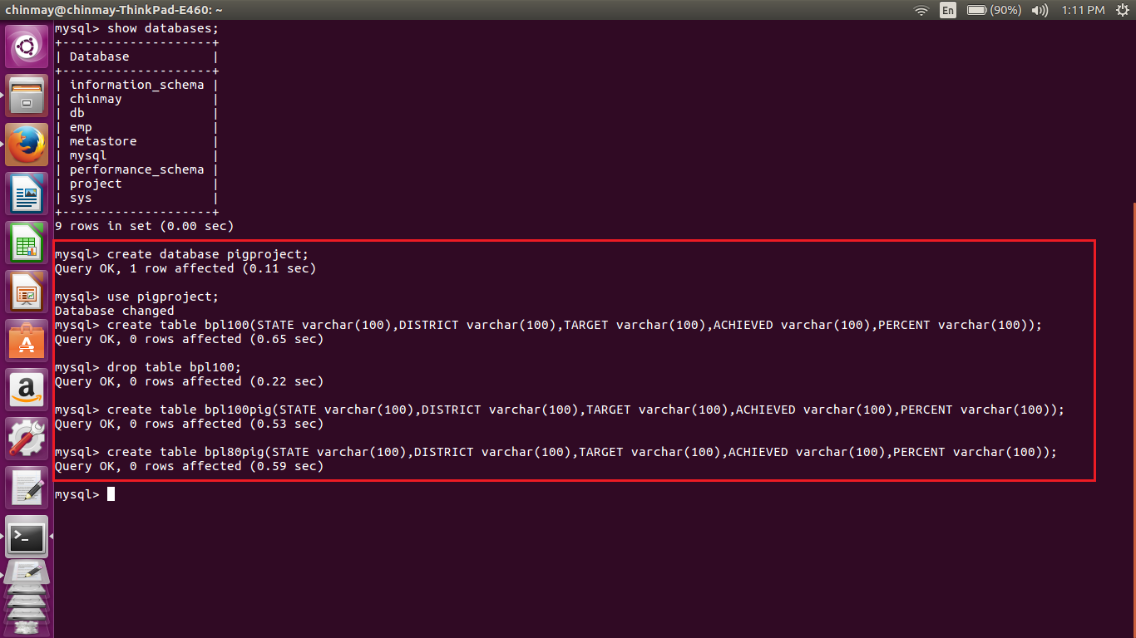

Sqoop job execution

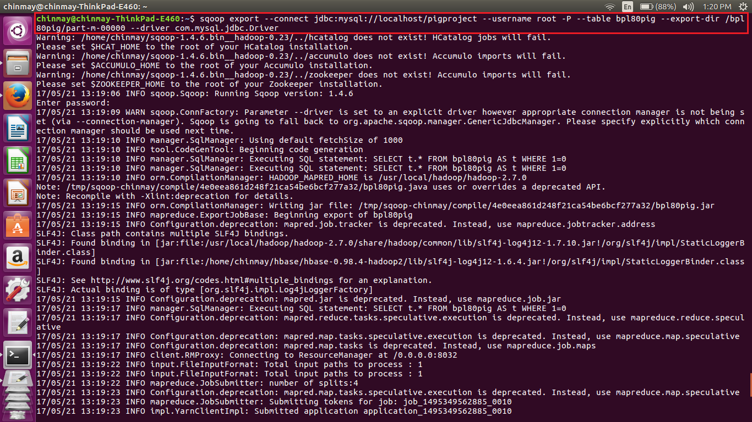

Completion of the sqoop job



Sample output of the sqoop job in mysql db

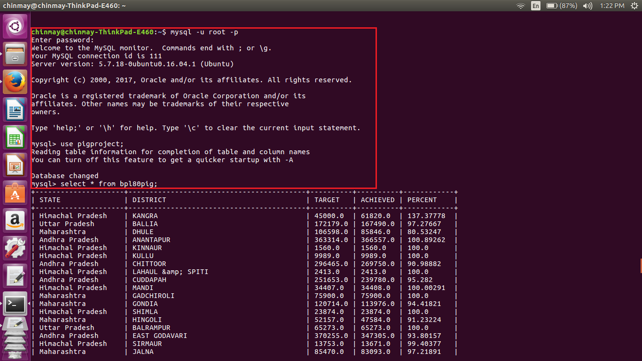

1. **Using Pig Script(Shell Script Execution)**

We are naming the file as pigscript.sh.

The above shell script uses the same jars that were used while implementing the individually steps. Here in the shell script all the steps will be executed at once and the output will be stored in the mysqldb.

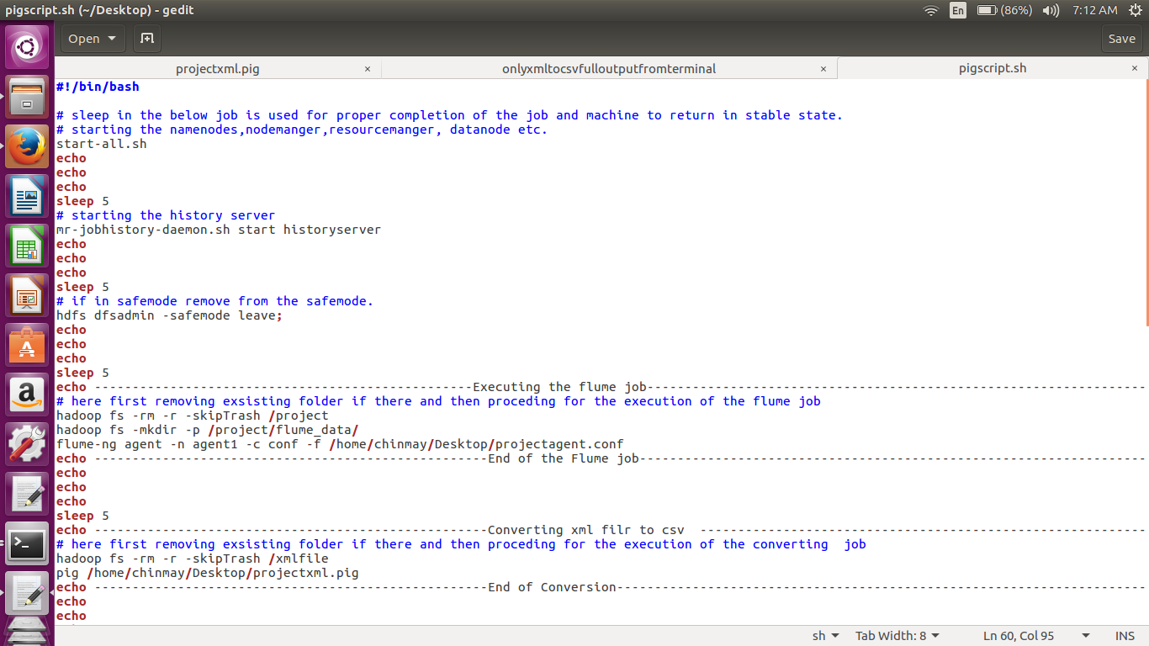

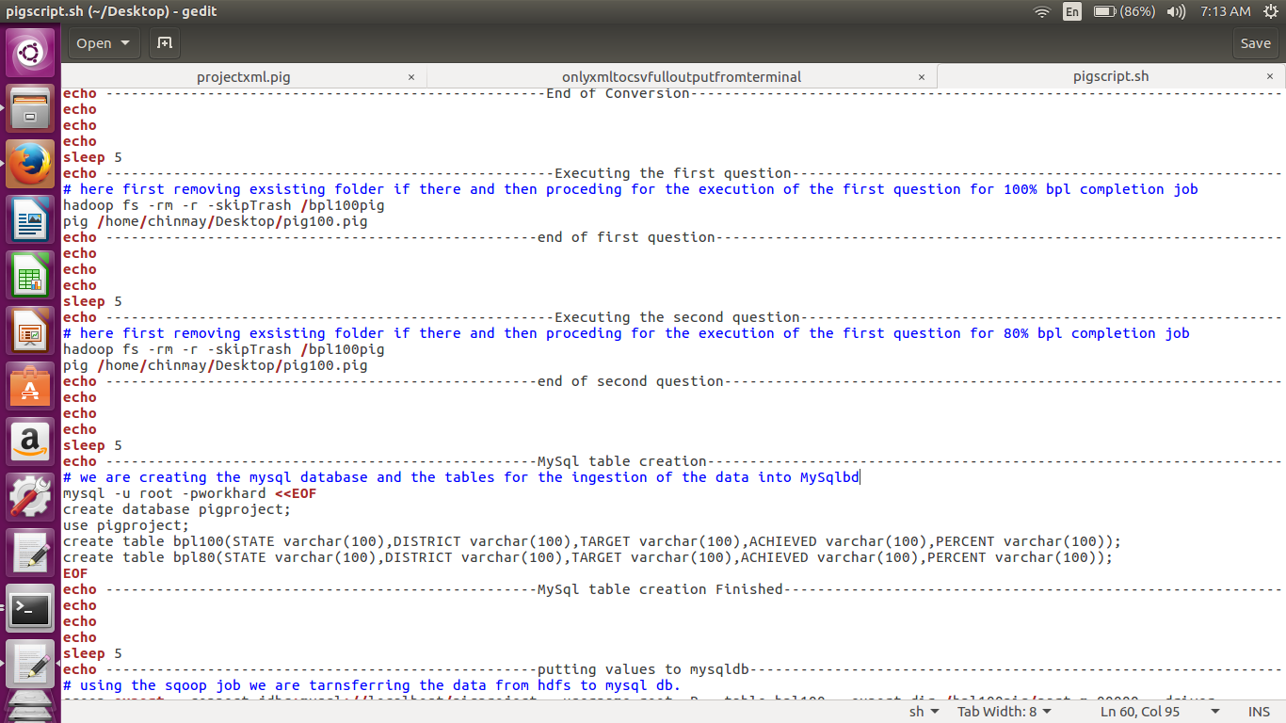

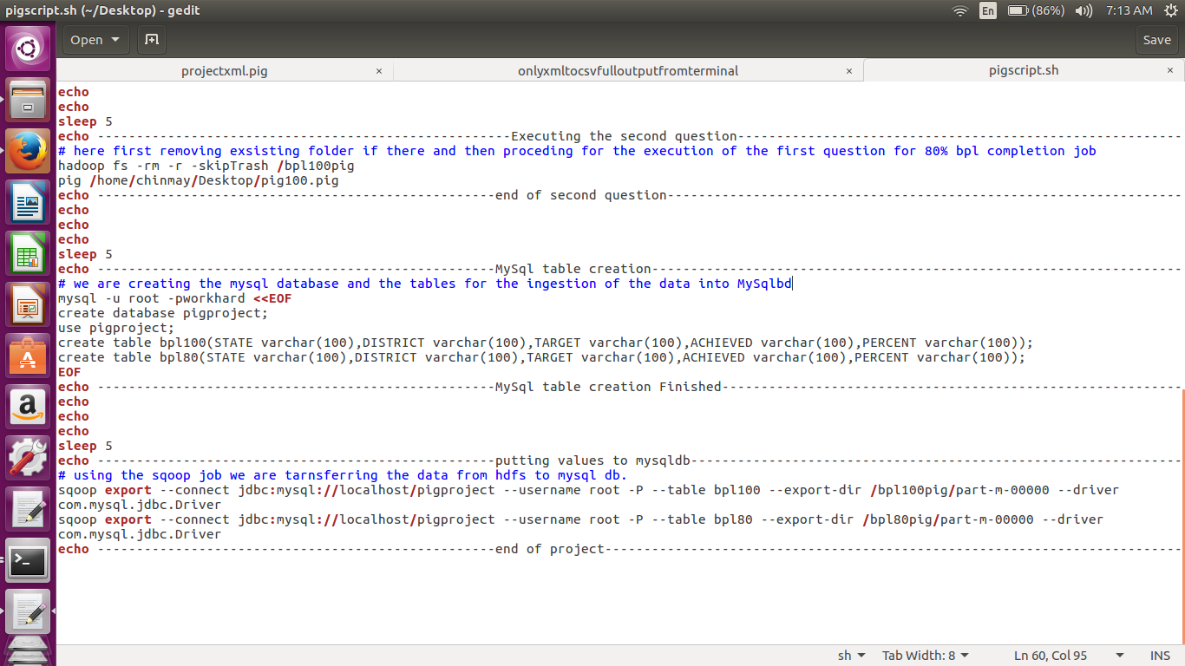

Below are the screen shots of the major part of the execution of the pig script

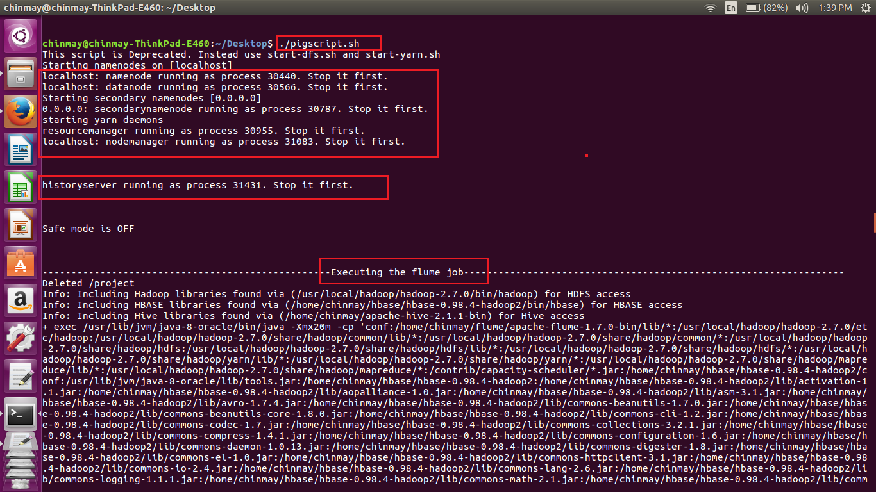

As we know that flume is continuously streaming hence after completion we are kill the flume job by using crlt-c.

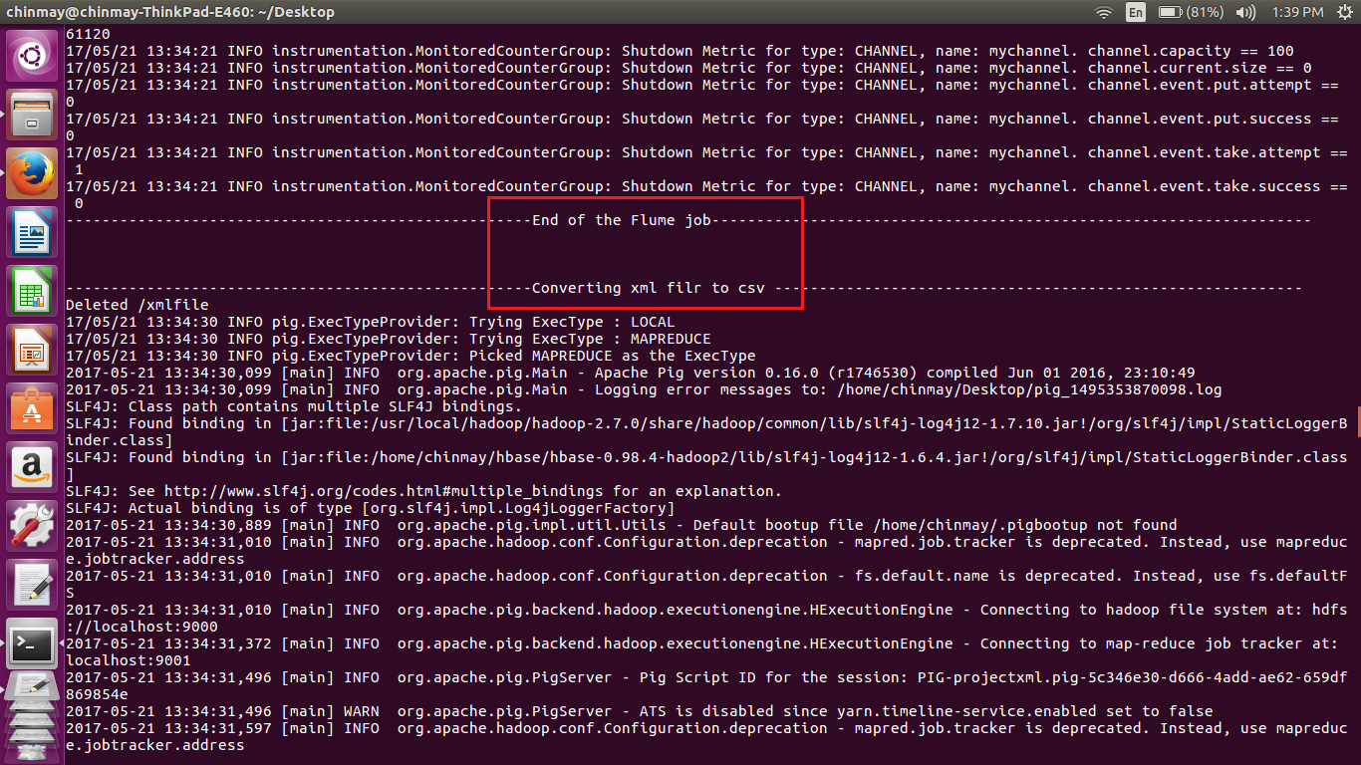

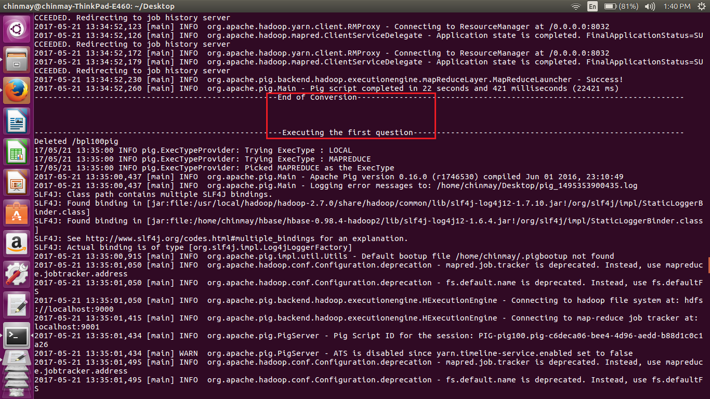

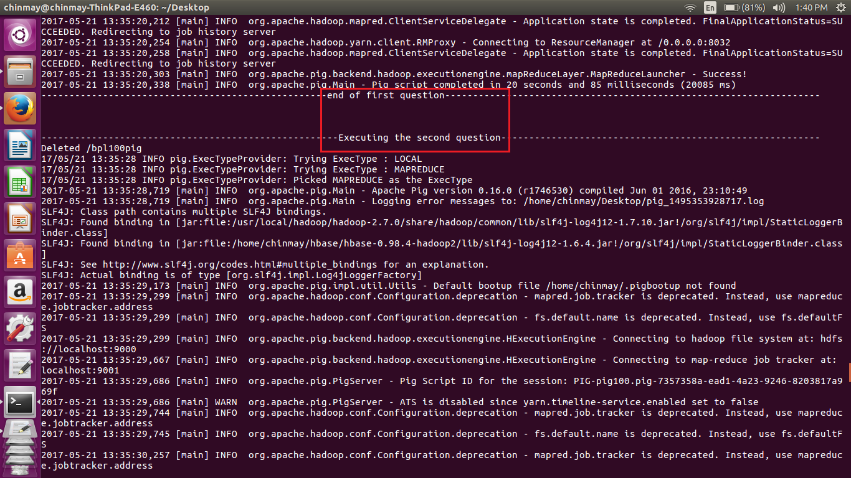

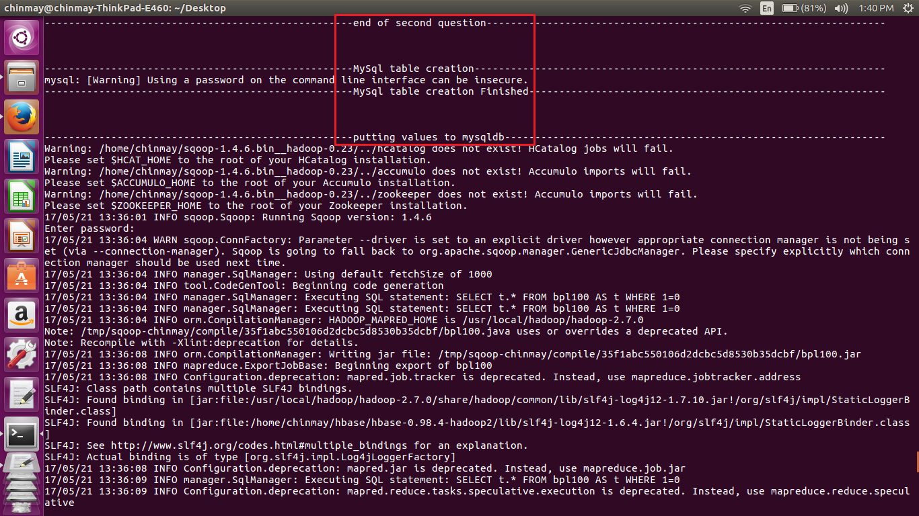

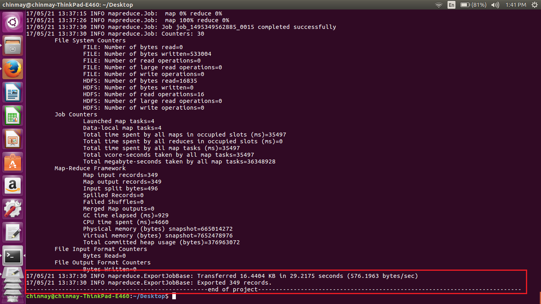

Sample output of the table in mysql db

For 100 % accomplishment

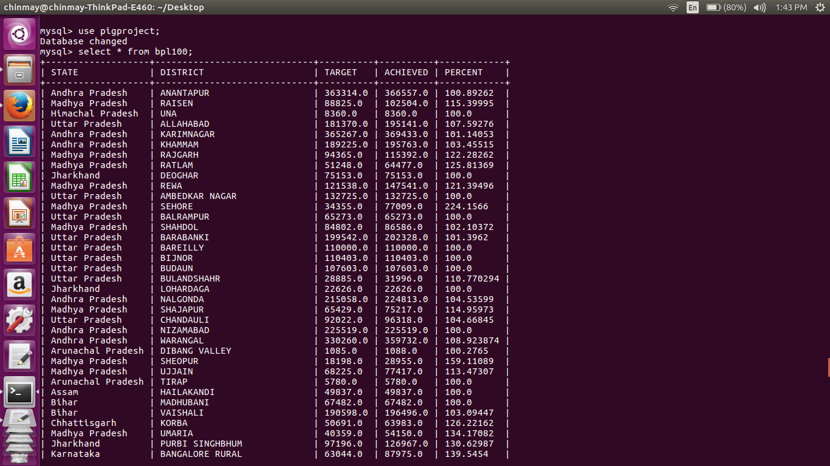

For 80 % accomplishment

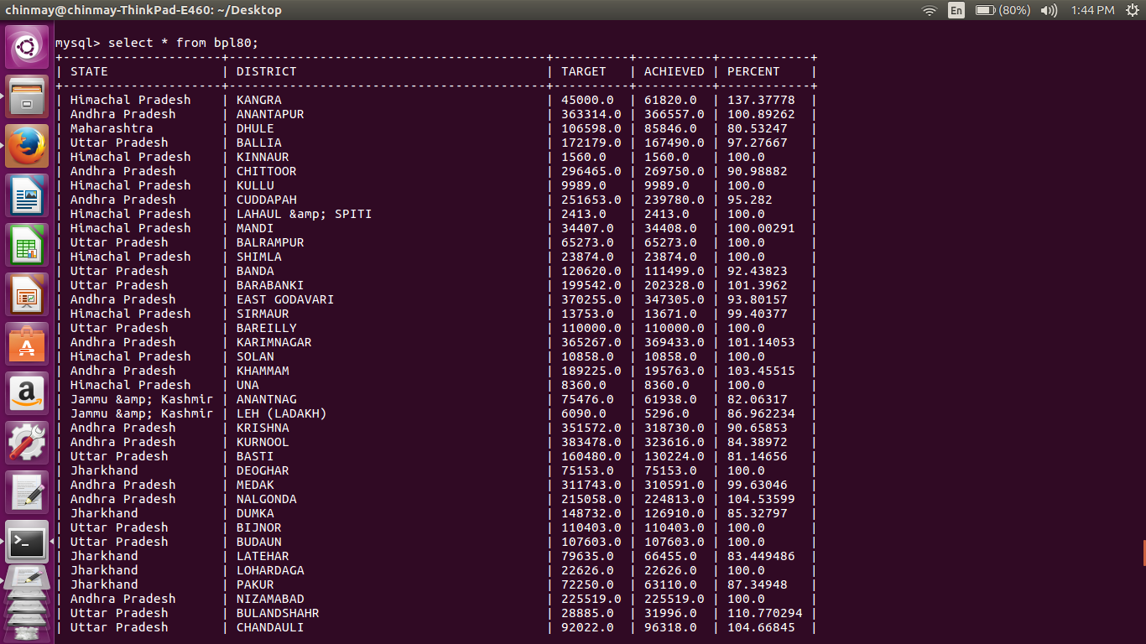

The final output after the execution of the shell scripting from the terminal shown below

mysql> use pigproject;

Database changed

mysql> select * from bpl100;

+-------------------+-----------------------------+----------+----------+------------+

| STATE | DISTRICT | TARGET | ACHIEVED | PERCENT |

+-------------------+-----------------------------+----------+----------+------------+

| Andhra Pradesh | ANANTAPUR | 363314.0 | 366557.0 | 100.89262 |

| Madhya Pradesh | RAISEN | 88825.0 | 102504.0 | 115.39995 |

| Himachal Pradesh | UNA | 8360.0 | 8360.0 | 100.0 |

| Uttar Pradesh | ALLAHABAD | 181370.0 | 195141.0 | 107.59276 |

| Andhra Pradesh | KARIMNAGAR | 365267.0 | 369433.0 | 101.14053 |

| Andhra Pradesh | KHAMMAM | 189225.0 | 195763.0 | 103.45515 |

| Madhya Pradesh | RAJGARH | 94365.0 | 115392.0 | 122.28262 |

| Madhya Pradesh | RATLAM | 51248.0 | 64477.0 | 125.81369 |

| Jharkhand | DEOGHAR | 75153.0 | 75153.0 | 100.0 |

| Madhya Pradesh | REWA | 121538.0 | 147541.0 | 121.39496 |

| Uttar Pradesh | AMBEDKAR NAGAR | 132725.0 | 132725.0 | 100.0 |

| Madhya Pradesh | SEHORE | 34355.0 | 77009.0 | 224.1566 |

| Uttar Pradesh | BALRAMPUR | 65273.0 | 65273.0 | 100.0 |

| Madhya Pradesh | SHAHDOL | 84802.0 | 86586.0 | 102.10372 |

| Uttar Pradesh | BARABANKI | 199542.0 | 202328.0 | 101.3962 |

| Uttar Pradesh | BAREILLY | 110000.0 | 110000.0 | 100.0 |

| Uttar Pradesh | BIJNOR | 110403.0 | 110403.0 | 100.0 |

| Uttar Pradesh | BUDAUN | 107603.0 | 107603.0 | 100.0 |

| Uttar Pradesh | BULANDSHAHR | 28885.0 | 31996.0 | 110.770294 |

| Jharkhand | LOHARDAGA | 22626.0 | 22626.0 | 100.0 |

| Andhra Pradesh | NALGONDA | 215058.0 | 224813.0 | 104.53599 |

| Madhya Pradesh | SHAJAPUR | 65429.0 | 75217.0 | 114.95973 |

| Uttar Pradesh | CHANDAULI | 92022.0 | 96318.0 | 104.66845 |

| Andhra Pradesh | NIZAMABAD | 225519.0 | 225519.0 | 100.0 |

| Andhra Pradesh | WARANGAL | 330260.0 | 359732.0 | 108.923874 |

| Arunachal Pradesh | DIBANG VALLEY | 1085.0 | 1088.0 | 100.2765 |

| Madhya Pradesh | SHEOPUR | 18198.0 | 28955.0 | 159.11089 |

| Madhya Pradesh | UJJAIN | 68225.0 | 77417.0 | 113.47307 |

| Arunachal Pradesh | TIRAP | 5780.0 | 5780.0 | 100.0 |

| Assam | HAILAKANDI | 49837.0 | 49837.0 | 100.0 |

| Bihar | MADHUBANI | 67482.0 | 67482.0 | 100.0 |

| Bihar | VAISHALI | 190598.0 | 196496.0 | 103.09447 |

| Chhattisgarh | KORBA | 50691.0 | 63983.0 | 126.22162 |

| Madhya Pradesh | UMARIA | 40359.0 | 54150.0 | 134.17082 |

| Jharkhand | PURBI SINGHBHUM | 97196.0 | 126967.0 | 130.62987 |

| Karnataka | BANGALORE RURAL | 63044.0 | 87975.0 | 139.5454 |

| Goa | NORTH GOA | 15000.0 | 15000.0 | 100.0 |

| Uttar Pradesh | CHITRAKOOT | 38082.0 | 42652.0 | 112.00042 |

| Uttar Pradesh | ETAH | 62001.0 | 69139.0 | 111.51272 |

| Karnataka | HASSAN | 64134.0 | 64134.0 | 100.0 |

| Karnataka | KOLAR | 43183.0 | 85744.0 | 198.55962 |

| Maharashtra | GADCHIROLI | 75900.0 | 75900.0 | 100.0 |

| Maharashtra | RATNAGIRI | 95726.0 | 102182.0 | 106.744255 |

| Uttar Pradesh | ETAWAH | 94097.0 | 94097.0 | 100.0 |

| Uttar Pradesh | FARRUKHABAD | 120471.0 | 120471.0 | 100.0 |

| Uttar Pradesh | FIROZABAD | 19843.0 | 19843.0 | 100.0 |

| Uttar Pradesh | GHAZIABAD | 10810.0 | 10810.0 | 100.0 |

| Maharashtra | SINDHUDURG | 43874.0 | 43874.0 | 100.0 |

| Gujarat | AHMEDABAD | 80192.0 | 80192.0 | 100.0 |

| Gujarat | BHAVNAGAR | 31305.0 | 31563.0 | 100.82415 |

| Uttar Pradesh | HARDOI | 199989.0 | 199989.0 | 100.0 |

| Uttar Pradesh | JAUNPUR | 250000.0 | 250924.0 | 100.3696 |

| Gujarat | DANGS | 27900.0 | 27900.0 | 100.0 |

| Meghalaya | WEST GARO HILLS | 44385.0 | 44385.0 | 100.0 |

| Mizoram | CHAMPHAI | 11077.0 | 11077.0 | 100.0 |

| Karnataka | MANGALORE(DAKSHINA KANNADA) | 59478.0 | 59478.0 | 100.0 |

| Karnataka | SHIMOGA | 99428.0 | 99996.0 | 100.571266 |

| Karnataka | UDUPI | 52348.0 | 52348.0 | 100.0 |

| Uttar Pradesh | JHANSI | 58826.0 | 59119.0 | 100.49808 |

| Uttar Pradesh | JYOTIBA PHULE NAGAR | 48008.0 | 48008.0 | 100.0 |

| Gujarat | JAMNAGAR | 45478.0 | 47822.0 | 105.154144 |

| Uttar Pradesh | KANNAUJ | 101497.0 | 101616.0 | 100.11724 |

| Uttar Pradesh | LAKHIMPUR KHERI | 73000.0 | 95742.0 | 131.15343 |

| Kerala | ALAPPUZHA | 114359.0 | 114359.0 | 100.0 |

| Gujarat | MAHESANA | 61499.0 | 61938.0 | 100.71384 |

| Uttar Pradesh | LUCKNOW | 113188.0 | 113188.0 | 100.0 |

| Kerala | ERNAKULAM | 54585.0 | 55916.0 | 102.4384 |

| Kerala | IDUKKI | 86535.0 | 89553.0 | 103.48761 |

| Kerala | KANNUR | 34121.0 | 37628.0 | 110.27813 |

| Gujarat | NAVSARI | 75015.0 | 75015.0 | 100.0 |

| Gujarat | PATAN | 58741.0 | 60002.0 | 102.146706 |

| Gujarat | PORBANDAR | 17024.0 | 17024.0 | 100.0 |

| Kerala | KASARGOD | 56965.0 | 59153.0 | 103.84096 |

| Uttar Pradesh | MAHAMAYA NAGAR(HATHRAS) | 25153.0 | 25277.0 | 100.49298 |

| Uttar Pradesh | MAHARAJGANJ | 145090.0 | 145090.0 | 100.0 |

| Kerala | KOLLAM | 95130.0 | 95130.0 | 100.0 |

| Mizoram | LAWNGTLAI | 16544.0 | 16544.0 | 100.0 |

| Punjab | BARNALA | 12137.0 | 12593.0 | 103.75711 |

| Kerala | KOTTAYAM | 28118.0 | 28118.0 | 100.0 |

| Punjab | FATEHGARH SAHIB | 2485.0 | 2630.0 | 105.83501 |

| Gujarat | RAJKOT | 78753.0 | 79436.0 | 100.86727 |

| Gujarat | SURAT | 158797.0 | 158797.0 | 100.0 |

| Kerala | KOZHIKODE | 42285.0 | 42285.0 | 100.0 |

| Kerala | MALAPPURAM | 60592.0 | 61905.0 | 102.166954 |

| Punjab | HOSHIARPUR | 11112.0 | 19094.0 | 171.83224 |

| Uttar Pradesh | MAHOBA | 53117.0 | 53117.0 | 100.0 |

| Uttar Pradesh | MATHURA | 25005.0 | 25110.0 | 100.419914 |

| Uttar Pradesh | MIRZAPUR | 231315.0 | 233308.0 | 100.861595 |

| Gujarat | VALSAD | 85274.0 | 109073.0 | 127.90886 |

| Kerala | PALAKKAD | 107018.0 | 107018.0 | 100.0 |

| Haryana | BHIWANI | 48947.0 | 49247.0 | 100.6129 |

| Uttar Pradesh | MORADABAD | 76018.0 | 76018.0 | 100.0 |

| Kerala | PATHANAMTHITTA | 53799.0 | 53799.0 | 100.0 |

| Kerala | THIRUVANANTHAPURAM | 129000.0 | 137004.0 | 106.20465 |

| Kerala | THRISSUR | 48669.0 | 51017.0 | 104.824425 |

| Punjab | LUDHIANA | 45422.0 | 46920.0 | 103.29796 |

| Punjab | NAWANSHAHR | 7273.0 | 11581.0 | 159.23279 |

| Uttar Pradesh | MUZAFFARNAGAR | 51660.0 | 51660.0 | 100.0 |

| Kerala | WAYANAD | 50655.0 | 50655.0 | 100.0 |

| Madhya Pradesh | ALIRAJPUR | 38225.0 | 52971.0 | 138.57686 |

| Punjab | S.A.S Nagar | 4008.0 | 4025.0 | 100.42415 |

| Rajasthan | HANUMANGARH | 31621.0 | 31621.0 | 100.0 |

| Sikkim | EAST SIKKIM | 24109.0 | 26852.0 | 111.37749 |

| Sikkim | NORTH SIKKIM | 4978.0 | 5461.0 | 109.7027 |

| Madhya Pradesh | ANUPPUR | 39615.0 | 55336.0 | 139.68446 |

| Uttar Pradesh | PILIBHIT | 95178.0 | 95178.0 | 100.0 |

| Uttar Pradesh | PRATAPGARH | 141368.0 | 143517.0 | 101.52014 |

| Madhya Pradesh | BARWANI | 75695.0 | 84663.0 | 111.84754 |

| Madhya Pradesh | BETUL | 43427.0 | 43688.0 | 100.601006 |

| Madhya Pradesh | BHOPAL | 20010.0 | 31380.0 | 156.82158 |

| Uttar Pradesh | RAE BARELI | 190306.0 | 190430.0 | 100.06516 |

| Madhya Pradesh | BURHANPUR | 41047.0 | 43340.0 | 105.58628 |

| Madhya Pradesh | DATIA | 11997.0 | 18386.0 | 153.25499 |

| Madhya Pradesh | DEWAS | 59245.0 | 79734.0 | 134.58351 |

| Madhya Pradesh | DHAR | 100281.0 | 119944.0 | 119.6079 |

| Sikkim | SOUTH SIKKIM | 8970.0 | 12446.0 | 138.75139 |

| Sikkim | WEST SIKKIM | 13245.0 | 13345.0 | 100.755 |

| Uttar Pradesh | SAHARANPUR | 49458.0 | 49586.0 | 100.258804 |

| Uttar Pradesh | SHAHJAHANPUR | 194645.0 | 194959.0 | 100.161316 |

| Haryana | FARIDABAD | 22254.0 | 22254.0 | 100.0 |

| Uttar Pradesh | SONBHADRA | 138370.0 | 138370.0 | 100.0 |

| Uttar Pradesh | SULTANPUR | 168843.0 | 168843.0 | 100.0 |

| Uttarakhand | NAINITAL | 14314.0 | 18039.0 | 126.02347 |

| Madhya Pradesh | GWALIOR | 32128.0 | 39081.0 | 121.64156 |

| Haryana | GURGAON | 10522.0 | 14822.0 | 140.86676 |

| Madhya Pradesh | HARDA | 23589.0 | 31545.0 | 133.72758 |

| Madhya Pradesh | HOSHANGABAD | 50677.0 | 83469.0 | 164.70786 |

| Tamil Nadu | DHARMAPURI | 152872.0 | 152921.0 | 100.03206 |

| Tamil Nadu | ERODE | 165306.0 | 165306.0 | 100.0 |

| Madhya Pradesh | INDORE | 48998.0 | 50152.0 | 102.355194 |

| Madhya Pradesh | JABALPUR | 106290.0 | 117804.0 | 110.832634 |

| Haryana | HISAR | 46463.0 | 46463.0 | 100.0 |

| Haryana | JHAJJAR | 22014.0 | 22014.0 | 100.0 |

| Tamil Nadu | KANCHIPURAM | 147350.0 | 154480.0 | 104.83882 |

| Tamil Nadu | KANYAKUMARI(NAGERCOIL) | 76233.0 | 84822.0 | 111.26678 |

| Uttarakhand | RUDRAPRAYAG | 13150.0 | 13810.0 | 105.01901 |

| West Bengal | DAKSHIN DINAJPUR | 182621.0 | 184153.0 | 100.8389 |

| Haryana | KARNAL | 45973.0 | 46015.0 | 100.09136 |

| Haryana | KURUKSHETRA | 30598.0 | 30681.0 | 100.27126 |

| Haryana | MAHENDRAGARH | 17500.0 | 17500.0 | 100.0 |

| Madhya Pradesh | JHABUA | 81491.0 | 94244.0 | 115.64958 |

| Madhya Pradesh | KATNI | 53000.0 | 68295.0 | 128.85849 |

| Madhya Pradesh | KHANDWA(EAST NIMAR) | 60123.0 | 82598.0 | 137.3817 |

| Tamil Nadu | KARUR | 105280.0 | 105280.0 | 100.0 |

| Tamil Nadu | NAMAKKAL | 117538.0 | 117538.0 | 100.0 |

| Tamil Nadu | PUDUKKOTTAI | 176710.0 | 198097.0 | 112.102875 |

| Madhya Pradesh | KHARGONE | 91083.0 | 91458.0 | 100.41171 |

| Haryana | PANCHKULA | 8760.0 | 8760.0 | 100.0 |

| Haryana | PANIPAT | 28000.0 | 28000.0 | 100.0 |

| Madhya Pradesh | MANDSAUR | 46666.0 | 67848.0 | 145.39066 |

| Madhya Pradesh | MORENA | 32478.0 | 39727.0 | 122.319725 |

| Haryana | ROHTAK | 22171.0 | 22171.0 | 100.0 |

| West Bengal | MIDNAPUR EAST | 392371.0 | 527389.0 | 134.4108 |

| West Bengal | MIDNAPUR WEST | 509496.0 | 596291.0 | 117.03546 |

| Madhya Pradesh | NEEMUCH | 27790.0 | 42843.0 | 154.16696 |

| Haryana | SIRSA | 35400.0 | 35400.0 | 100.0 |

| Haryana | SONIPAT | 29808.0 | 30300.0 | 101.65056 |

| Tamil Nadu | RAMANATHAPURAM | 105000.0 | 156708.0 | 149.24571 |

| Tamil Nadu | TIRUCHIRAPPALLI | 77747.0 | 77747.0 | 100.0 |

| Tamil Nadu | TIRUNELVELI | 125763.0 | 139323.0 | 110.78218 |

| Tamil Nadu | TIRUVANNAMALAI | 209116.0 | 209116.0 | 100.0 |

| Tamil Nadu | TIRUVARUR | 80920.0 | 87918.0 | 108.64805 |

| Tripura | DHALAI | 53507.0 | 53507.0 | 100.0 |

| Tripura | SOUTH TRIPURA | 139456.0 | 139456.0 | 100.0 |

| Tripura | WEST TRIPURA | 183405.0 | 183405.0 | 100.0 |

| Uttar Pradesh | AGRA | 54188.0 | 54789.0 | 101.1091 |

| Himachal Pradesh | BILASPUR | 11931.0 | 13078.0 | 109.61361 |

| Himachal Pradesh | CHAMBA | 44429.0 | 58422.0 | 131.4952 |

| Himachal Pradesh | HAMIRPUR | 11593.0 | 11593.0 | 100.0 |

| Himachal Pradesh | KANGRA | 45000.0 | 61820.0 | 137.37778 |

| Himachal Pradesh | KINNAUR | 1560.0 | 1560.0 | 100.0 |

| Himachal Pradesh | KULLU | 9989.0 | 9989.0 | 100.0 |

| Himachal Pradesh | LAHAUL &amp; SPITI | 2413.0 | 2413.0 | 100.0 |

| Himachal Pradesh | MANDI | 34407.0 | 34408.0 | 100.00291 |

| Himachal Pradesh | SHIMLA | 23874.0 | 23874.0 | 100.0 |

| Himachal Pradesh | SOLAN | 10858.0 | 10858.0 | 100.0 |

+-------------------+-----------------------------+----------+----------+------------+

176 rows in set (0.01 sec)

mysql> select * from bpl80;

+---------------------+------------------------------------------+----------+----------+------------+

| STATE | DISTRICT | TARGET | ACHIEVED | PERCENT |

+---------------------+------------------------------------------+----------+----------+------------+

| Himachal Pradesh | KANGRA | 45000.0 | 61820.0 | 137.37778 |

| Andhra Pradesh | ANANTAPUR | 363314.0 | 366557.0 | 100.89262 |

| Maharashtra | DHULE | 106598.0 | 85846.0 | 80.53247 |

| Uttar Pradesh | BALLIA | 172179.0 | 167490.0 | 97.27667 |

| Himachal Pradesh | KINNAUR | 1560.0 | 1560.0 | 100.0 |

| Andhra Pradesh | CHITTOOR | 296465.0 | 269750.0 | 90.98882 |

| Himachal Pradesh | KULLU | 9989.0 | 9989.0 | 100.0 |

| Andhra Pradesh | CUDDAPAH | 251653.0 | 239780.0 | 95.282 |

| Himachal Pradesh | LAHAUL &amp; SPITI | 2413.0 | 2413.0 | 100.0 |

| Himachal Pradesh | MANDI | 34407.0 | 34408.0 | 100.00291 |

| Uttar Pradesh | BALRAMPUR | 65273.0 | 65273.0 | 100.0 |

| Himachal Pradesh | SHIMLA | 23874.0 | 23874.0 | 100.0 |

| Uttar Pradesh | BANDA | 120620.0 | 111499.0 | 92.43823 |

| Uttar Pradesh | BARABANKI | 199542.0 | 202328.0 | 101.3962 |

| Andhra Pradesh | EAST GODAVARI | 370255.0 | 347305.0 | 93.80157 |

| Himachal Pradesh | SIRMAUR | 13753.0 | 13671.0 | 99.40377 |

| Uttar Pradesh | BAREILLY | 110000.0 | 110000.0 | 100.0 |

| Andhra Pradesh | KARIMNAGAR | 365267.0 | 369433.0 | 101.14053 |

| Himachal Pradesh | SOLAN | 10858.0 | 10858.0 | 100.0 |

| Andhra Pradesh | KHAMMAM | 189225.0 | 195763.0 | 103.45515 |

| Himachal Pradesh | UNA | 8360.0 | 8360.0 | 100.0 |

| Jammu &amp; Kashmir | ANANTNAG | 75476.0 | 61938.0 | 82.06317 |

| Jammu &amp; Kashmir | LEH (LADAKH) | 6090.0 | 5296.0 | 86.962234 |

| Andhra Pradesh | KRISHNA | 351572.0 | 318730.0 | 90.65853 |

| Andhra Pradesh | KURNOOL | 383478.0 | 323616.0 | 84.38972 |

| Uttar Pradesh | BASTI | 160480.0 | 130224.0 | 81.14656 |

| Jharkhand | DEOGHAR | 75153.0 | 75153.0 | 100.0 |

| Andhra Pradesh | MEDAK | 311743.0 | 310591.0 | 99.63046 |

| Andhra Pradesh | NALGONDA | 215058.0 | 224813.0 | 104.53599 |

| Jharkhand | DUMKA | 148732.0 | 126910.0 | 85.32797 |

| Uttar Pradesh | BIJNOR | 110403.0 | 110403.0 | 100.0 |

| Uttar Pradesh | BUDAUN | 107603.0 | 107603.0 | 100.0 |

| Jharkhand | LATEHAR | 79635.0 | 66455.0 | 83.449486 |

| Jharkhand | LOHARDAGA | 22626.0 | 22626.0 | 100.0 |

| Jharkhand | PAKUR | 72250.0 | 63110.0 | 87.34948 |

| Andhra Pradesh | NIZAMABAD | 225519.0 | 225519.0 | 100.0 |

| Uttar Pradesh | BULANDSHAHR | 28885.0 | 31996.0 | 110.770294 |

| Uttar Pradesh | CHANDAULI | 92022.0 | 96318.0 | 104.66845 |

| Uttar Pradesh | CHITRAKOOT | 38082.0 | 42652.0 | 112.00042 |

| Uttar Pradesh | DEORIA | 181225.0 | 172222.0 | 95.03214 |

| Uttar Pradesh | ETAH | 62001.0 | 69139.0 | 111.51272 |

| Uttar Pradesh | ETAWAH | 94097.0 | 94097.0 | 100.0 |

| Uttar Pradesh | FAIZABAD | 103376.0 | 101638.0 | 98.31876 |

| Uttar Pradesh | FARRUKHABAD | 120471.0 | 120471.0 | 100.0 |

| Uttar Pradesh | FATEHPUR | 104414.0 | 99961.0 | 95.735245 |

| Uttar Pradesh | FIROZABAD | 19843.0 | 19843.0 | 100.0 |

| Uttar Pradesh | GAUTAM BUDDHA NAGAR | 14574.0 | 14302.0 | 98.13367 |

| Jharkhand | PURBI SINGHBHUM | 97196.0 | 126967.0 | 130.62987 |

| Karnataka | BAGALKOT | 74926.0 | 68863.0 | 91.90801 |

| Karnataka | BANGALORE RURAL | 63044.0 | 87975.0 | 139.5454 |

| Karnataka | CHICKMAGALUR | 67568.0 | 64863.0 | 95.99663 |

| Uttar Pradesh | GHAZIABAD | 10810.0 | 10810.0 | 100.0 |

| Andhra Pradesh | RANGAREDDI | 212629.0 | 174460.0 | 82.04901 |

| Uttar Pradesh | GHAZIPUR | 184061.0 | 182471.0 | 99.136154 |

| Karnataka | CHITRADURGA | 75400.0 | 73585.0 | 97.592834 |

| Karnataka | DHARWAD | 53596.0 | 49843.0 | 92.99761 |

| Andhra Pradesh | WARANGAL | 330260.0 | 359732.0 | 108.923874 |

| Karnataka | GADAG | 46821.0 | 39414.0 | 84.180176 |

| Karnataka | HASSAN | 64134.0 | 64134.0 | 100.0 |

| Karnataka | KODAGU | 38838.0 | 38638.0 | 99.48504 |

| Karnataka | KOLAR | 43183.0 | 85744.0 | 198.55962 |

| Karnataka | KOPPAL | 60869.0 | 53275.0 | 87.524025 |

| Andhra Pradesh | WEST GODAVARI | 344272.0 | 319477.0 | 92.797844 |

| Karnataka | MANDYA | 128782.0 | 116773.0 | 90.674934 |

| Uttar Pradesh | GONDA | 136500.0 | 118593.0 | 86.88132 |

| Arunachal Pradesh | DIBANG VALLEY | 1085.0 | 1088.0 | 100.2765 |

| Uttar Pradesh | GORAKHPUR | 211033.0 | 211010.0 | 99.9891 |

| Uttar Pradesh | HAMIRPUR | 101382.0 | 85181.0 | 84.019844 |

| Uttar Pradesh | HARDOI | 199989.0 | 199989.0 | 100.0 |

| Uttar Pradesh | JALAUN | 101928.0 | 90824.0 | 89.10603 |

| Uttar Pradesh | JAUNPUR | 250000.0 | 250924.0 | 100.3696 |

| Karnataka | MANGALORE(DAKSHINA KANNADA) | 59478.0 | 59478.0 | 100.0 |

| Karnataka | RAMANAGARA | 41876.0 | 37293.0 | 89.055786 |

| Arunachal Pradesh | LOHIT | 8800.0 | 8410.0 | 95.56818 |

| Uttar Pradesh | JHANSI | 58826.0 | 59119.0 | 100.49808 |

| Uttar Pradesh | JYOTIBA PHULE NAGAR | 48008.0 | 48008.0 | 100.0 |

| Karnataka | SHIMOGA | 99428.0 | 99996.0 | 100.571266 |

| Uttar Pradesh | KANNAUJ | 101497.0 | 101616.0 | 100.11724 |

| Uttar Pradesh | KANPUR DEHAT | 126650.0 | 121414.0 | 95.865776 |

| Uttar Pradesh | KANPUR NAGAR | 87235.0 | 81750.0 | 93.71239 |

| Uttar Pradesh | KAUSHAMBI | 127875.0 | 123820.0 | 96.82893 |

| Arunachal Pradesh | TIRAP | 5780.0 | 5780.0 | 100.0 |

| Assam | BAGSHA | 85697.0 | 73500.0 | 85.767296 |

| Karnataka | UDUPI | 52348.0 | 52348.0 | 100.0 |

| Uttar Pradesh | KUSHINAGAR | 287089.0 | 236062.0 | 82.22607 |

| Uttar Pradesh | LAKHIMPUR KHERI | 73000.0 | 95742.0 | 131.15343 |

| Assam | CACHAR | 119931.0 | 101075.0 | 84.277626 |

| Assam | DIBRUGARH | 77606.0 | 69914.0 | 90.088394 |

| Uttar Pradesh | LALITPUR | 90107.0 | 89046.0 | 98.82251 |

| Kerala | ALAPPUZHA | 114359.0 | 114359.0 | 100.0 |

| Kerala | ERNAKULAM | 54585.0 | 55916.0 | 102.4384 |

| Kerala | IDUKKI | 86535.0 | 89553.0 | 103.48761 |

| Kerala | KANNUR | 34121.0 | 37628.0 | 110.27813 |

| Kerala | KASARGOD | 56965.0 | 59153.0 | 103.84096 |

| Assam | GOALPARA | 65070.0 | 55747.0 | 85.672356 |

| Kerala | KOLLAM | 95130.0 | 95130.0 | 100.0 |

| Kerala | KOTTAYAM | 28118.0 | 28118.0 | 100.0 |

| Kerala | KOZHIKODE | 42285.0 | 42285.0 | 100.0 |

| Kerala | MALAPPURAM | 60592.0 | 61905.0 | 102.166954 |

| Assam | GOLAGHAT | 79743.0 | 77985.0 | 97.79542 |

| Kerala | PALAKKAD | 107018.0 | 107018.0 | 100.0 |

| Kerala | PATHANAMTHITTA | 53799.0 | 53799.0 | 100.0 |

| Kerala | THIRUVANANTHAPURAM | 129000.0 | 137004.0 | 106.20465 |

| Kerala | THRISSUR | 48669.0 | 51017.0 | 104.824425 |

| Kerala | WAYANAD | 50655.0 | 50655.0 | 100.0 |

| Madhya Pradesh | ALIRAJPUR | 38225.0 | 52971.0 | 138.57686 |

| Assam | HAILAKANDI | 49837.0 | 49837.0 | 100.0 |

| Assam | JORHAT | 65070.0 | 52698.0 | 80.98663 |

| Assam | KAMRUP | 85785.0 | 84725.0 | 98.76435 |

| Madhya Pradesh | ANUPPUR | 39615.0 | 55336.0 | 139.68446 |

| Madhya Pradesh | BARWANI | 75695.0 | 84663.0 | 111.84754 |

| Assam | KARIMGANJ | 78992.0 | 75800.0 | 95.95908 |

| Assam | KOKRAJHAR | 84830.0 | 75889.0 | 89.4601 |

| Uttar Pradesh | LUCKNOW | 113188.0 | 113188.0 | 100.0 |

| Uttar Pradesh | MAHAMAYA NAGAR(HATHRAS) | 25153.0 | 25277.0 | 100.49298 |

| Madhya Pradesh | BETUL | 43427.0 | 43688.0 | 100.601006 |

| Assam | LAKHIMPUR | 73224.0 | 60821.0 | 83.06156 |

| Assam | MARIGAON | 60770.0 | 56490.0 | 92.95705 |

| Uttar Pradesh | MAHARAJGANJ | 145090.0 | 145090.0 | 100.0 |

| Uttar Pradesh | MAHOBA | 53117.0 | 53117.0 | 100.0 |

| Assam | NAGAON | 168391.0 | 158290.0 | 94.00146 |

| Assam | SIBSAGAR | 74686.0 | 63774.0 | 85.389496 |

| Assam | SONITPUR | 120048.0 | 101250.0 | 84.34126 |

| Assam | TINSUKIA | 68774.0 | 58808.0 | 85.509056 |

| Bihar | BEGUSARAI | 192877.0 | 168344.0 | 87.280495 |

| Madhya Pradesh | BHOPAL | 20010.0 | 31380.0 | 156.82158 |

| Uttar Pradesh | MAINPURI | 84258.0 | 77399.0 | 91.85953 |

| Madhya Pradesh | BURHANPUR | 41047.0 | 43340.0 | 105.58628 |

| Bihar | MADHUBANI | 67482.0 | 67482.0 | 100.0 |

| Bihar | MUZAFFARPUR | 333183.0 | 321510.0 | 96.49652 |

| Uttar Pradesh | MATHURA | 25005.0 | 25110.0 | 100.419914 |

| Uttar Pradesh | MAU | 133766.0 | 108577.0 | 81.16936 |

| Uttar Pradesh | MEERUT | 25514.0 | 25357.0 | 99.38465 |

| Uttar Pradesh | MIRZAPUR | 231315.0 | 233308.0 | 100.861595 |

| Madhya Pradesh | DATIA | 11997.0 | 18386.0 | 153.25499 |

| Madhya Pradesh | DEWAS | 59245.0 | 79734.0 | 134.58351 |

| Bihar | SAHARSA | 101440.0 | 83048.0 | 81.86909 |

| Uttar Pradesh | MORADABAD | 76018.0 | 76018.0 | 100.0 |

| Bihar | VAISHALI | 190598.0 | 196496.0 | 103.09447 |

| Madhya Pradesh | DHAR | 100281.0 | 119944.0 | 119.6079 |

| Madhya Pradesh | DINDORI | 63701.0 | 59880.0 | 94.00166 |

| Madhya Pradesh | GUNA | 53901.0 | 43146.0 | 80.04675 |

| Madhya Pradesh | GWALIOR | 32128.0 | 39081.0 | 121.64156 |

| Uttar Pradesh | MUZAFFARNAGAR | 51660.0 | 51660.0 | 100.0 |

| Uttar Pradesh | PILIBHIT | 95178.0 | 95178.0 | 100.0 |

| Madhya Pradesh | HARDA | 23589.0 | 31545.0 | 133.72758 |

| Madhya Pradesh | HOSHANGABAD | 50677.0 | 83469.0 | 164.70786 |

| Madhya Pradesh | INDORE | 48998.0 | 50152.0 | 102.355194 |

| Uttar Pradesh | PRATAPGARH | 141368.0 | 143517.0 | 101.52014 |

| Uttar Pradesh | RAE BARELI | 190306.0 | 190430.0 | 100.06516 |

| Uttar Pradesh | RAMPUR | 56948.0 | 51954.0 | 91.2306 |

| Chhattisgarh | DHAMTARI | 38501.0 | 32195.0 | 83.6212 |

| Chhattisgarh | JASHPUR | 56623.0 | 56014.0 | 98.92446 |

| Madhya Pradesh | JABALPUR | 106290.0 | 117804.0 | 110.832634 |

| Chhattisgarh | KANKER | 50835.0 | 41245.0 | 81.13505 |

| Chhattisgarh | KORBA | 50691.0 | 63983.0 | 126.22162 |

| Uttar Pradesh | SAHARANPUR | 49458.0 | 49586.0 | 100.258804 |

| Uttar Pradesh | SANT RAVIDAS NAGAR( BHADOHI) | 75119.0 | 69904.0 | 93.05768 |

| Uttar Pradesh | SHAHJAHANPUR | 194645.0 | 194959.0 | 100.161316 |

| Uttar Pradesh | SHRAVASTI | 104902.0 | 98761.0 | 94.145966 |

| Madhya Pradesh | JHABUA | 81491.0 | 94244.0 | 115.64958 |

| Madhya Pradesh | KATNI | 53000.0 | 68295.0 | 128.85849 |

| Madhya Pradesh | KHANDWA(EAST NIMAR) | 60123.0 | 82598.0 | 137.3817 |

| Uttar Pradesh | SIDDHARTHNAGAR | 139597.0 | 124597.0 | 89.25478 |

| Uttar Pradesh | SITAPUR | 305299.0 | 273463.0 | 89.57219 |

| Chhattisgarh | KORIYA | 38296.0 | 30664.0 | 80.07103 |

| Chhattisgarh | SURGUJA | 168885.0 | 140083.0 | 82.94579 |

| Goa | NORTH GOA | 15000.0 | 15000.0 | 100.0 |

| Uttar Pradesh | SONBHADRA | 138370.0 | 138370.0 | 100.0 |

| Uttar Pradesh | SULTANPUR | 168843.0 | 168843.0 | 100.0 |

| Uttar Pradesh | UNNAO | 229599.0 | 223630.0 | 97.400246 |

| Gujarat | AHMEDABAD | 80192.0 | 80192.0 | 100.0 |

| Gujarat | AMRELI | 67802.0 | 61990.0 | 91.42798 |

| Madhya Pradesh | KHARGONE | 91083.0 | 91458.0 | 100.41171 |

| Madhya Pradesh | MANDLA | 98650.0 | 81286.0 | 82.39838 |

| Madhya Pradesh | MANDSAUR | 46666.0 | 67848.0 | 145.39066 |

| Madhya Pradesh | MORENA | 32478.0 | 39727.0 | 122.319725 |

| Madhya Pradesh | NARSINGHPUR | 67857.0 | 66714.0 | 98.315575 |

| Uttar Pradesh | VARANASI | 105408.0 | 102430.0 | 97.17479 |

| Uttarakhand | BAGESHWAR | 21447.0 | 17859.0 | 83.270386 |

| Uttarakhand | CHAMOLI | 27147.0 | 26043.0 | 95.93325 |

| Uttarakhand | DEHRADUN | 37212.0 | 31724.0 | 85.25207 |

| Madhya Pradesh | NEEMUCH | 27790.0 | 42843.0 | 154.16696 |

| Madhya Pradesh | RAISEN | 88825.0 | 102504.0 | 115.39995 |

| Madhya Pradesh | RAJGARH | 94365.0 | 115392.0 | 122.28262 |

| Gujarat | ANAND | 72058.0 | 69832.0 | 96.91082 |

| Uttarakhand | HARIDWAR | 42500.0 | 38188.0 | 89.85412 |

| Uttarakhand | NAINITAL | 14314.0 | 18039.0 | 126.02347 |

| Madhya Pradesh | RATLAM | 51248.0 | 64477.0 | 125.81369 |

| Uttarakhand | PITHORAGARH | 41110.0 | 34597.0 | 84.15714 |

| Uttarakhand | RUDRAPRAYAG | 13150.0 | 13810.0 | 105.01901 |

| Gujarat | BANAS KANTHA | 126536.0 | 125652.0 | 99.301384 |

| Madhya Pradesh | REWA | 121538.0 | 147541.0 | 121.39496 |

| Madhya Pradesh | SEHORE | 34355.0 | 77009.0 | 224.1566 |

| Madhya Pradesh | SEONI | 104769.0 | 92862.0 | 88.634995 |

| Madhya Pradesh | SHAHDOL | 84802.0 | 86586.0 | 102.10372 |

| Madhya Pradesh | SHAJAPUR | 65429.0 | 75217.0 | 114.95973 |

| Madhya Pradesh | SHEOPUR | 18198.0 | 28955.0 | 159.11089 |

| Madhya Pradesh | SINGRAULI | 53722.0 | 53354.0 | 99.314995 |

| Madhya Pradesh | UJJAIN | 68225.0 | 77417.0 | 113.47307 |

| Madhya Pradesh | UMARIA | 40359.0 | 54150.0 | 134.17082 |

| Madhya Pradesh | VIDISHA | 96852.0 | 82923.0 | 85.61826 |

| Maharashtra | AHMEDNAGAR | 134247.0 | 132145.0 | 98.43423 |

| Uttarakhand | TEHRI GARHWAL | 55173.0 | 46293.0 | 83.905174 |

| Gujarat | BHARUCH | 78463.0 | 75199.0 | 95.84008 |

| Gujarat | BHAVNAGAR | 31305.0 | 31563.0 | 100.82415 |

| Gujarat | DAHOD | 134798.0 | 131790.0 | 97.76852 |

| Uttarakhand | UDHAM SINGH NAGAR | 39427.0 | 37604.0 | 95.37627 |

| Maharashtra | BHANDARA | 93065.0 | 81460.0 | 87.53022 |

| Uttarakhand | UTTARKASHI | 28189.0 | 25523.0 | 90.54241 |

| Gujarat | DANGS | 27900.0 | 27900.0 | 100.0 |

| West Bengal | BARDHAMAN | 700047.0 | 601906.0 | 85.9808 |

| Maharashtra | GADCHIROLI | 75900.0 | 75900.0 | 100.0 |

| West Bengal | DAKSHIN DINAJPUR | 182621.0 | 184153.0 | 100.8389 |

| Gujarat | GANDHINAGAR | 13830.0 | 11290.0 | 81.634125 |

| West Bengal | HOOGHLY | 271737.0 | 269779.0 | 99.27945 |

| Gujarat | JAMNAGAR | 45478.0 | 47822.0 | 105.154144 |

| Gujarat | JUNAGADH | 56444.0 | 55874.0 | 98.99015 |

| West Bengal | HOWRAH | 231860.0 | 230190.0 | 99.27974 |

| West Bengal | JALPAIGURI | 372999.0 | 337740.0 | 90.547165 |

| West Bengal | MIDNAPUR EAST | 392371.0 | 527389.0 | 134.4108 |

| West Bengal | MIDNAPUR WEST | 509496.0 | 596291.0 | 117.03546 |

| Gujarat | KACHCHH | 45596.0 | 37781.0 | 82.86034 |

| Gujarat | KHEDA | 140212.0 | 138896.0 | 99.061424 |

| West Bengal | NADIA | 346696.0 | 321462.0 | 92.72157 |

| Gujarat | MAHESANA | 61499.0 | 61938.0 | 100.71384 |

| Gujarat | NARMADA | 58730.0 | 56924.0 | 96.92491 |

| Gujarat | NAVSARI | 75015.0 | 75015.0 | 100.0 |

| Gujarat | PANCH MAHALS | 156835.0 | 153720.0 | 98.01384 |

| Gujarat | PATAN | 58741.0 | 60002.0 | 102.146706 |

| West Bengal | NORTH 24 PARAGANAS | 361462.0 | 357960.0 | 99.03116 |

| Gujarat | PORBANDAR | 17024.0 | 17024.0 | 100.0 |

| West Bengal | SOUTH 24 PARAGANAS | 628712.0 | 593712.0 | 94.43306 |

| Gujarat | RAJKOT | 78753.0 | 79436.0 | 100.86727 |

| Gujarat | SABAR KANTHA | 151382.0 | 151187.0 | 99.871185 |

| Gujarat | SURAT | 158797.0 | 158797.0 | 100.0 |

| Gujarat | SURENDRANAGAR | 83235.0 | 69913.0 | 83.99471 |

| Gujarat | VADODARA | 140958.0 | 129194.0 | 91.65425 |

| Gujarat | VALSAD | 85274.0 | 109073.0 | 127.90886 |

| Haryana | AMBALA | 43428.0 | 39247.0 | 90.37257 |

| Haryana | BHIWANI | 48947.0 | 49247.0 | 100.6129 |

| Haryana | FARIDABAD | 22254.0 | 22254.0 | 100.0 |

| Haryana | FATEHABAD | 25642.0 | 25361.0 | 98.90414 |

| Haryana | GURGAON | 10522.0 | 14822.0 | 140.86676 |

| Haryana | HISAR | 46463.0 | 46463.0 | 100.0 |

| Haryana | JHAJJAR | 22014.0 | 22014.0 | 100.0 |

| Haryana | JIND | 58000.0 | 57039.0 | 98.3431 |

| Haryana | KAITHAL | 37046.0 | 36566.0 | 98.704315 |

| Haryana | KARNAL | 45973.0 | 46015.0 | 100.09136 |

| Haryana | KURUKSHETRA | 30598.0 | 30681.0 | 100.27126 |

| Haryana | MAHENDRAGARH | 17500.0 | 17500.0 | 100.0 |

| Haryana | MEWAT | 21875.0 | 19838.0 | 90.688 |

| Haryana | PANCHKULA | 8760.0 | 8760.0 | 100.0 |

| Haryana | PANIPAT | 28000.0 | 28000.0 | 100.0 |

| Haryana | REWARI | 30000.0 | 26548.0 | 88.49333 |

| Haryana | ROHTAK | 22171.0 | 22171.0 | 100.0 |

| Haryana | SIRSA | 35400.0 | 35400.0 | 100.0 |

| Haryana | SONIPAT | 29808.0 | 30300.0 | 101.65056 |

| Haryana | YAMUNANAGAR | 52539.0 | 51915.0 | 98.81231 |

| Himachal Pradesh | BILASPUR | 11931.0 | 13078.0 | 109.61361 |

| Himachal Pradesh | CHAMBA | 44429.0 | 58422.0 | 131.4952 |

| Himachal Pradesh | HAMIRPUR | 11593.0 | 11593.0 | 100.0 |

| Maharashtra | GONDIA | 120714.0 | 113976.0 | 94.41821 |

| Maharashtra | HINGOLI | 52157.0 | 47584.0 | 91.23224 |

| Maharashtra | JALNA | 85470.0 | 83093.0 | 97.21891 |

| Maharashtra | KOLHAPUR | 75993.0 | 60990.0 | 80.25739 |

| Maharashtra | NAGPUR | 67367.0 | 59513.0 | 88.34148 |

| Maharashtra | OSMANABAD | 54312.0 | 54300.0 | 99.977905 |

| Maharashtra | PARBHANI | 53647.0 | 46765.0 | 87.1717 |

| Maharashtra | PUNE | 97302.0 | 95068.0 | 97.704056 |

| Maharashtra | RATNAGIRI | 95726.0 | 102182.0 | 106.744255 |

| Maharashtra | SANGLI | 50210.0 | 41669.0 | 82.98944 |

| Maharashtra | SATARA | 83517.0 | 71679.0 | 85.82564 |

| Maharashtra | SINDHUDURG | 43874.0 | 43874.0 | 100.0 |

| Maharashtra | THANE | 235922.0 | 225323.0 | 95.507416 |

| Maharashtra | WARDHA | 63339.0 | 58768.0 | 92.78328 |

| Manipur | BISHNUPUR | 12152.0 | 10580.0 | 87.06386 |

| Manipur | IMPHAL EAST | 13189.0 | 12550.0 | 95.15505 |

| Manipur | TAMENGLONG | 13380.0 | 11846.0 | 88.53513 |

| Meghalaya | RI BHOI | 16276.0 | 13741.0 | 84.42492 |

| Meghalaya | SOUTH GARO HILLS | 12891.0 | 11670.0 | 90.528275 |

| Meghalaya | WEST GARO HILLS | 44385.0 | 44385.0 | 100.0 |

| Mizoram | CHAMPHAI | 11077.0 | 11077.0 | 100.0 |

| Mizoram | KOLASIB | 8833.0 | 8664.0 | 98.08672 |

| Mizoram | LAWNGTLAI | 16544.0 | 16544.0 | 100.0 |

| Mizoram | LUNGLEI | 19280.0 | 17229.0 | 89.36203 |

| Mizoram | MAMIT | 5459.0 | 5334.0 | 97.710205 |

| Mizoram | SAIHA | 7238.0 | 6417.0 | 88.65709 |

| Mizoram | SERCHHIP | 4947.0 | 4398.0 | 88.90237 |

| Nagaland | KOHIMA | 25610.0 | 23981.0 | 93.6392 |

| Nagaland | MOKOKCHUNG | 11000.0 | 10662.0 | 96.92728 |

| Nagaland | PHEK | 18742.0 | 16299.0 | 86.96511 |

| Orissa | BALESWAR | 281636.0 | 255557.0 | 90.74017 |

| Orissa | JAGATSINGHAPUR | 95623.0 | 91572.0 | 95.76357 |

| Punjab | BARNALA | 12137.0 | 12593.0 | 103.75711 |

| Punjab | FATEHGARH SAHIB | 2485.0 | 2630.0 | 105.83501 |

| Punjab | HOSHIARPUR | 11112.0 | 19094.0 | 171.83224 |

| Punjab | JALANDHAR | 19885.0 | 19653.0 | 98.83329 |

| Punjab | KAPURTHALA | 12617.0 | 12095.0 | 95.862724 |

| Punjab | LUDHIANA | 45422.0 | 46920.0 | 103.29796 |

| Punjab | MANSA | 25000.0 | 23398.0 | 93.592 |

| Punjab | NAWANSHAHR | 7273.0 | 11581.0 | 159.23279 |

| Punjab | S.A.S Nagar | 4008.0 | 4025.0 | 100.42415 |

| Rajasthan | AJMER | 27392.0 | 24512.0 | 89.48598 |

| Rajasthan | CHURU | 40000.0 | 37871.0 | 94.677505 |

| Rajasthan | DUNGARPUR | 130459.0 | 107920.0 | 82.723305 |

| Rajasthan | GANGANAGAR | 31756.0 | 31446.0 | 99.0238 |

| Rajasthan | HANUMANGARH | 31621.0 | 31621.0 | 100.0 |

| Rajasthan | JAISALMER | 17497.0 | 16244.0 | 92.83877 |

| Rajasthan | NAGAUR | 41537.0 | 40962.0 | 98.61569 |

| Rajasthan | SIKAR | 28460.0 | 23748.0 | 83.44343 |

| Sikkim | EAST SIKKIM | 24109.0 | 26852.0 | 111.37749 |

| Sikkim | NORTH SIKKIM | 4978.0 | 5461.0 | 109.7027 |

| Sikkim | SOUTH SIKKIM | 8970.0 | 12446.0 | 138.75139 |

| Sikkim | WEST SIKKIM | 13245.0 | 13345.0 | 100.755 |

| Tamil Nadu | COIMBATORE | 190006.0 | 174618.0 | 91.901306 |

| Tamil Nadu | CUDDALORE | 242992.0 | 239221.0 | 98.4481 |

| Tamil Nadu | DHARMAPURI | 152872.0 | 152921.0 | 100.03206 |

| Tamil Nadu | DINDIGUL | 131516.0 | 113525.0 | 86.32029 |

| Tamil Nadu | ERODE | 165306.0 | 165306.0 | 100.0 |

| Tamil Nadu | KANCHIPURAM | 147350.0 | 154480.0 | 104.83882 |

| Tamil Nadu | KANYAKUMARI(NAGERCOIL) | 76233.0 | 84822.0 | 111.26678 |

| Tamil Nadu | KARUR | 105280.0 | 105280.0 | 100.0 |

| Tamil Nadu | MADURAI | 153151.0 | 127148.0 | 83.02133 |

| Tamil Nadu | NAMAKKAL | 117538.0 | 117538.0 | 100.0 |

| Tamil Nadu | NILGIRIS(UDHAGAMANDALAM) | 43000.0 | 34543.0 | 80.33256 |

| Tamil Nadu | PERAMBALUR | 181496.0 | 174963.0 | 96.40047 |

| Tamil Nadu | PUDUKKOTTAI | 176710.0 | 198097.0 | 112.102875 |

| Tamil Nadu | RAMANATHAPURAM | 105000.0 | 156708.0 | 149.24571 |

| Tamil Nadu | SALEM | 232463.0 | 195327.0 | 84.02499 |

| Tamil Nadu | SIVAGANGA | 125730.0 | 118647.0 | 94.36649 |

| Tamil Nadu | THENI | 73362.0 | 71599.0 | 97.59685 |

| Tamil Nadu | THOOTHUKUDI | 91637.0 | 83855.0 | 91.5078 |

| Tamil Nadu | TIRUCHIRAPPALLI | 77747.0 | 77747.0 | 100.0 |

| Tamil Nadu | TIRUNELVELI | 125763.0 | 139323.0 | 110.78218 |

| Tamil Nadu | TIRUVANNAMALAI | 209116.0 | 209116.0 | 100.0 |

| Tamil Nadu | TIRUVARUR | 80920.0 | 87918.0 | 108.64805 |

| Tamil Nadu | VELLORE | 207635.0 | 199906.0 | 96.2776 |

| Tamil Nadu | VIRUDHUNAGAR | 174967.0 | 153350.0 | 87.6451 |

| Tripura | DHALAI | 53507.0 | 53507.0 | 100.0 |

| Tripura | NORTH TRIPURA | 78389.0 | 73704.0 | 94.02339 |

| Tripura | SOUTH TRIPURA | 139456.0 | 139456.0 | 100.0 |

| Tripura | WEST TRIPURA | 183405.0 | 183405.0 | 100.0 |

| Uttar Pradesh | AGRA | 54188.0 | 54789.0 | 101.1091 |

| Uttar Pradesh | ALIGARH | 73937.0 | 68096.0 | 92.10003 |

| Uttar Pradesh | ALLAHABAD | 181370.0 | 195141.0 | 107.59276 |

| Uttar Pradesh | AMBEDKAR NAGAR | 132725.0 | 132725.0 | 100.0 |

| Uttar Pradesh | AZAMGARH | 188141.0 | 162413.0 | 86.32515 |

| Uttar Pradesh | BAGPAT | 31467.0 | 26774.0 | 85.08597 |

+---------------------+------------------------------------------+----------+----------+------------+

349 rows in set (0.01 sec)

mysql>